Project ID.: ITB-018

**Coventry University**

**Programme Code: 173-19431**

**BSc (Hons) BSc (Hons) Information Technology for Business**

**Module Code: 303COM**

**Final Year Project Report**

**Project Title: Class Management System with TensorFlow Deep Learning Face Recognition System**

**Student Name: Li Yat Long**

**Student ID: 55201950**

**Project Supervisor: Terence Chan**

**2nd Assessor: Bryan Cheung**

**Submission date: 22-5-2020**

**Word count: 9979**

Declaration of Originality

I declare that this is all my work and has not been copied in part or in whole from any other source except where duly acknowledged. As such, all use of previously published work (from books, journals, magazines, internet, etc.) has been acknowledged by citation within the main report to an item in the references or bibliography list. I also agree that an electronic copy of this project may be stored and used for the purposes of plagiarism prevention and detection.

Statement of Copyright

I acknowledge that the copyright of this project report, and any product developed as part of the project, belongs to Coventry University.

Signed: by Student  Date: 22-5-2020

Table of Contents

1. Abstract 5

2. Background 5

3. Introduction 6

3.1 Statement of the problem 6

3.2 Objective 7

3.3 Project scope 8

4. Literature Review 9

4.1 Face recognition 9

4.2 Computer Vision Library 9

4.3 Machine Learning and Deep Learning 10

4.4 Machine Learning Libraries 11

4.5 Database 11

4.6 Web Camera 12

4.7 System Design Methodology (SDLC) 12

**4.7.1 Waterfall model** 12

**4.7.2 Agile Methodology** 12

4.8 Programming Language 13

4.9 Course Management System (CMS) and Learning Management System (LMS) 13

4.10 Node.js 14

5. Marketing research 14

6. Project Plan 15

6.1 Work Breakdown Structure (WBS) 15

**6.1.1 WBS Dictionary** 15

6.2 Gantt Chart 18

7. System Design 19

7.1 Proposed Hardware and Software 19

7.2 Proposed Implementation 21

7.3 ER Diagram 21

7.4 Database Model Diagram 24

7.5 Use Case Diagram 25

7.6 User Interface (UI) 25

**7.6.1 Login Interface** 26

**7.6.2 Main menu** 28

**7.6.3 Form page** 30

**7.6.4 List page** 31

7.7 User Manual 31

**7.7.1 Attendance taking Terminal** 31

**7.7.2 Main Program** 34

**7.7.2.1 Face Capture** 34

**7.7.2.2 Face training** 35

**7.7.2.3 Add new student/staff information** 36

**7.7.2.4 Add new course** 37

**7.7.2.5 Add/delete course member** 38

**7.7.2.6 Add course’s timetable** 39

**7.7.2.7 Student/staff/course/timetable modification** 39

**7.7.2.8 View student/staff list** 41

**7.7.2.9 View course list** 42

**7.7.2.10 View course member** 45

**7.7.2.11 View timetable** 47

**7.7.2.12 View Attendance** 49

**7.7.2.13 Send Notifications** 52

**7.7.2.14 View Notifications** 52

7.8 Logic of the face recognition system in detailed 54

**7.8.1 Face capture** 54

**7.8.2 Face training** 54

**7.8.3 Face recognition** 56

7.9 Security and privacy 56

7.10 System limitation 57

8. Testing 58

8.1 Test plan 58

8.2 Test cases 60

9. Further development 93

10 Conclusion 94

10.1 Evaluation 95

**10.1.1 Questionnaire design** 95

**10.1.2 Findings and Discussion** 96

**10.1.3 Conclusion on evaluation** 99

10.2 Reflection 100

List of References 101

Appendix A: Project Meeting Log (Term 1) 107

Appendix A: Project Meeting Log (Term 2) 107

Appendix B: Questionnaire 109

Appendix C: GitHub link 113

Appendix D: Questionnaire result 114

# **1. Abstract**

The introduction of advanced technology including computer, internet and machine learning highly improves and advances the daily store and exchange of data and information due to the characteristics of anytime and anywhere access.

Schools including universities and secondary schools are also affected by the trend and implement a variety of technology including class management system or other smart learning management system. Although the introduction of those system can help improve speed of exchange data, those system still requires a lot of input from staff, especially on taking attendance, resulting in loss of data easily which is hard to trace back the data and required extra manpower.

Two different apps are developed to solve the problems, including a face recognition attendance taking terminal and a main program for administrators, school officers, teachers and students to view the attendance taking by the terminal, with other features including class members, timetable and notifications provided.

It is found out that the system can helps the school to manage the class effectively with the automation feature allows teachers and students focus learning during class.

Keywords: Face recognition, deep learning, class management system

# **2. Background**

Schools in Hong Kong no matter universities or secondary schools are required to record attendance of students, which these kinds of administrative task are important to schools as it is not just tracking the appearing rate of student or fulfil the requirements from the government department including Education Bureau, but also improving and contributing the learning outcome of the student. According to Conrad (2017), the illustration of student present in schools is important as the content processing and dual coding in school is more effective than read text alone, which even demonstrate the reason the school’s belief on taking attendance is important.

In reality, there a variety of tools and methods to record the attendance records to computer, but most of them still required a lot of paperwork and step before inputted to the computer. For example, in City University if Hong Kong (CityU), tutors usually spread the paper listing the name list and the date among the class during lecture to tutorial, allowing students to sign for record. Another way to implement this is to using the attendance taking feature in Learning Management System (LMS). Canvas which is an example of LMS also equipped with Roll Call features, allowing tutors or teachers to take attendance including identify the students is on time, late or absent with its absent reason like “university excused absence” manually on the system according to the class list (Canvas Doc Team 2020). On the other hand, some schools implemented another method by using RFID ID card identification to the system. The RFID system introduced a reader and tag (card), the radio frequency from the RFID reader can activate the tag and exchange the student data, allowing taking attendance (Chandrashekar, Shinde and Mane 2013).

Besides, internet allows instant announcement between schools or teachers to the student, allowing them to provide latest update on school activities, exam information and class suspension information. These feature are implemented in most of the LMS including canvas. Moreover, class and timetable management could be achieve and modify easily through computer and its software with sharing through internet.

# **3. Introduction**

## **3.1 Statement of the problem**

The above background demonstrates the necessary of an class management system with effective attendance taking system.

The main problem identified are listed and explain below:

*It is unable to identify the true identity of the student*:

There are three methods listed in the background above including record on marking on table printed on paper, using the features built in to the LMS and the RFID card, which students are easily utilizing the loophole of the above system to achieve fake class attending records.

For mark on paper method, not only many steps are required before entered to the computer including spend the table to the students, wait to collect and type to the computer, but also have other disadvantages including paper lost easily and record received may not reflect the reality. The record on paper are the only one information without back up, it is difficult to trace back the record if the table is missed during pass through big lecture theatre or during transportation from room to room by the teacher. Moreover, students can easily help their friends to sign for attendance as the limited time of class with tight schedule results in tutors unable to double confirm is the numbers of record meets the reality.

The features built in to the LMS also facing similar problems, some universities allow students not in class list listen to the lecture, this convenience unable to block students pretend as another students. As skipping class is common in universities, tutors may not even notice or recognize every student’s face, especially in class with large number of students.

This loophole can also apply to the RFID method, students can easily borrow their cards to their classmates to generate attendance record.

## **3.2 Objective**

There are four objectives to deliver in this project

1. Increase the confirmation of identity of student

As mentioned before, those method currently operating have significant loopholes, it is important to fix the problem as the problem is important to some teachers and schools, especially secondary schools, which consider students should attend the lesson as it helps and contributing to the great academic result.

1. Decrease the work load of teachers/officer

The limited time of each lesson which mainly is one to two hours and tight teaching schedule frequently occur on schools. This administrative paper work is waste of time to the teachers as they need to spend minutes on beginning of each lesson. The repetitive work is also annoying to the teachers, leading to the inaccurate result of the attendance table. The implantation of the system helps teachers focus on teaching during lesson instead of distract on repetitive administrative work.

On the other hand, the automation feature like record of the attendance is uploaded to the database and form for appending or modifying data reduces workload of officer.

1. Allow students to receive latest information from school

In the era of advanced internet technology, student should be able to obtain the timetable and the announcement of school including class suspension easily through the system.

1. Grouped all features in to one platform

As mentioned before, class management system or LMS is a key item in today’s learning and benefits not only schools, but also teachers and students, combining all of the above features in to one which saves time and improves the efficiency.

## **3.3 Project scope**

Two system (app) will be developed and linked to the same database which stores all data including student, staff, course, login information.

Attendance taking terminal

* Install in the entrance of each classroom
* Allowing student to taking attendance before attending the lesson
* Using face recognition to identify each student identity

Class management system main program

Admin/ Officer

* Capture the face of each student for face recognition model training
* Training the image capture to build a model of each student
* Append/modify/view information of each student/staff/course/course member/course’s timetable/attendance record
* Send/broadcast notifications
* View/clear new/past notifications
* Install on every computers in the school office
* Allow users to install on their personal computers

Teacher

* View information of each student/staff/course/course member/course’s timetable/attendance record
  + Course/course member/course’s timetable/attendance record only show the record related to/taught by that teacher
* Send/broadcast notification
* View/clear new/past notifications
* Install on every computers in the school office
* Allow users to install on their personal computers

Student

* View information of each course/course member/course’s timetable/attendance record
  + Course/course member/course’s timetable/attendance record only show the record related to that student
* View/clear new/past notification
* Allow users to install on their personal computers

# **4. Literature Review**

## **4.1 Face recognition**

The development of face recognition can be traced backed to 1970s and 80s, which is believed that the facial of human is the most distinctive identity of the person (Bruce and Young 1986). In the modern society, face recognition is one of the key biometric authentication methods used worldwide, including Apple’s FaceID to unlock our phones and authenticate for Apple Pay or App Store Payment. Besides, it is reported that one public CCTV with face recognition software is installed for every 4.1 citizen in China and France test face recognition to check whether their citizen wear mask in metro (Casiano 2020 and Fouquet 2020), demonstrating the popularity of face recognition system implementation worldwide.

There are various of face recognition methods, according to Sufyanu et al. (2016), it can be classified to four categories, including:

1. Template matching like line edge map, detecting the rough line of face edge
2. Appearance based, like using the holistic texture features which encode the pixel intensity array representation of faces without the detection of any facial feature
3. Model based like Elastic Graph Matching employs object adaptive graphs which refers to fiducially points on the face including pupils and mouths in order to compare the fiducially points
4. Neural networks

In recent years, people are tend to investigate the development on deep learning facial recognition, which use the large amount of images to build a neural network for identifying faces, increasing the accuracy of the recognition.

## **4.2 Computer Vision Library**

Open Source Computer Vision Library (OpenCV) is one of the computer vision libraries for tracking object, faces, camera movement, moving objects and extract 3D models of objects, is used by well-known companies including Google (OpenCV 2020). It supports variety of most popular programming languages including C++, Java and Python and available on multiple platforms including windows and mac. There are also similar tools available, including Google Cloud Vision API and Amazon Rekognition, allow developers to implement object detection.

To detect object or faces, OpenCV provides tools using effective Haar-feature-based cascade classifiers for developer to train the model or use their pretrained model to identify objects, including human faces. According to Viola and Jones (2001), the logic behinds Haar-feature-based cascade classifiers are:

To implement face detection, lots of images with faces and lots of images with faces and without faces. The system classify the image base on the rectangle features rather than pixel in the image, with Adaboost selects the most useful and significant feature from the image and apply to all training image. The final classifier is grouped by weak classifier to detect about 6000 features, with features grouped to 38 stages which if a sample failed one of the stages will stop the identification progress in order to speed up the progress.

## **4.3 Machine Learning and Deep Learning**

Machine Learning is a computer program that learn the from the sample to improve the executive result. According to Expert System (2017), there are four types of machine learning:

* Supervised machine learning algorithms method is about using knowledge from known training data set with labelled examples to predict future events.
* Unsupervised machine learning algorithms is opposite, by using data neither classified nor labelled in order to generate hidden structures from unlabelled data.
* Semi-supervised machine learning algorithms is the mixed of both supervised machine learning algorithms and unsupervised machine learning algorithms, using both labelled and unlabelled data.
* Reinforcement machine learning algorithms interacts with the environment through producing actions and discover errors or rewards, allowing machines and software agents determine the ideal behaviour within a specific context automatically to maximize the performance.

The deep learning is a subset of the machine learning, using neural networks classify the object. The neural networks are inspired by humans brain, where the input of data is non-linear to achieve gradual level increase of abstraction with the feature extraction is done and classified by the algorithm automatically (Serokell 2020 and Pai 2020).

According to Pai (2020), deep learning can be classified as three types:

* Artificial Neural Network (ANN), with 3 layers including input, hidden and output
* Recurrent Neural Networks (RNN) adds a looping constraint on the hidden layer
* Convolution Neural Networks (CNN) learns the filters automatically with capture of spatial features of an object, suitable for recognising human faces

## **4.4 Machine Learning Libraries**

TensorFlow developed by Google is one of the examples which is an open source library for numerical computation and large-scale machine learning, providing a platform for user to perform deep neural model training and implement machine learning in to their system. The system are built base on the experience on the first generation DistBelief, allowing user to run training not only on machines with thousands GPUS, but also in mobile platforms (Abadi et al. 2015).

Besides TensorFlow, there are other libraries for machine learning, including Keras which is a deep learning built as the high level API and run on top of libraries including TensorFlow and Scikit-learn focus on providing simple and effective tools for data mining and data analysis.

The tools mentioned are becoming popular nowadays as those tools helps the developer to omit the math and matrix operations, allowing everyone even without machine learning knowledge to develop a model.

## **4.5 Database**

Database is necessary for the project as there are a lot of data need to store and organised, including the student’s basic information, class information and teacher information. The data stored in data base is structured and grouped in fields with its searching query like SQL is able to find the exact results, comparing to other data storing method like Information Retrieval (IR). The data stored in IR is unstructured, difficult to find the relationship between data and it’s no field storing system and non-centralized storing method may leads to unable to find the desired results, which is why the database is suggested to be used for this project’s system.

## **4.6 Web Camera**

The Web Camera allows video record and streaming to the computer through the internet. The advance in internet achieve the popularity of using web camera for video conferencing and security purpose. In this project, web camera is suggested for the face recognition features by analysis the face of the students recorded.

## **4.7 System Design Methodology (SDLC)**

### **4.7.1 Waterfall model**

It is the most basic SDLC approach which introduced a linear development process including:

* Requirement analysis, collecting and document the requirements of the system
* System design, specifying the overall system architecture
* Implementation
* Testing
* Deployment, releasing the software after testing
* Maintenance, fixing bugs or regular maintenance or system architecture

Although the waterfall model is easy to understand, it is not practical in real world system development as requirements is always changing, which the process is waterfall model is irreversible that once the system is designing, the requirements cannot be changed.

However, if the development is facing short development time that a wrong solution may be better than a delayed correct solution, we may still consider to use the straight-forward waterfall model in real life project (Womersley 2018).

### **4.7.2 Agile Methodology**

Compared to the linearity of waterfall model, agile methodology is iterative with more interactive and discussion with customer. SCRUM is one of the agile, with the process of:

* Product Backlog allows the development team assign the features collected from user story to the different sprint and priority according to story points
* Sprint Planning Meeting attended by product owner, SCRUM master and the scrum team allows the product owners to introduce the highest priority feature to the SCRUM team and the SCRUM team will select the features to be complete in sprint
* Sprint Backlog list out tasks in each sprints with the relative estimate effort time to complete each features
* During each 2 - 4 weeks sprint, there will be daily SCRUM for the team to discuss and synchronize the development plan for the next 24 hours
* At the end of each sprint, the team will discuss how to improve the process last sprint and discuss what should be implemented in the next sprint

The agile methodology works best when the customer willing to constantly discuss with the SCRUM team regarding the requirements and design of the system, contributing to a product meets the customer and market needs.

## **4.8 Programming Language**

Programming language mostly refers to high level language which is similar to human language than assembly language, is a used to instructing a computer or computing device to perform specific tasks through set of grammar and vocabulary (Beal 2020).

Python is the third popular programming languages in 2020 (TIBOE Software 2020), supporting multiple platform and object oriented programming. The advantages of python is that it have extensive support of libraries, integrates the Enterprise Application Integration for easy web development and the simpler syntax with no need to declaring variables name and types which simplifies coding.

Java and C are the other popular languages in the market. Compared to python, they have a more complex syntax with the advantages of java to develop desktop GUI apps and C to develop hardware operable applications.

## **4.9 Course Management System (CMS) and Learning Management System (LMS)**

Learning Management System (LMS) is a platform aimed as a central hub to host and track online learning, allowing learners such as students to access the learning materials. (EThink 2019). Many schools especially university have implemented this kind of system, including Canvas in City University of Hong Kong, not only allow distribution of learning materials, but also for notification about latest status and event in school. Besides, companies can also utilize the LMS as a tool for staff training. The market and popularity of LMS increase significantly, as the e-learning market will reached US$406 Billion in 2024, due to the people are building knowledge base as an important force for economic development and the need of learning anytime and anywhere (Global Industry Analysts n.d.)

Watson, W. and Watson, S. L. (2007) define the difference of the both as:

CMS is primarily for storing course materials, student submission, tracking performance of student, student with course association and communication platform between students and instructor

LMS is aimed to deliver and manages educational materials with identification, tracking and assesses individual and organizational learning goal

However, the boundary of those are becoming blur and many tools including Blackboard and Canvas adapted the LMS name (Coble 2020).

## **4.10 Node.js**

It is an open source server environment that allows users to run JavaScript files. The Asynchronous and event-driven characteristics which the server do not wait for API to return data and no buffering contributes to the implementation on data intensive real time and JSON application (TutorialsPoint 2020).

# **5. Marketing research**

**Canvas**

It is a cloud based cross platform LMS running, not only providing basic features like course notification, attendance, course document upload/ download, homework submission, but also providing a analytics, e-profolio, Learning Tools Interoperability (LTI) integration such as direct link to Turnitin – a platform checking plagiarism and Zoom for video conferencing lectures.

The roll call attendance tool is the solution of canvas to take attendance. It allows teacher to take attendance by class and date, create an assignment called Roll Call Attendance which allows student to view their appearance record, calculate marks according to attendance and export the data (Canvas Doc Team 2020).

**Blackboard**

It is the alternative of Canvas allows data to store not only on the cloud, but also locally with similar features including student preview, data and group management, calendar, drive, course enrol, assignment and announcement.

Attendance taking is also available in Blackboard. Similar to Canvas, it displays all the members in the group with overall view and meeting view which shows all meeting’s attendance or today’s attendance, with grading feature and export (Blackboard 2018).

**Schoology**

It is the another alternative of Canvas by providing similar features with advance analytics and 1:1 course transform. Attendance taking is also provided by ticking the table just like Canvas and Blackboard.

**Google classroom**

The platform developed by google contribute to online learning by exchanging learning materials online with integration to its Google Drive and Google Docs. Besides, teachers are able to mark and distribute the assignment and make announcement to the class. However, there are no attendance taking features included.

# **6. Project Plan**

## **6.1 Work Breakdown Structure (WBS)**

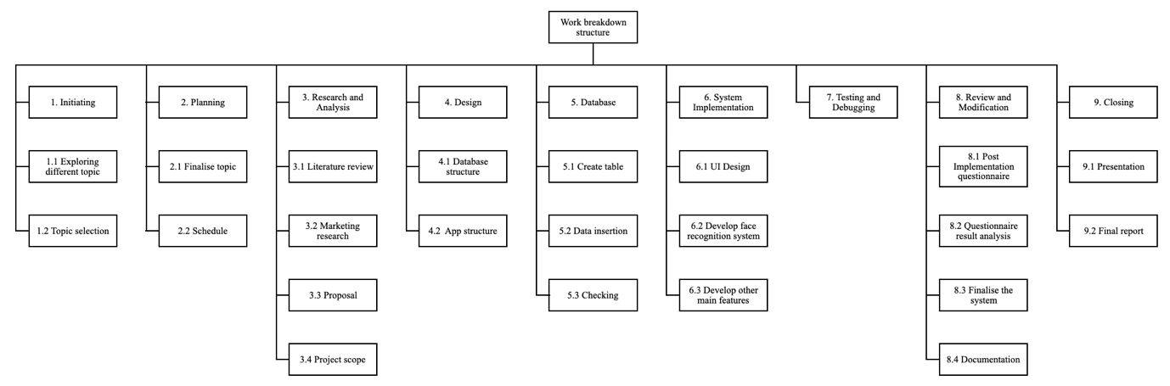

Fig 1

### **6.1.1 WBS Dictionary**

1. Initialling
   1. Exploring different topic
   2. Topic selection – select the top found in the last step
2. Planning

2.1 Finalize topic

2.2 Schedule – planning the whole project schedule

3. Research and Analysis

3.1 Literature review

3.2 Marketing research

3.3 Proposal

3.4 Project scope

4. Design

4.1 Database structure – planning table name, relationship between table

4.2 App structure – planning system features, structure

5. Database

5.1 Create table

5.2 Data insertion

5.3 Checking

6. System implementation

6.1 UI Design – user interface design

6.2 Develop face recognition system

6.3 Develop other main features – features like timetable and notifications

7. Testing and Debugging

8. Review and Modification

8.1 Post implementation questionnaire –evaluate the effectiveness of the product

8.2 Questionnaire result analysis

8.3 Finalise the system

8.4 Documentation

9. Closing

9.1 Presentation

9.2 Final report

## **6.2 Gantt Chart**

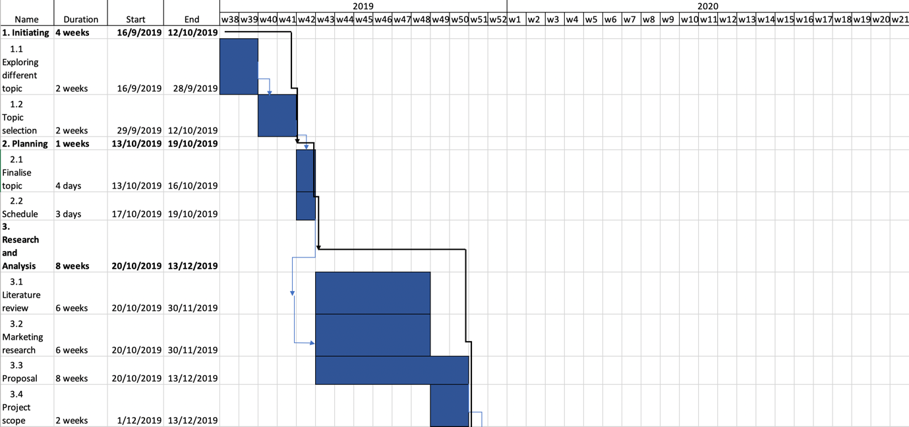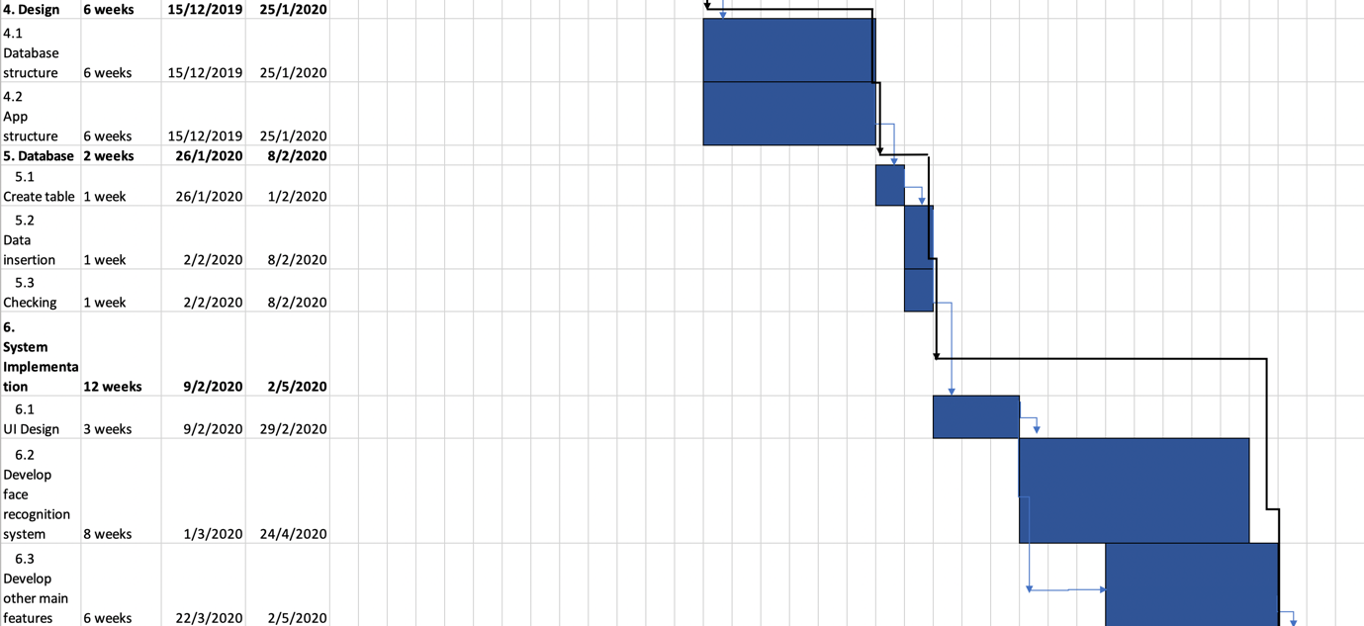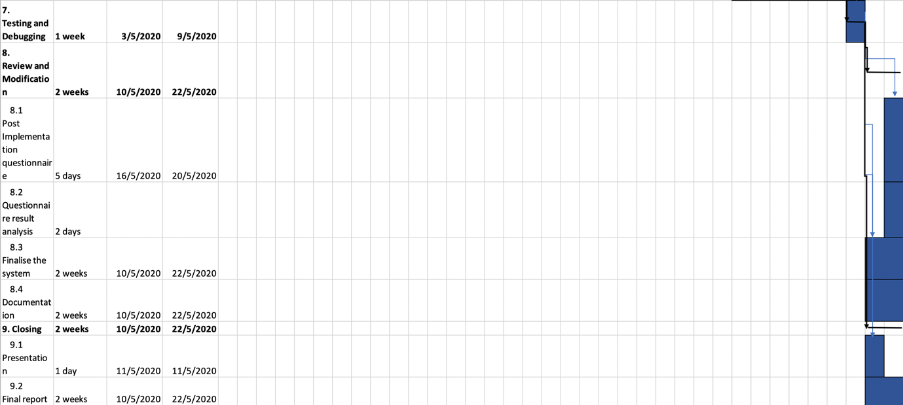

Fig 2

# **7. System Design**

## **7.1 Proposed Hardware and Software**

Hardware:

* Computer running Windows/ macOS
* Web camera

It is suggested that the machine for training the model of each students should be powerful enough like latest octa-core CPU. Besides, as TensorFlow support CUDA®-enabled Nvidia GPU cards to boost the performance (TensorFlow 2020), it is recommend to also chosen a computer with that GPU.

For web camera, it is suggested to not use a camera with low image quality which may leads to poor recognition and model accuracy.

Software:

* Python 3.6
  + Keras 2.2.4
  + PyMySQL 0.9.3
  + dlib 19.8.1
  + face-recognition 1.3.0
  + google-auth 1.12
  + matplotlib 3.2.1
  + opencv-contrib-python 3.4.7.28
  + sklearn 0.0
  + tesnorflow 1.13.1
  + urlib3 1.25.8
* Xampp
  + PhpMyAdmin
* Node.js
* It is suggested to use PyCharm Integrated Development Environment (IDE) to run all the python files as user can download the packages or libraries through the setting of the IDE with selection of package versions, providing easy to use GUI interface instead of command in command prompt or terminal in Mac.

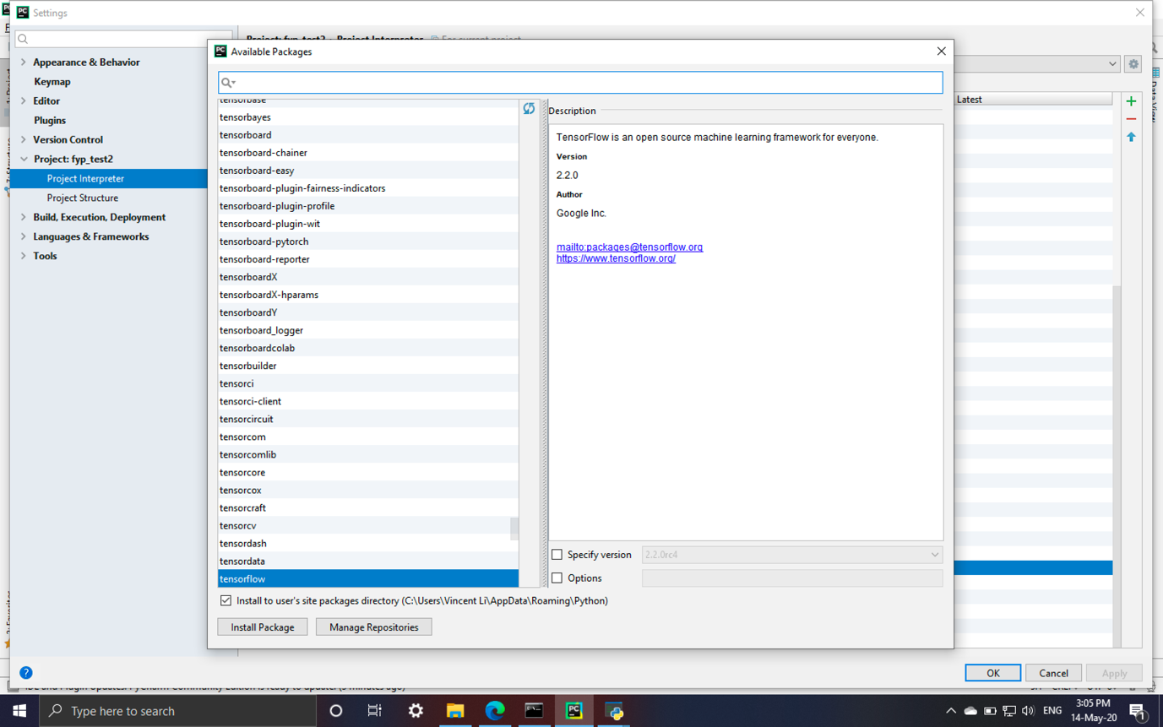Fig 3, PyCharm package install menu, allowing user to select the version they want.

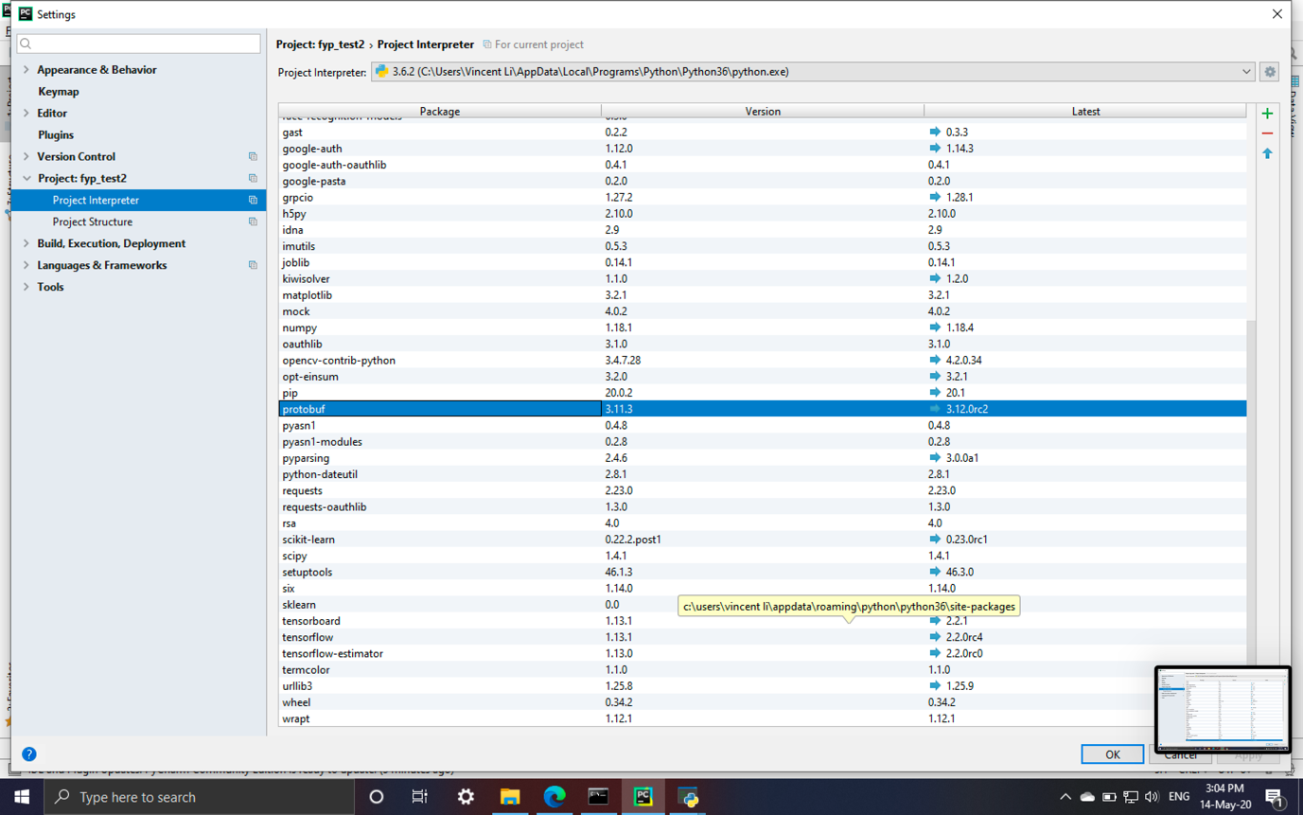

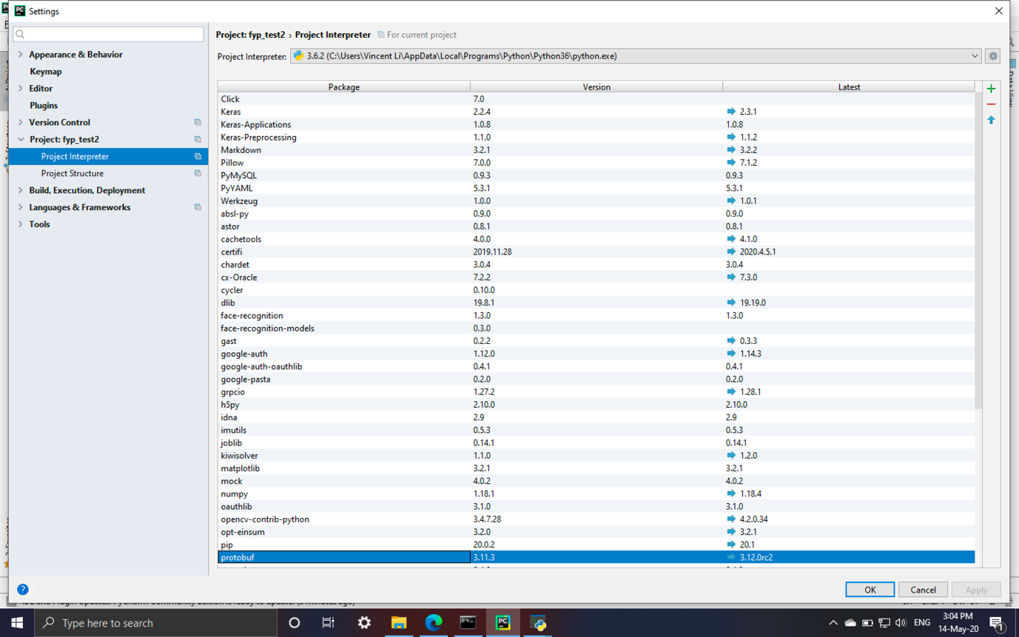 Fig 4 & 5, All packages install on my computer.

## **7.2 Proposed Implementation**

For the attendance taking terminal, a computer running Windows or Mac with a camera and software installed will be place at the entrance of every classroom. Before the teachers get into the classroom and prepared for the lesson, they should first login to the attendance taking terminal allowing the system to ready for taking attendance on specific lesson. Then, the student can take the record using their face and Student ID.

For the main program, it app should not only be installed on all computers in the staff office, but also allowing the staffs and student installing in their personal computer

## **7.3 ER Diagram**

The ER diagram below demonstrate the entity relationship between tables within database.

**Course_timetable**

This table stores the attributes need for storing timetable information of each course, with many to one relationship to course:

time_table_id (primary key) - identifying each timeslot and lesson of the course

course_id (foreign key) - identifying the course

day - store the lesson’s date

time - store the lesson’s time

room - store the lesson’s room

**Course**

This table stores the basic information of the courses, with one to many relationship with course_timetable, many to one relationship with staff and one to many relationship with student_course:

course_id (primary key) - identifying the course

course_name – the name of the course

staff_id (foreign key) – ID of teacher responsible for the course

**Staff**

This table stores the information of the staff, with one to many relationship with course:

staff_id (primary key) – identifying the staff

password – password of staff login to the system

first_name – first name of staff

last_name – last name of staff

position – like Teacher/ Admin/ Officer

sex – sex of staff

date_of_birth – birthday of staff

**Student_course**

This table is used to store information of which attend a course, with many to one relationship with course and student:

student_id (foreign key) – identify the student

course_id (foreign key) – identify the course

**Student**

This table stores the information of the student, with one to many relationship with course and login_record:

first_name - first name of student

last_name – last name of student

sex - sex of student

date_of_birth – birthday of student

student_id (primary key) – identify of student

face_cap – identify is the face captured by the system yet

face_train – identify is the face model trained

password - password of student login to the system

**Login_record**

This table stores the attendance taking record of the student, with many to one relationship with student:

student_id (foreign key) – identify the student

login_date – attendance taking recorded date and time

login_id (primary key) – identify each record

time_table_id (foreign key) - identifying each timeslot and lesson of the course

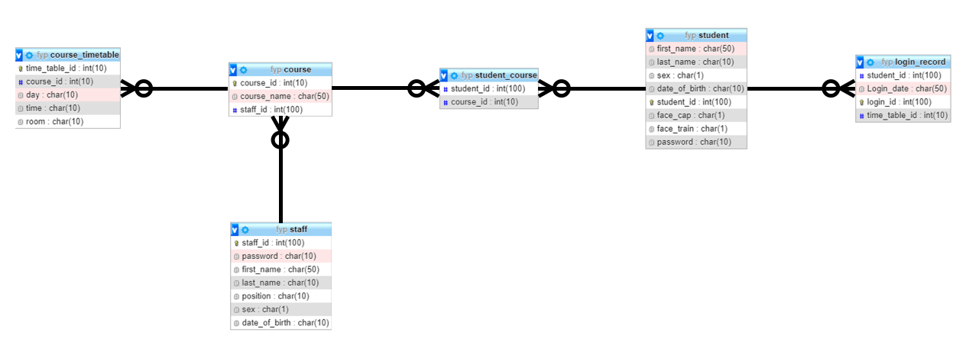

Fig 6, relationship between tables

## **7.4 Database Model Diagram**

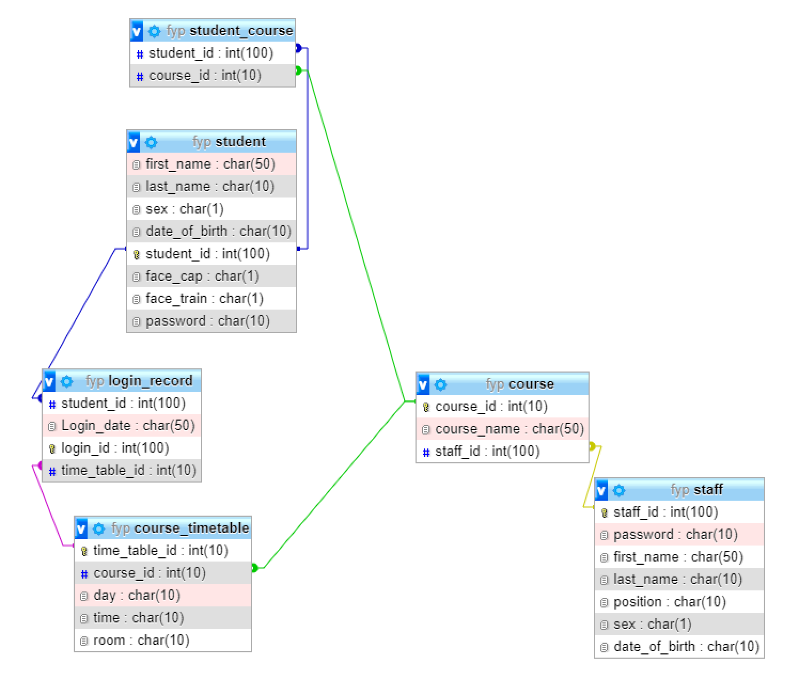Fig 7, the database model diagram shows how the foreign keys are connected in the system.

**7.5 Use Case Diagram**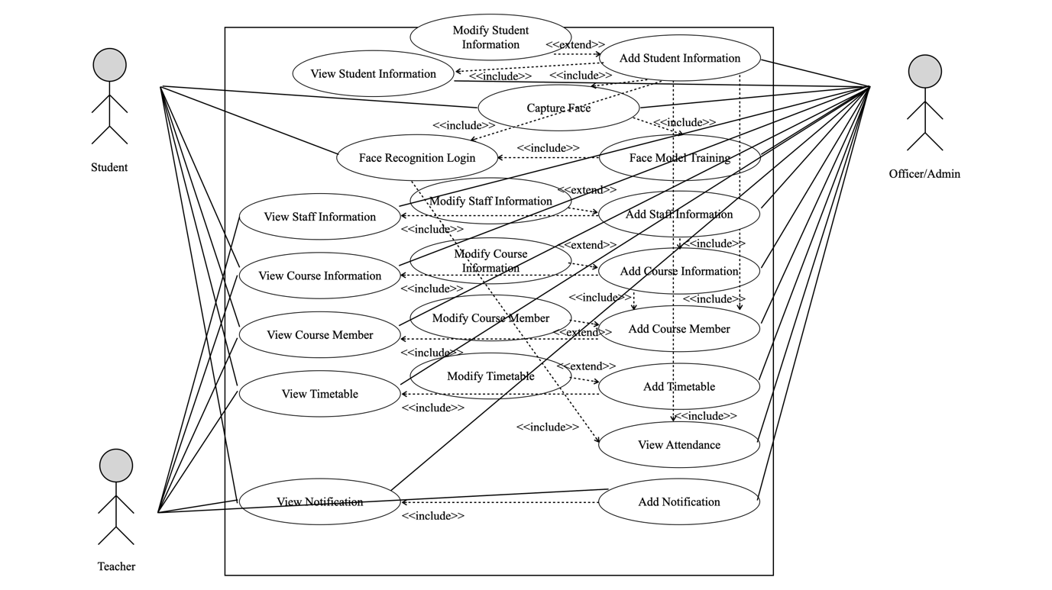

Fig 8

The use case diagram presents the relationship between the users (student, teacher, officer and administrator) and system’s use cases. For example, the student and able to capture their face and the functionally of this feature is included in face model training. Moreover, the extend means that the feature is the extension of the other feature.

## **7.6 User Interface (UI)**

Both systems provide graphical user interface (GUI), allowing every user with or without computer knowledge to use the system easily.

**7.6.1 Login Interface**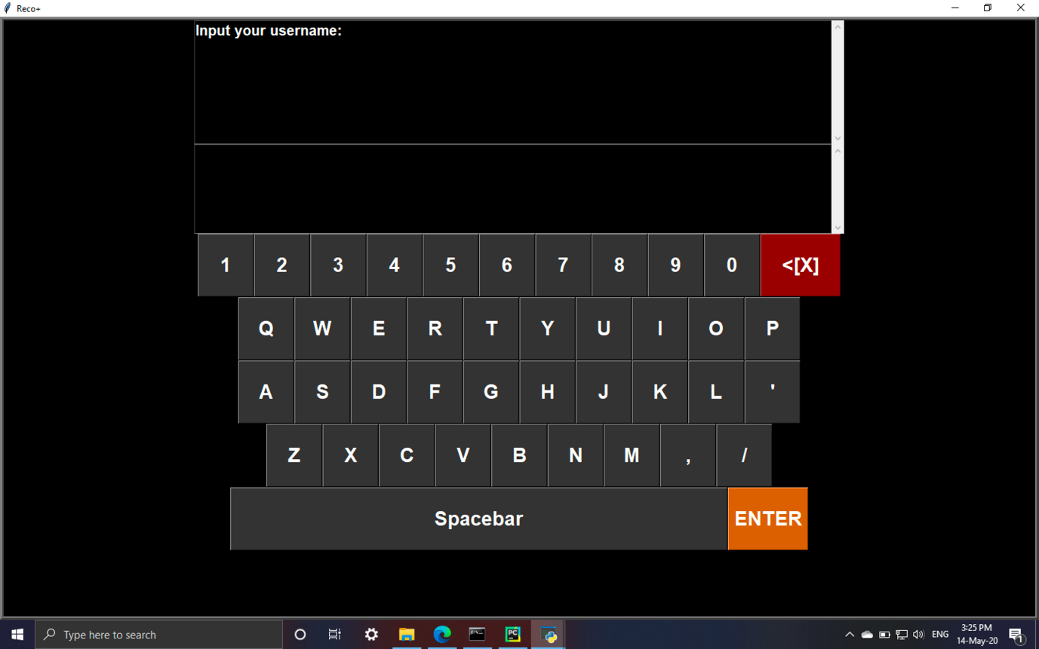

Fig 9

The virtual keyboard allows user to type through the touch screen with the advantages of others are unable to predict the password by the checking which keys are used frequently in the real keyboard.

Student ID selection screen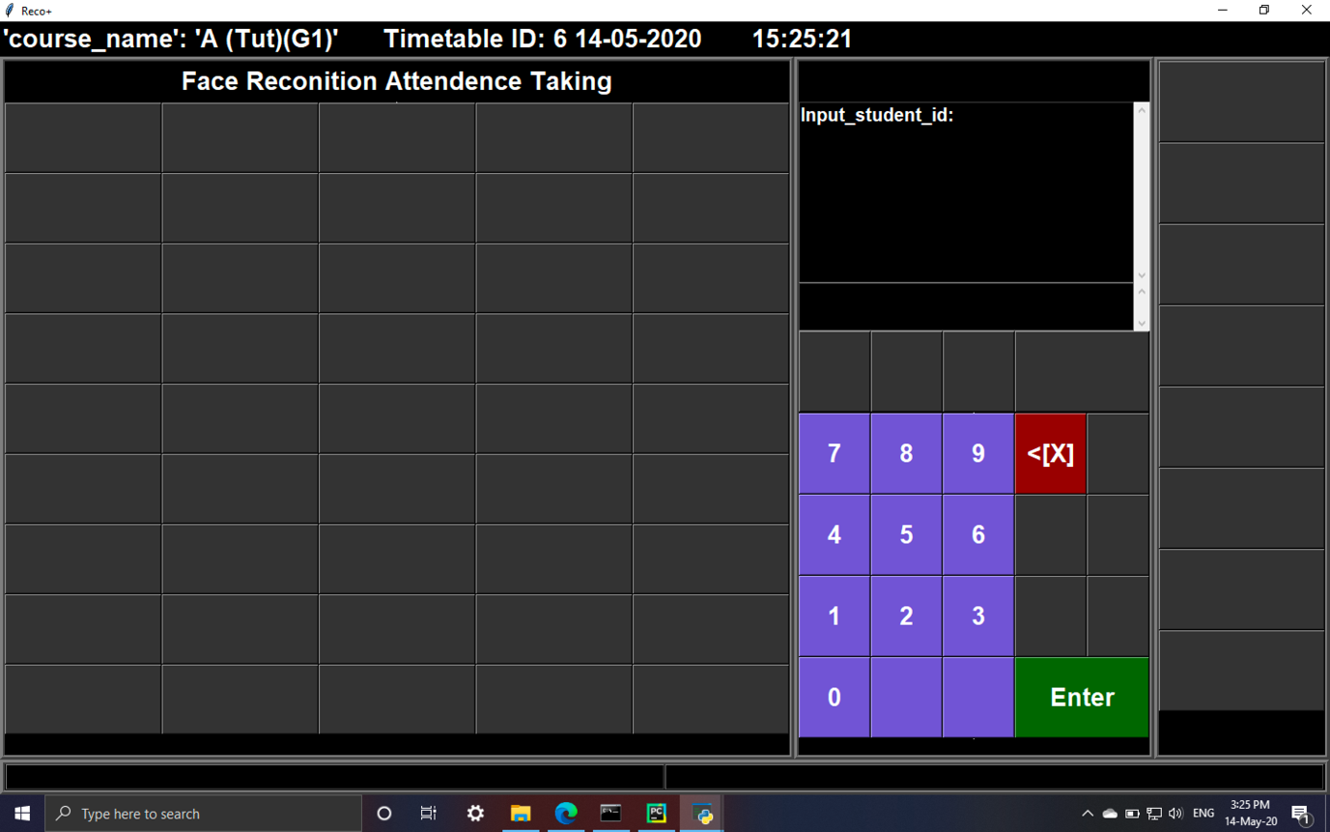

Fig 10

This screen allows user to search the through the keypad no matter he/she is using mouse or touch screen.

### **7.6.2 Main menu**

Administrator/Officer 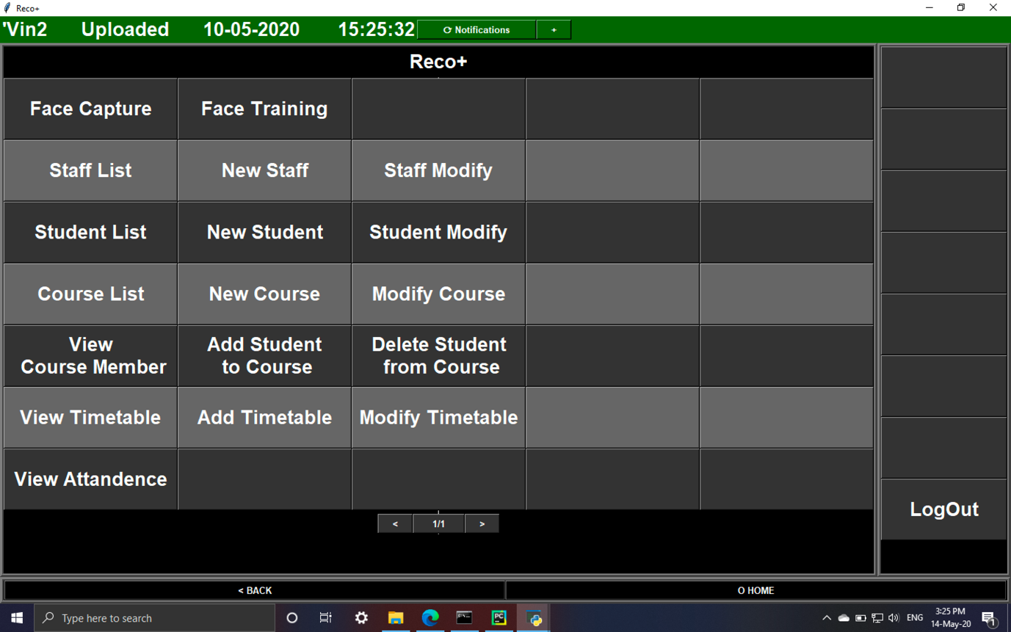

Fig 11

Teacher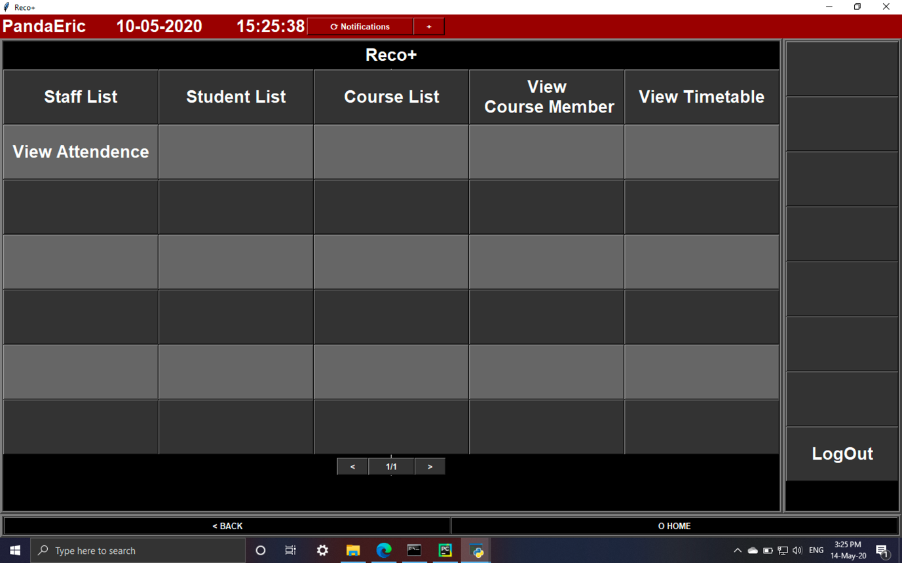Fig 12

Student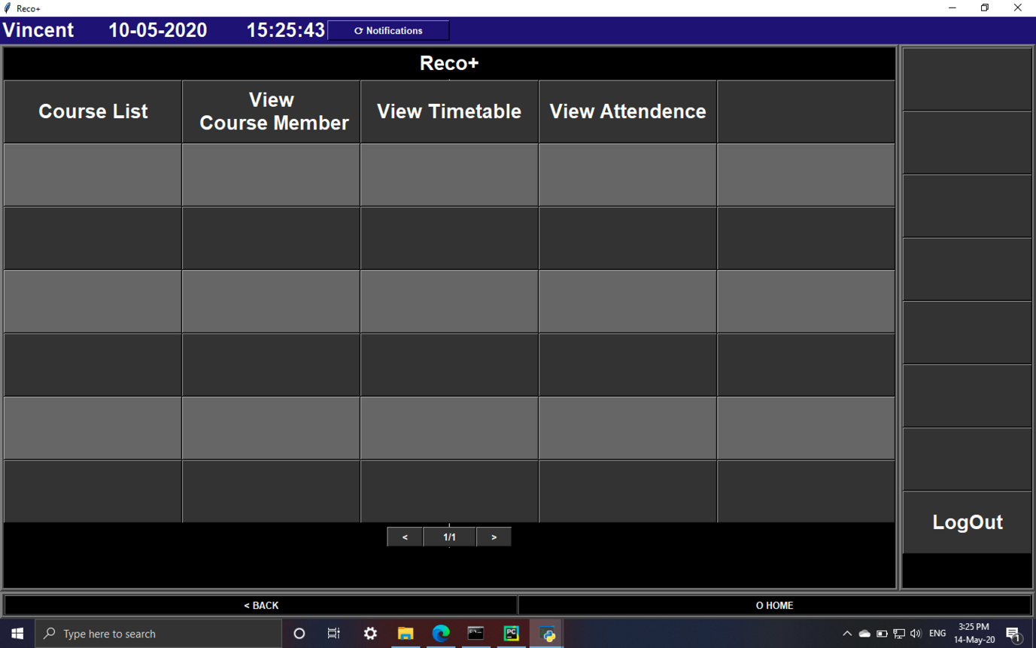

Fig 13

The main menu displays all the features that the user can access to the system, with the colour difference on the status bar on top to identify the permission of the account (Green for admin/officer, red for teacher and blue for student).

**7.6.3 Form page**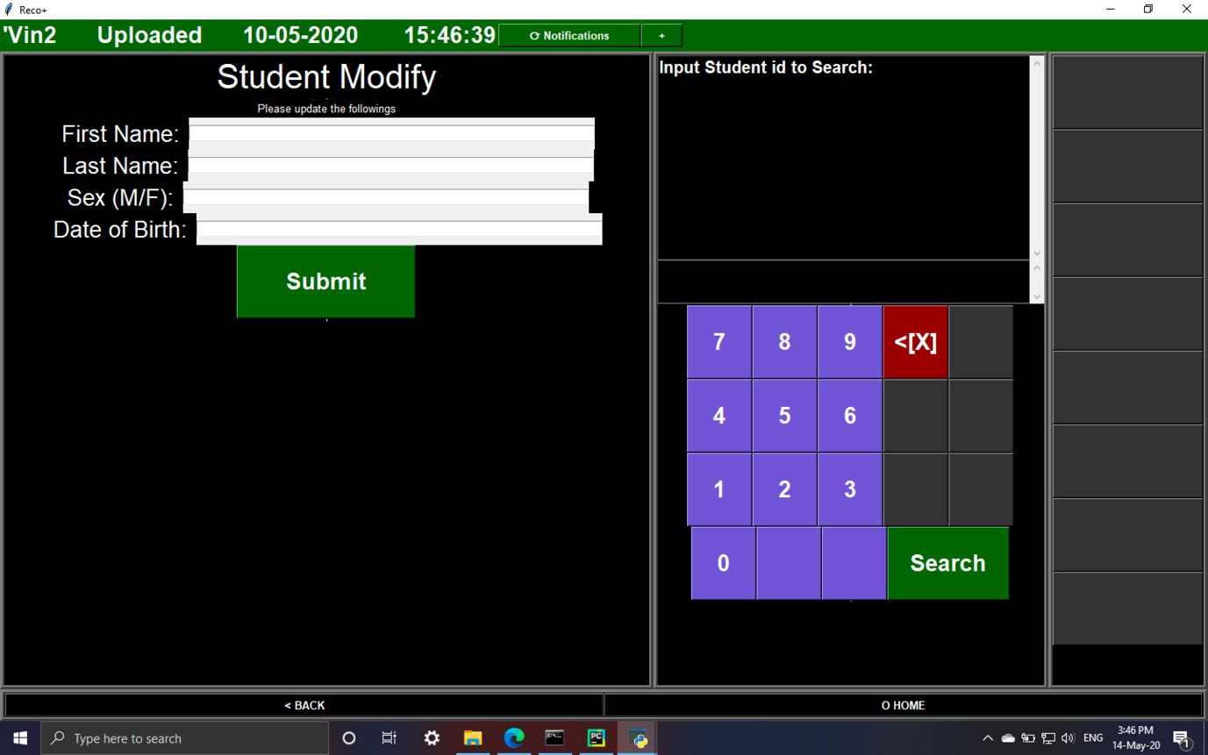

Fig 14

The form page will be appeared when the user need to insert data to the database, with the keypads appear when the features requires user to select the ID first.

**7.6.4 List page**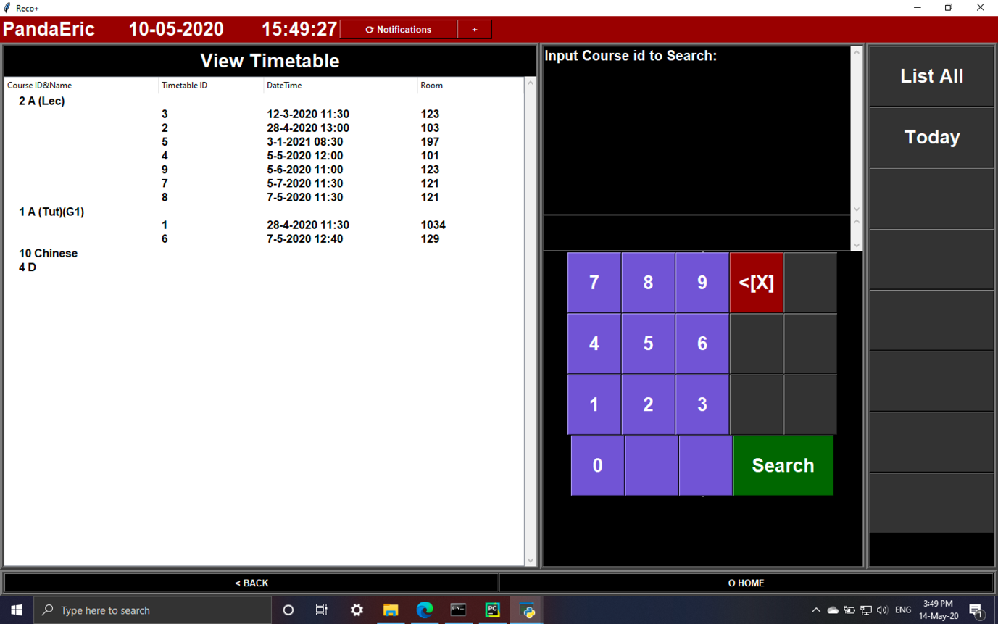

Fig 15

The list page appears for the list/view feature, displaying the data in table with keypad for ID search and buttons to change the display order.

## **7.7 User Manual**

### **7.7.1 Attendance taking Terminal**

Teacher/staff

1. Login with Staff ID
2. Select Timetable ID of the course
3. Confirm the Course Name and Timetable ID on the top left of status bar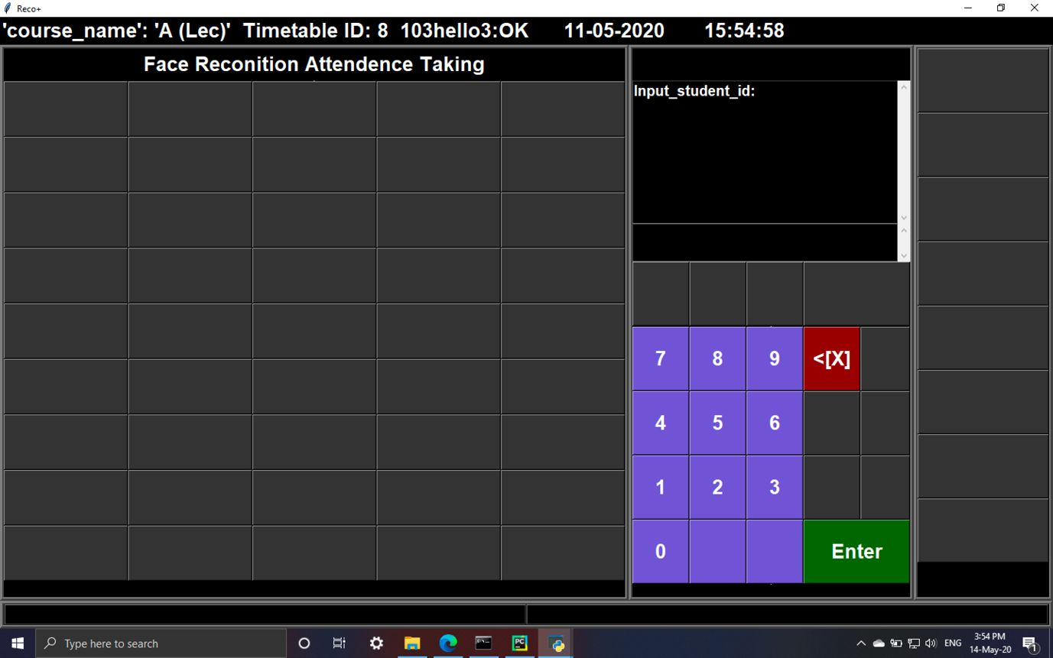Fig 16
4. The system is ready for student to take attendance

Student

1. Input their own student ID
2. The camera will be open after clicking Enter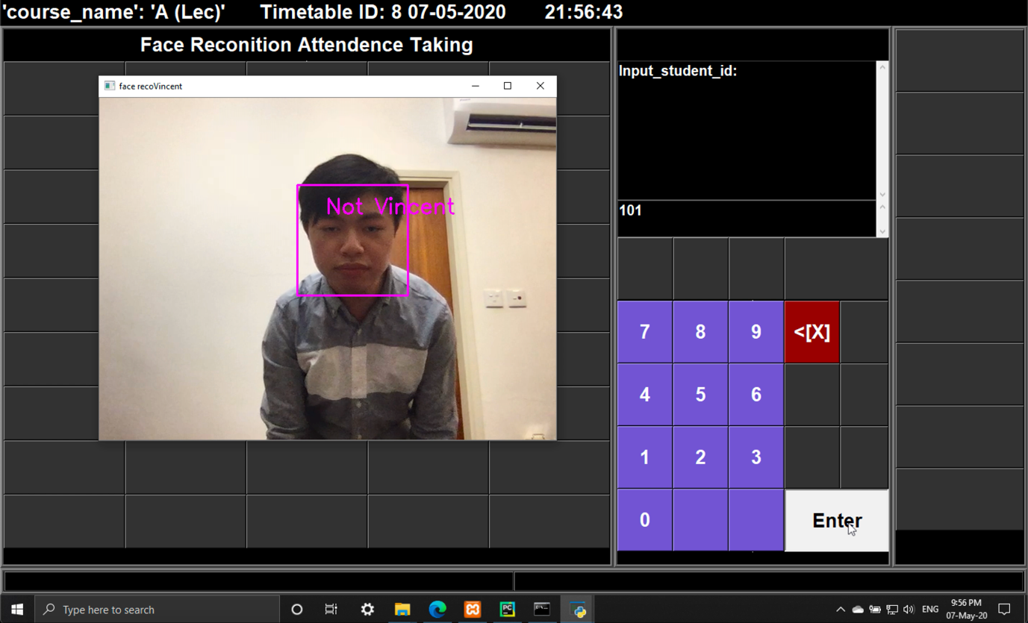Fig 17, Camera turned on
3. Walk closer to allow the camera capture the face
4. OK will be displayed and the camera window will be disappear when the system identify the face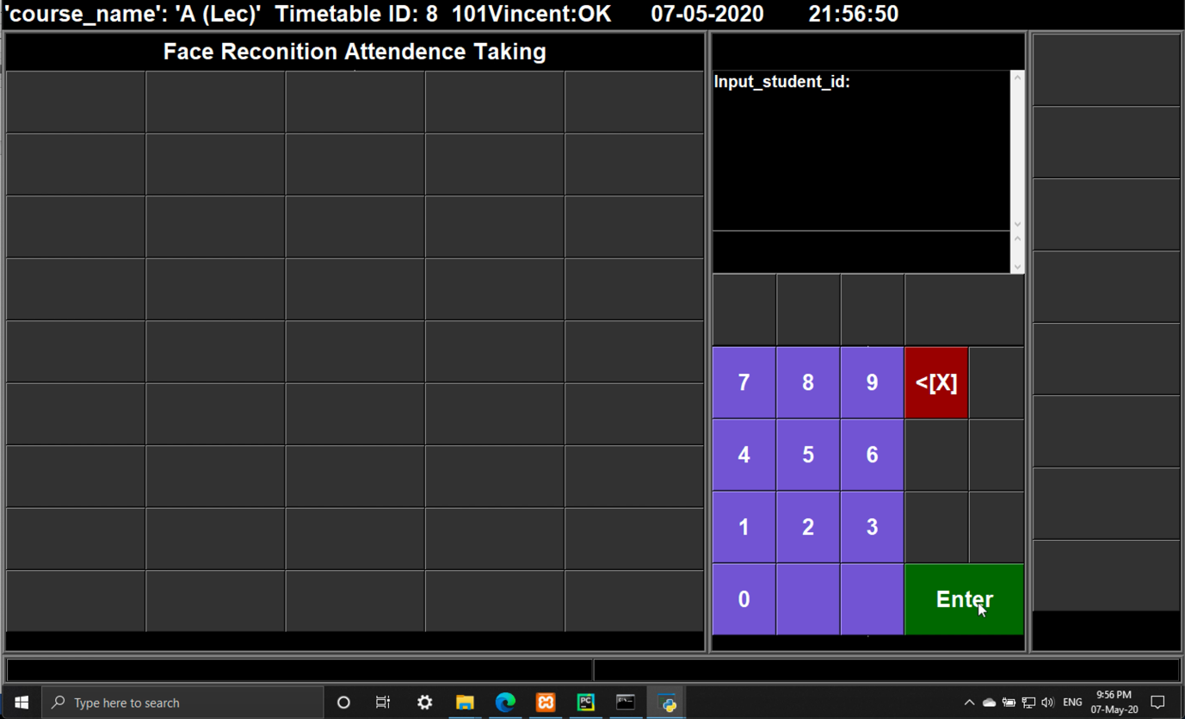Fig 18

### **7.7.2 Main Program**

#### **7.7.2.1 Face Capture**

1. Input the student ID of the capture target
2. If the face has not been captured, the camera will be opened and 1000 face images will be taken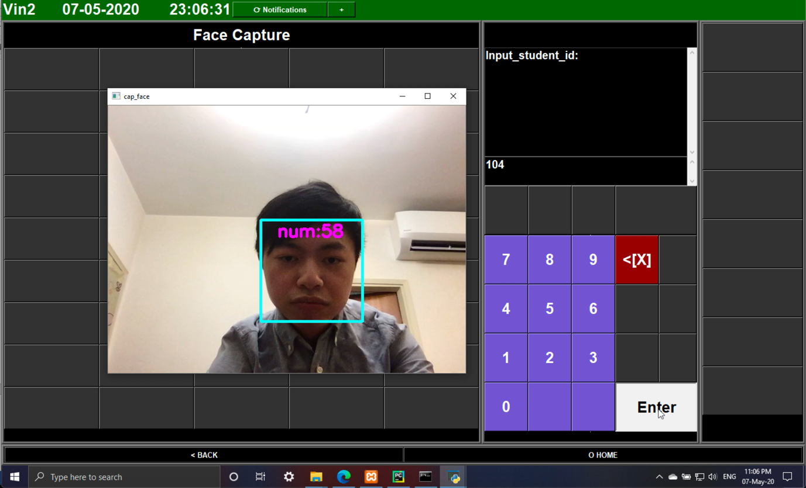Fig 19, System capturing my face
3. ‘Captured’ will be displayed on the status bar and the camera will be off automatically
4. Image is saved to file named by the Student ID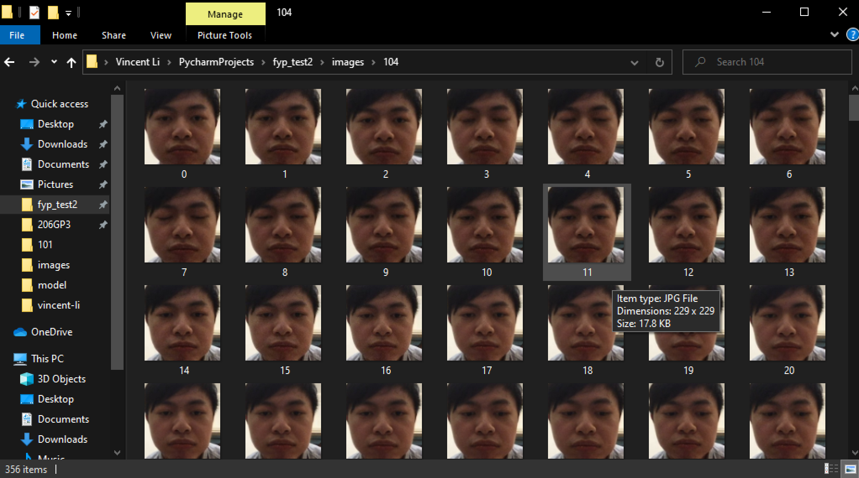Fig 20, Image stored at the same folder

#### **7.7.2.2 Face training**

1. Input the student ID of the training target
2. Training will be run automatically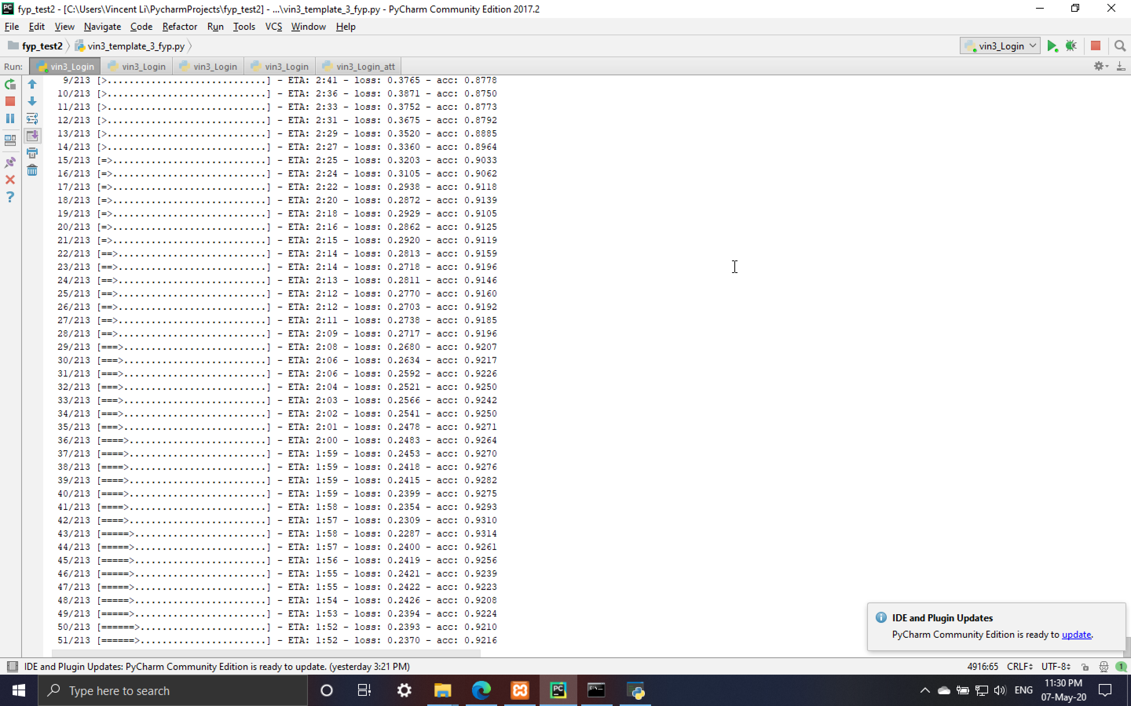Fig 21, Model training
3. Accuracy of the model will be displayed

#### **7.7.2.3 Add new student/staff information**

1. Input the information according to the screen 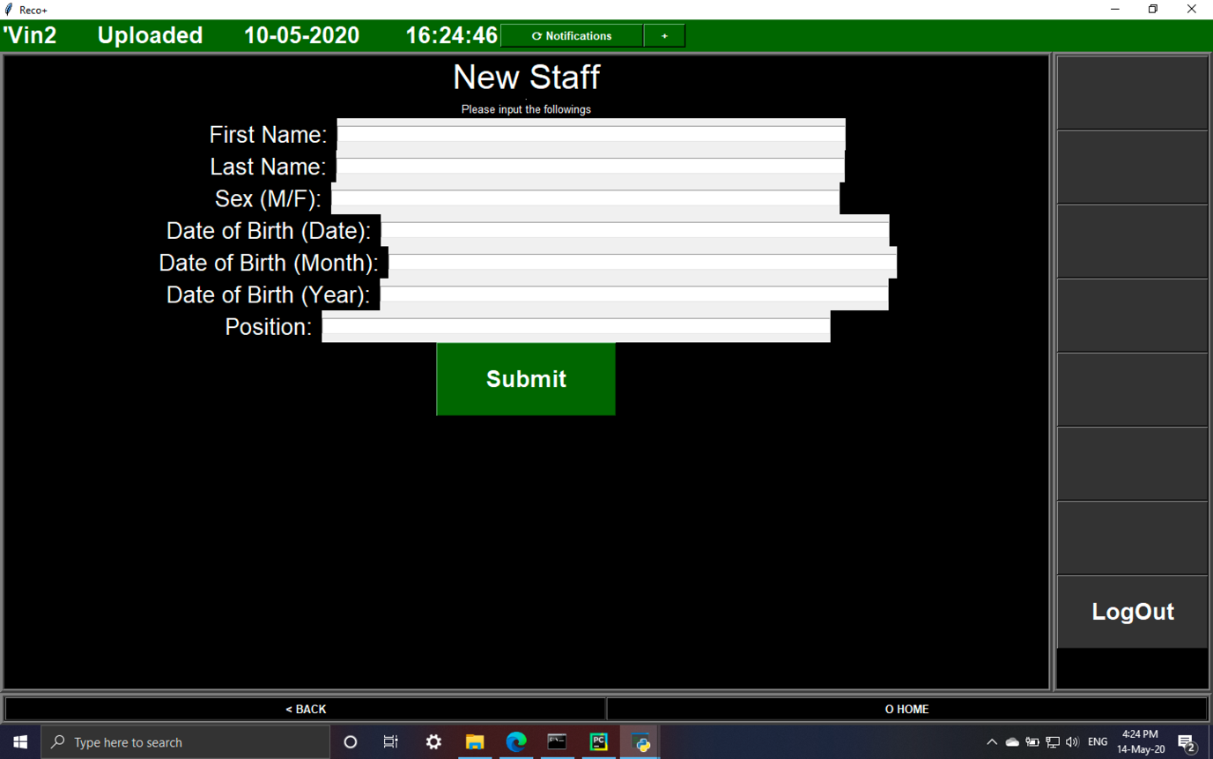Fig 22, Staff form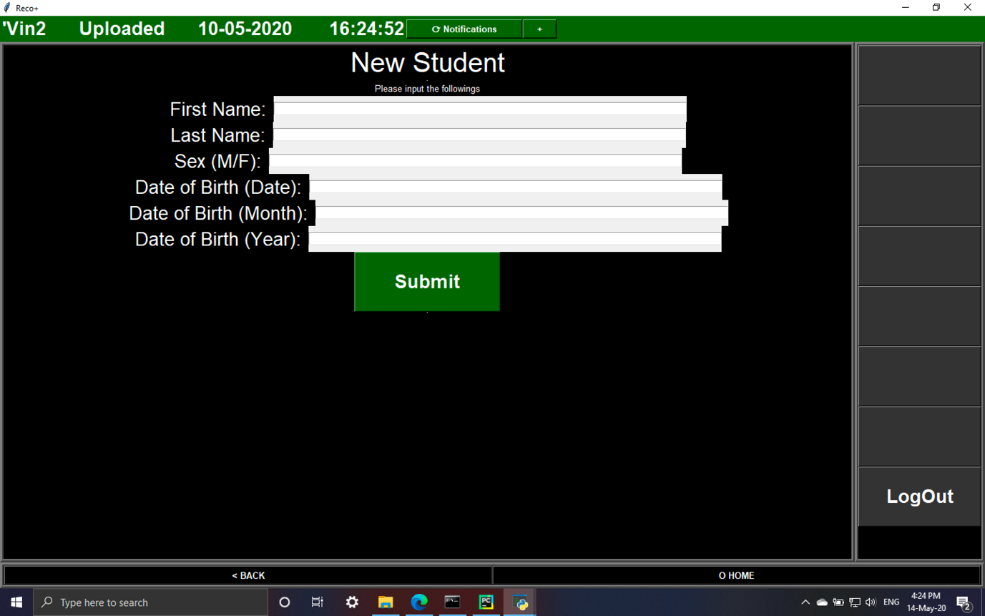 Fig 23, Student form
2. The data will be appended to database

#### **7.7.2.4 Add new course**

1. Input the course name and teacher’s Staff ID responsible for course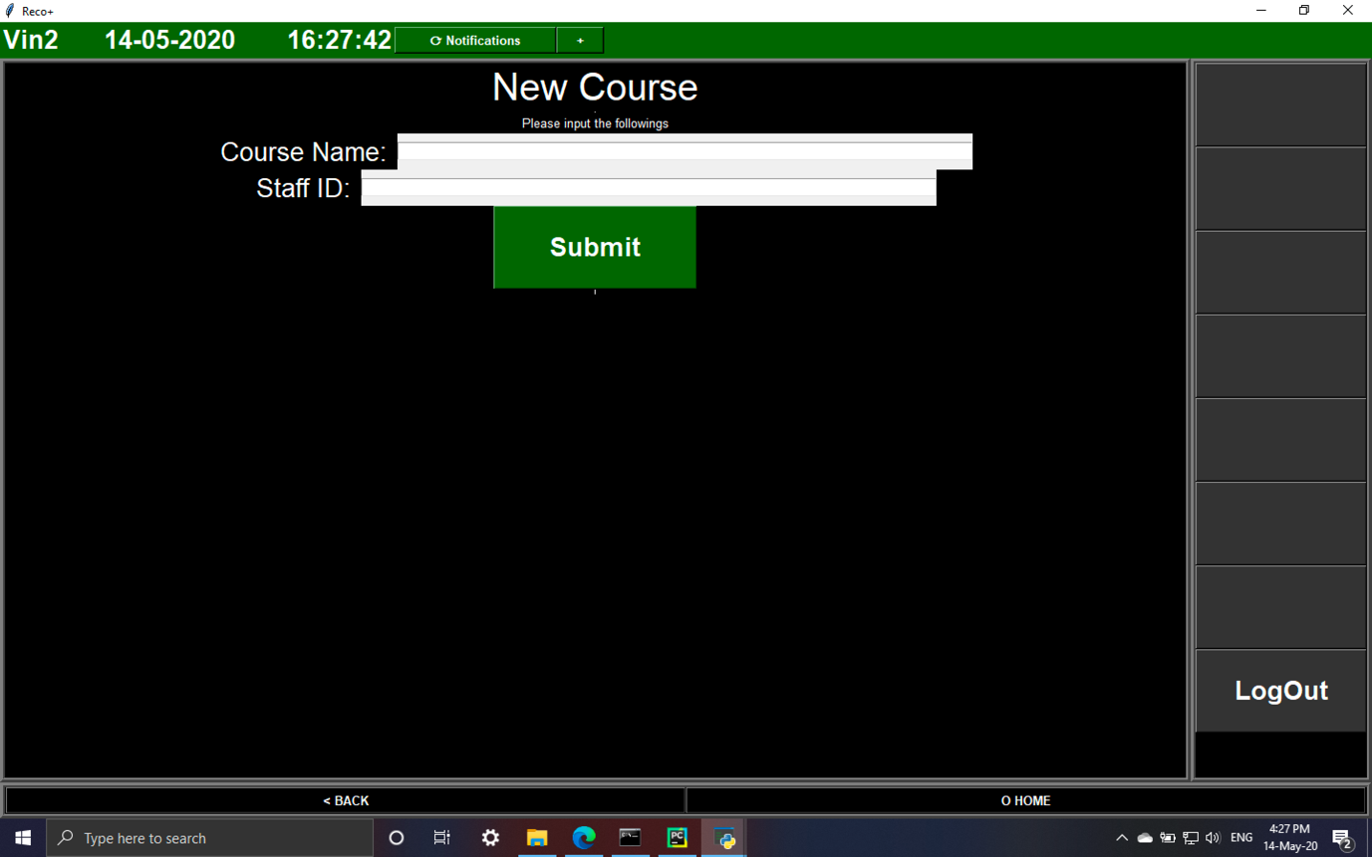Fig 24
2. The data will be appended to database

#### **7.7.2.5 Add/delete course member**

1. Input Student ID of the student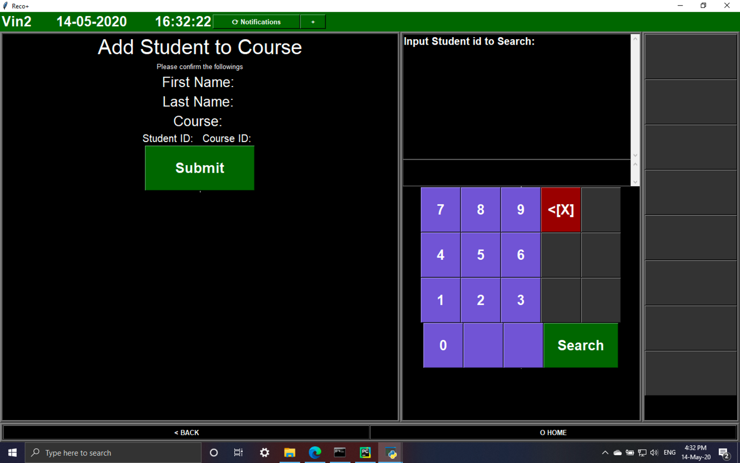Fig 25
2. Input Course ID
3. The data will be appended to/deleted from database

#### **7.7.2.6 Add course’s timetable**

1. Input Course ID and the date, time and venue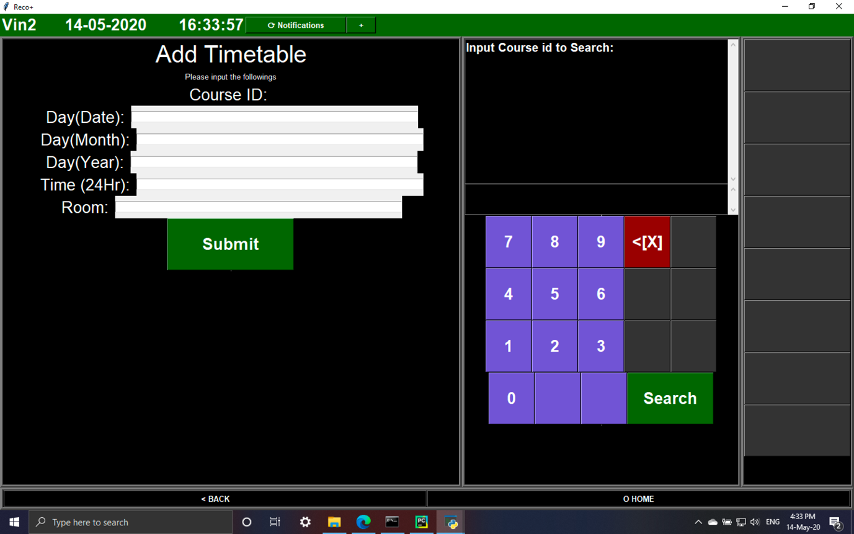Fig 26
2. The data will be appended to database

#### **7.7.2.7 Student/staff/course/timetable modification**

1. Input the student/staff/course/timetable ID
2. The current data will be displayed in the input box on left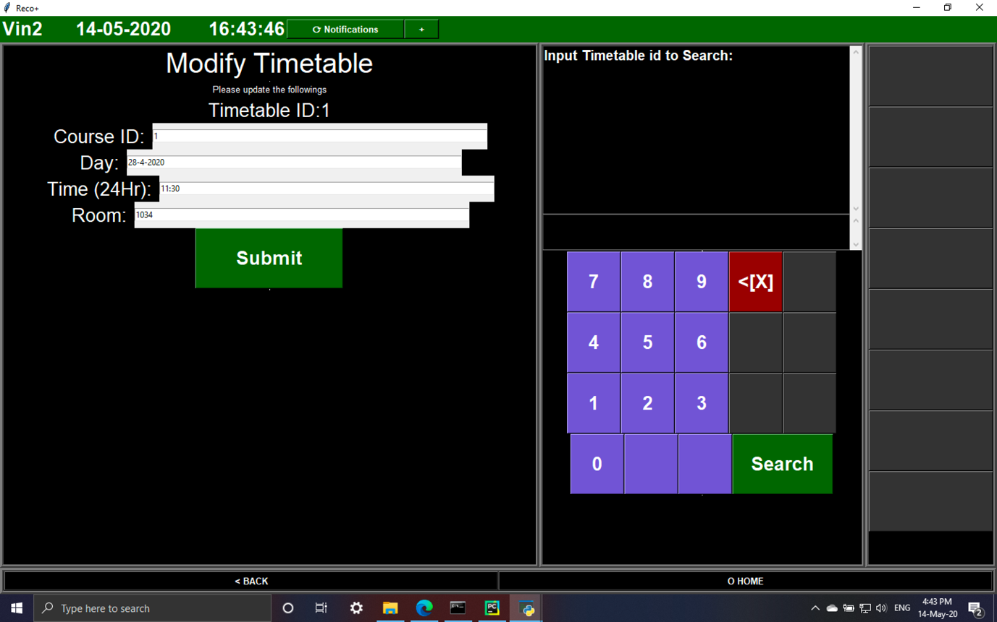Fig 27
3. Update the input box
4. The database record will be updated

#### **7.7.2.8 View student/staff list**

1. The system will displays all student/staff information 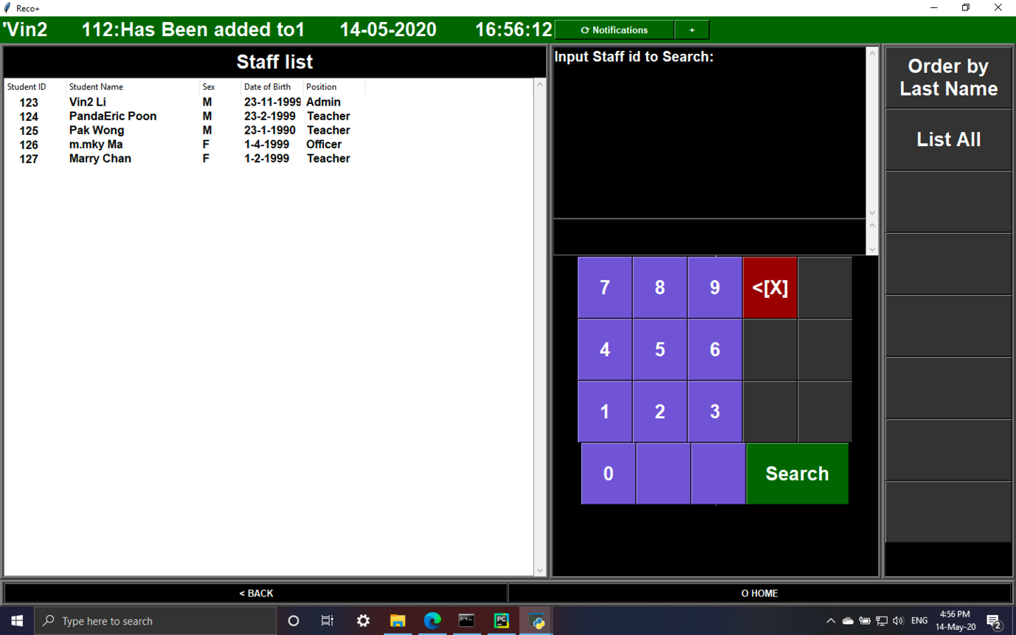Fig 28
2. The user are able to change the listing order or search by student/staff ID

#### **7.7.2.9 View course list**

Admin/officer

1. All courses in school will be displayed ordered by the course name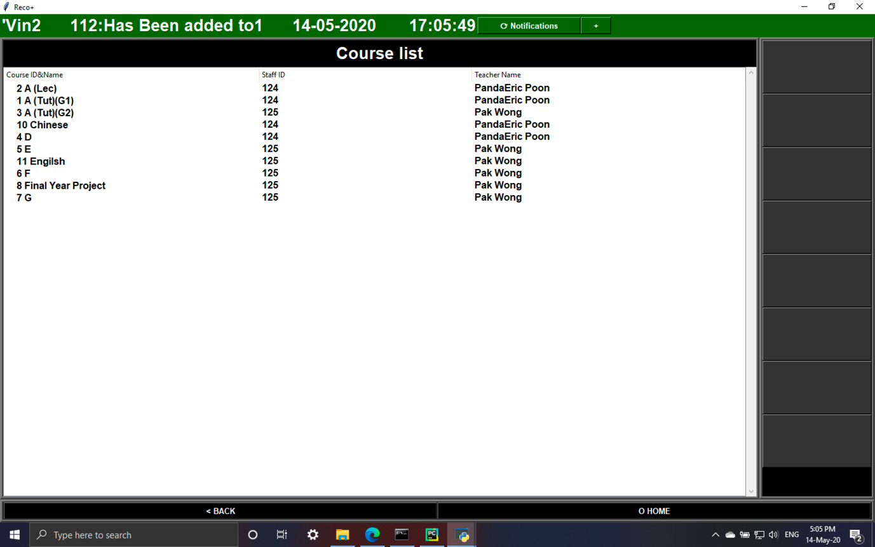Fig 29

Teacher

1. The courses taught by the teacher will be displayed with buttons to view all other courses in school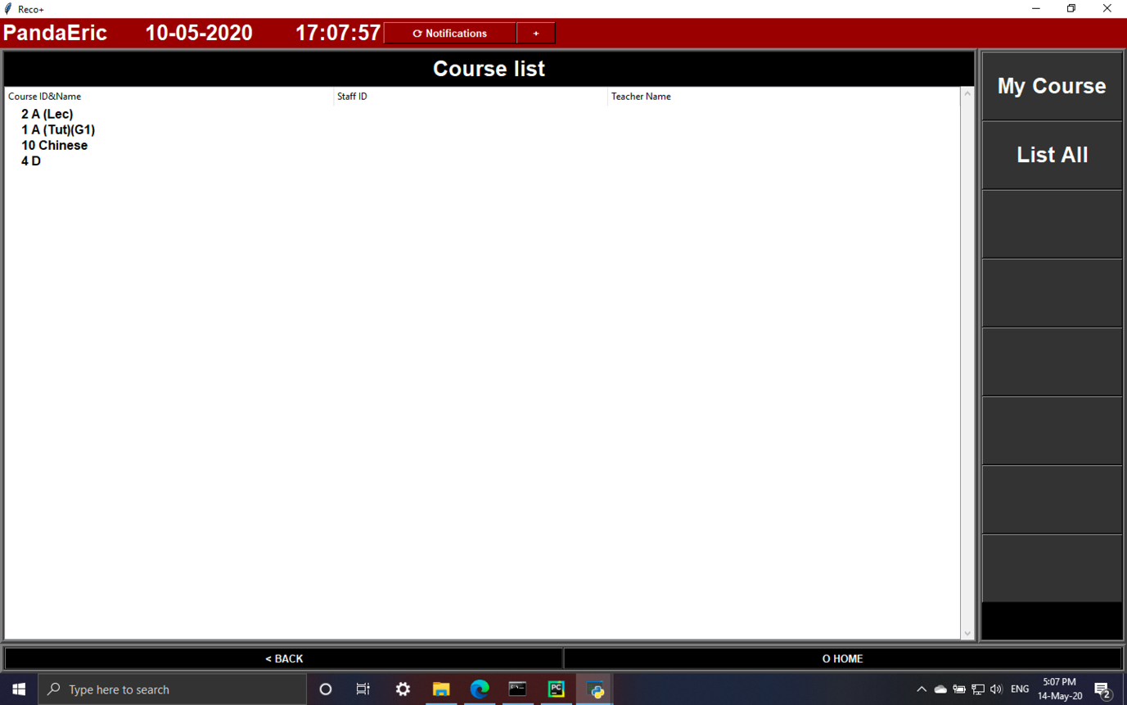Fig 30

Student

1. All the course the student need to attend will be listed outFig 31

#### **7.7.2.10 View course member**

Admin/officer

1. They are able to view the members of the course by inputting the Course ID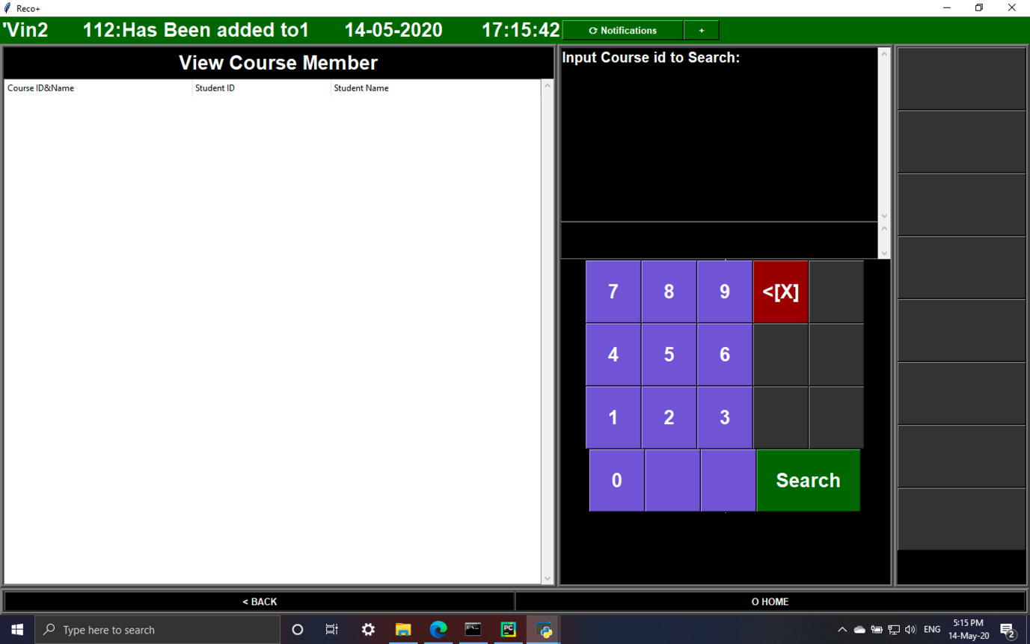Fig 32

Teacher/Student

1. The system will automatically lists out the courses they are studying/teaching with the course member. The system also allowed to view the specific course through searching by Course ID. 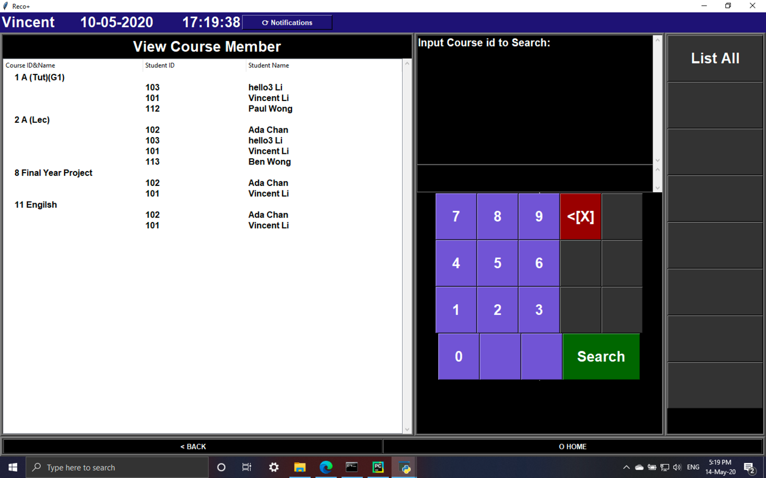Fig 33

#### **7.7.2.11 View timetable**

Admin/officer

1. The system allows the user to search the timetable of each course through searching by the Course ID 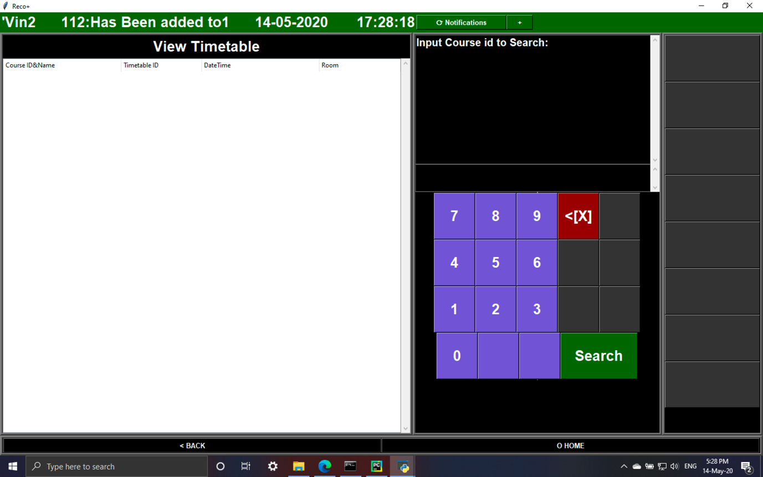Fig 34

Teacher/student

1. The system will automatically lists out the course they are studying/teaching with the timetable. The system also allowed to view the specific course through searching by Course ID. There is also a Today View listing the schedule of today including what class need to attend today, with its time and venue. 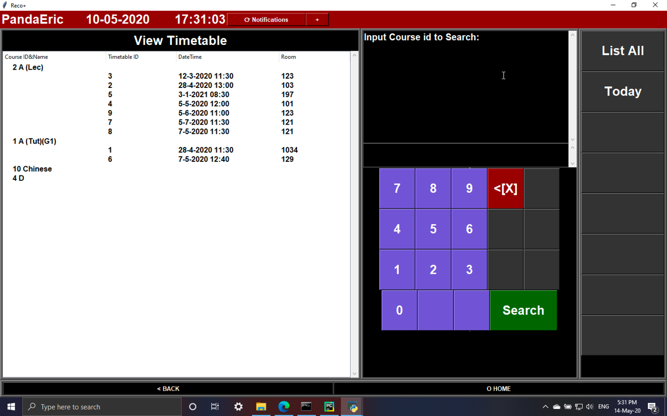Fig 35

#### **7.7.2.12 View Attendance**

Admin/officer

1. The system allows the user to search the attendance of specific course by inputting the Timetable/Course ID 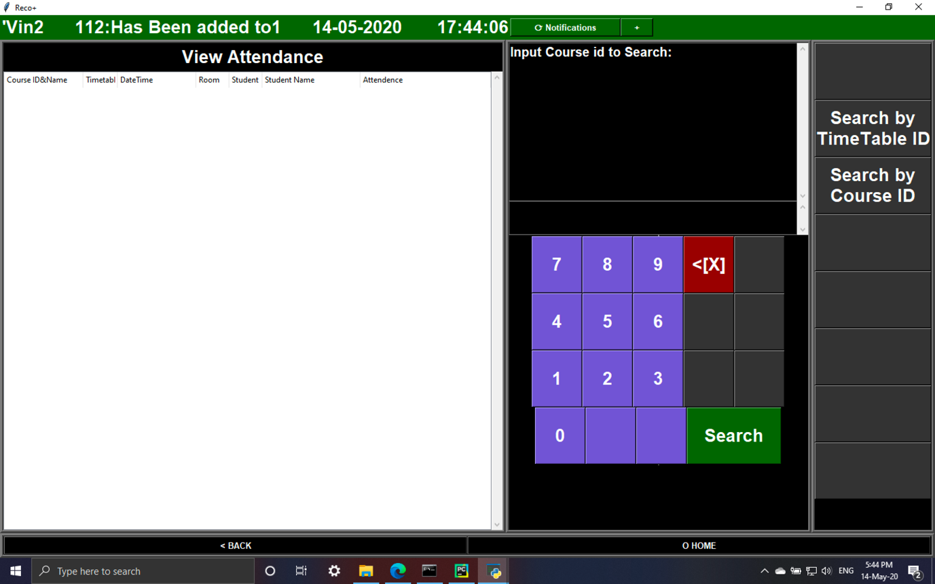Fig 36

Teacher

1. The system automatically lists out all the courses the teacher is teaching with the students list of the courses and the attendance record. Besides, the system also allows the user to search specific course by inputting the Timetable/Course ID 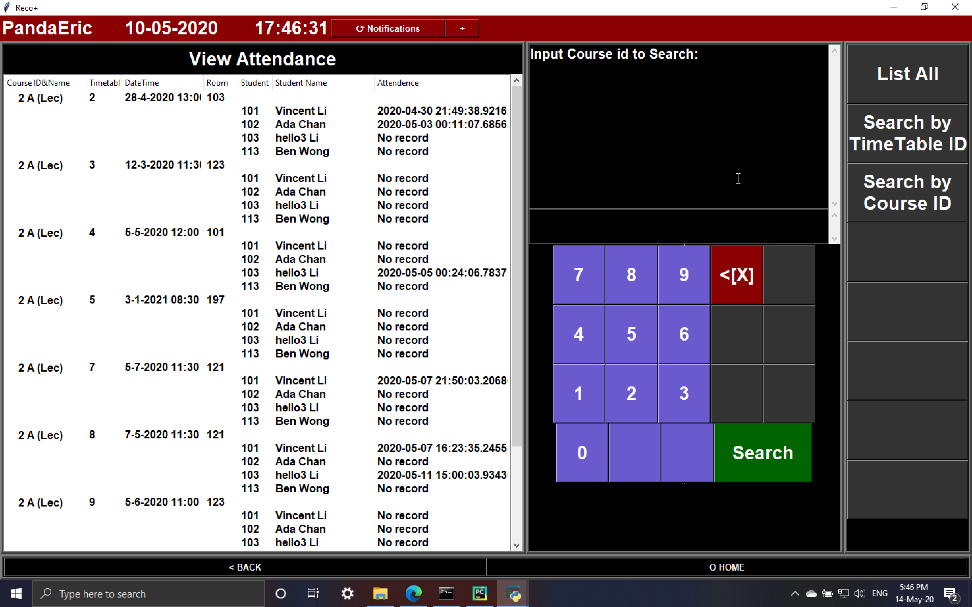 Fig 37

Student

1. The system automatically displays all the courses with the lesson time and attendance taking time. Besides, the system also allows the user to search specific course by inputting the Timetable/Course ID 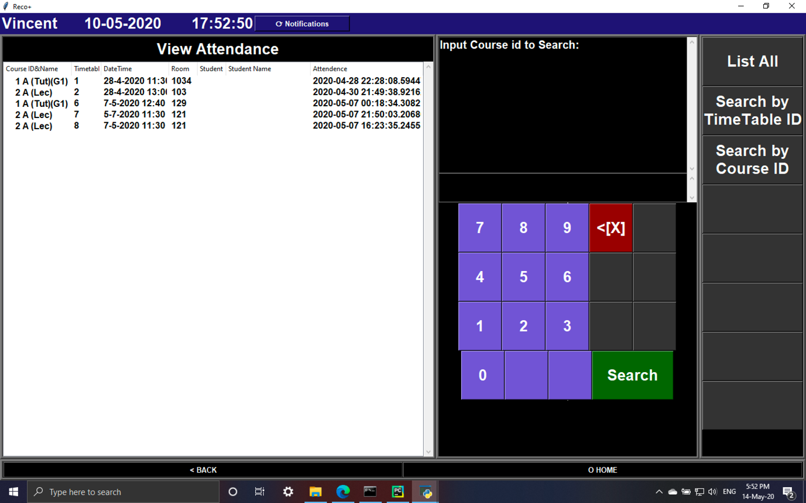Fig 38

#### **7.7.2.13 Send Notifications**

1. Type the notification message in the input box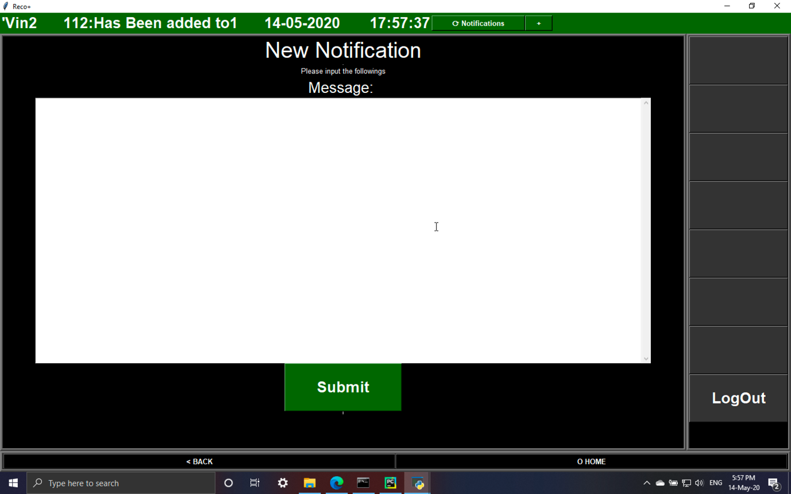Fig 39
2. The notification will be sent through node.js.

#### **7.7.2.14 View Notifications**

* The system will automatically refresh and download the latest notification from node.js when the user click the notification button, displaying the message content with its date and time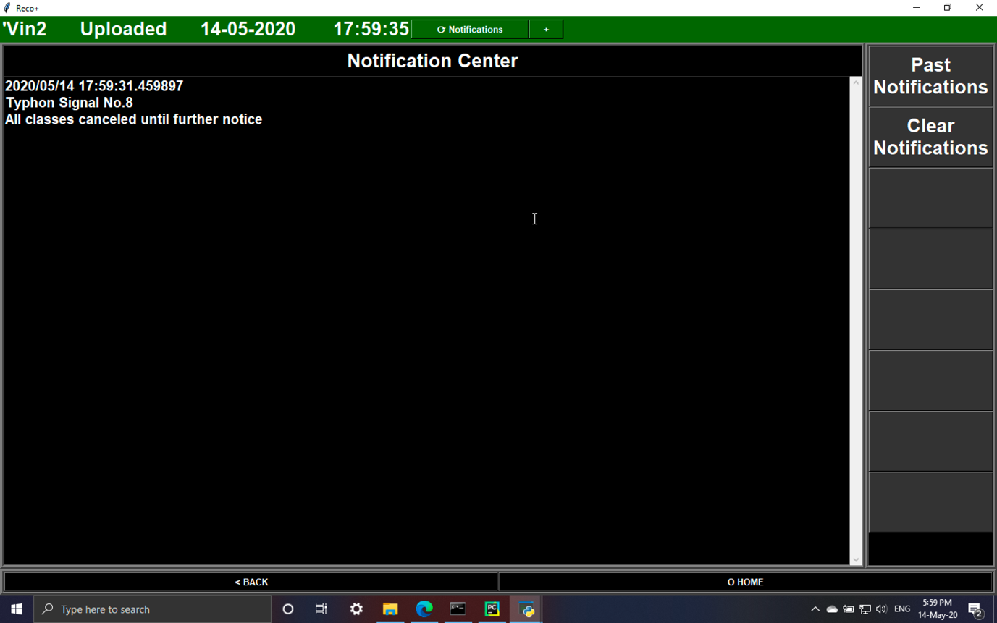Fig 40
* The new notification will be saved to the text file automatically
* Past notifications lists out all notification stored in text file and the user are able to clear all the notifications. 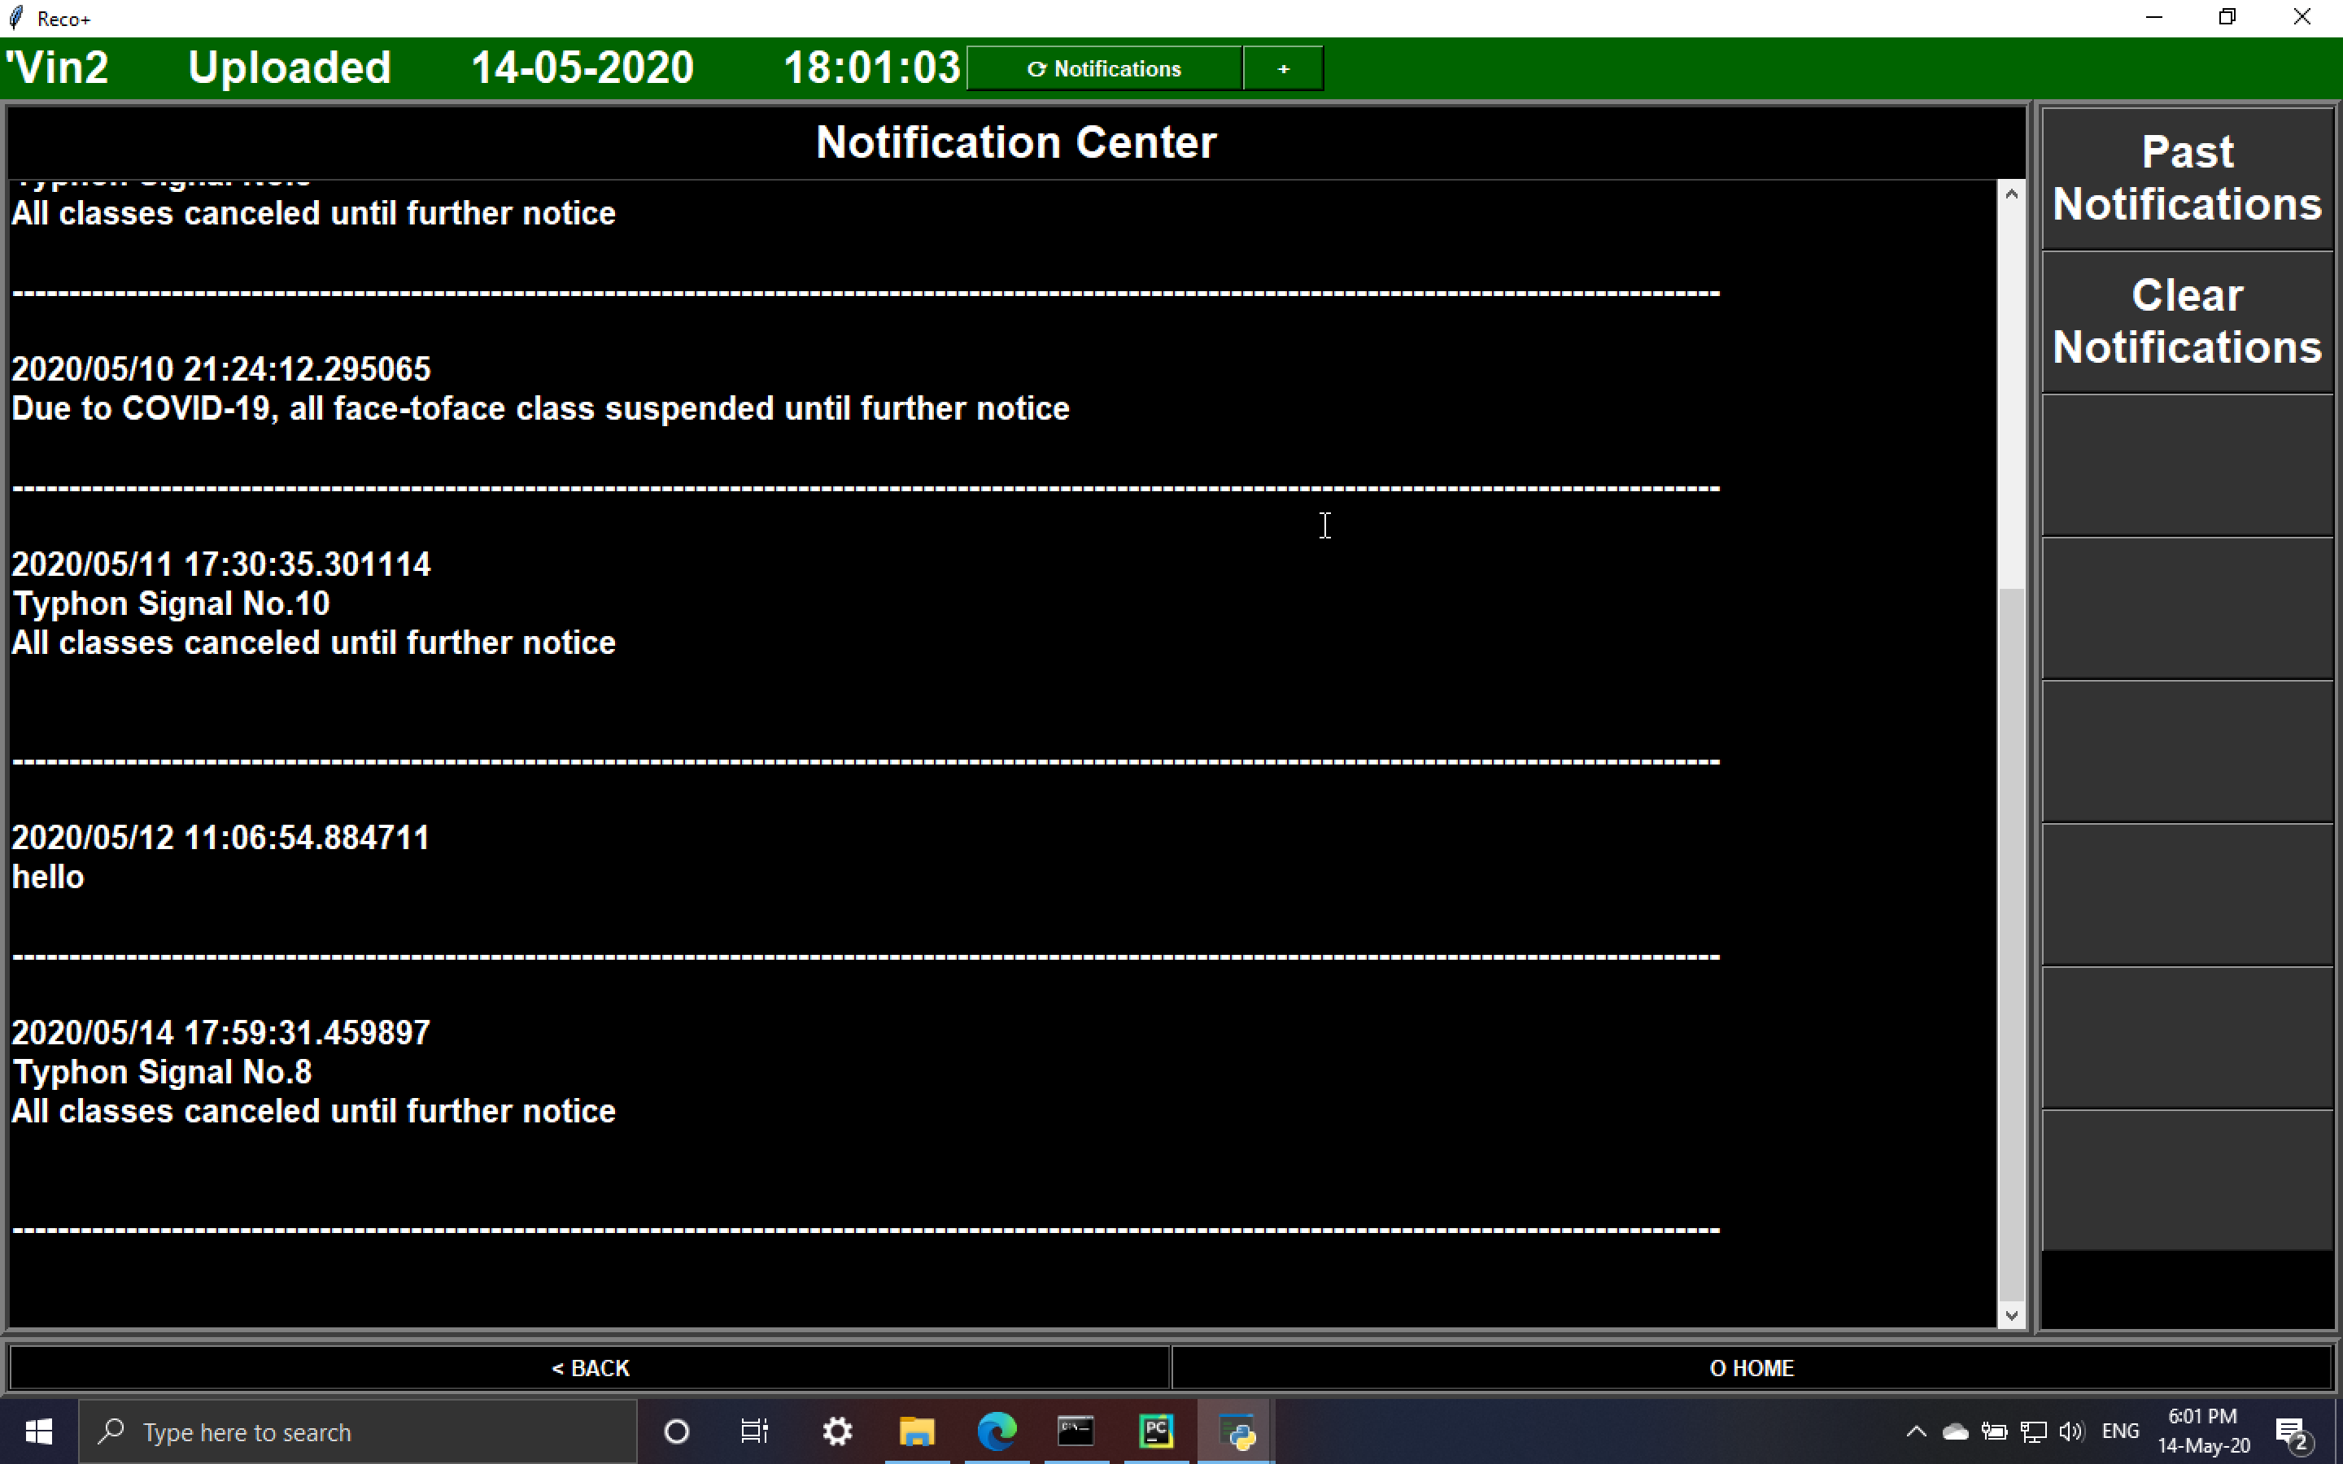Fig 41

## **7.8 Logic of the face recognition system in detailed**

As mentioned in the user manual, the face recognition system include three steps: face capture, face training and face recognition.

### **7.8.1 Face capture**

The face capture use the Haar feature-based cascade classifiers mentioned in literature review to identify the face a person. The OpenCV already provides a number of trained models and can be downloaded from GitHub, including:

* haarcascade_eye.xml, haarcascade_eye_tree_eyeglasses.xml, haarcascade_lefteye_2splits.xml, haarcascade_righteye_2splits – eye detection
* haarcascade_frontalcatface.xml, haarcascade_frontalcatface_extended.xml – Identifying the face of cat
* haarcascade_frontalface_alt.xml, haarcascade_frontalface_alt_tree.xml, haarcascade_frontalface_alt2.xml, haarcascade_frontalface_default.xml – Identifying human face
* haarcascade_fullbody.xml, haarcascade_lowerbody.xml, haarcascade_upperbody.xml - Identifying human body

In this project, haarcascade_frontalface_alt2.xml is selected to identify the face of the student. The identification will occur after the staff select the Student ID name of the file storing the images captured. The system will turned the camera image to greyscale for processing and once the system believes it is human face, a rectangle will be displayed on user screen to highlight the face. Besides, a number of photos captured will also be displayed for staff to identify the process.

Currently, 1000 images of each students are captured to ensure the every features of each student is extracted and the amount of images captured can be adjusted in the future. The 1000 image of each category is come from the original ImageNet classification challenge, which is proved the number is good enough for training (Warden 2017).

### **7.8.2 Face training**

After the image is being captured and stored according to the file named by Student ID under the images file, the staff can start the model training process. The model of the system is trained by using all images located in the images file including library from Specs on Faces (SoF) Dataset. There are 42,592 images taken from different lighting direction on 112 persons in different ages (66 males and 46 females) in SoF dataset, which is used for deep gender classification investigation (Afifi and Abdelhamed 2017). Although there is no need to identify the gender of each student in this project, the large size image library is extremely useful for the model training process, especially when there are not that many students captured, increasing the confidence on identifying the uniqueness of each person.

The system will first load the all the images and label them by the Student ID selected for training and the images other than Student ID selected for training. Then, the image data will be randomize before creating a model.

Convolution Neural Networks (CNN) mentioned above is used in the system, including two main big steps featuring learning and classification. According to Prabhu (2018), the there are few process in CNN:

* Convolution layer is a math operation to learn the image features through the square pixel of the image. Different filters like edge detection and sharpen can be implement with strides and padding which shift pixels and cut and pad the images to fit the size.
* Pooling layer reduce parameters if the image is too large
* The above two process will repeat for a few times before entering into classification
* In classification, fully connected layer will be build which is a neural network that all features map matrix extracted before will be transformed to vector and all the vector will be connected.
* Finally, the system will be able to identify the object

After the model is build, some images will be used for training by the system automatically and a evaluation report will be outputted, allowing the staff the decide if it is necessary to captured and trained again.

The model will be named by the Student ID and will be stored in the model file.

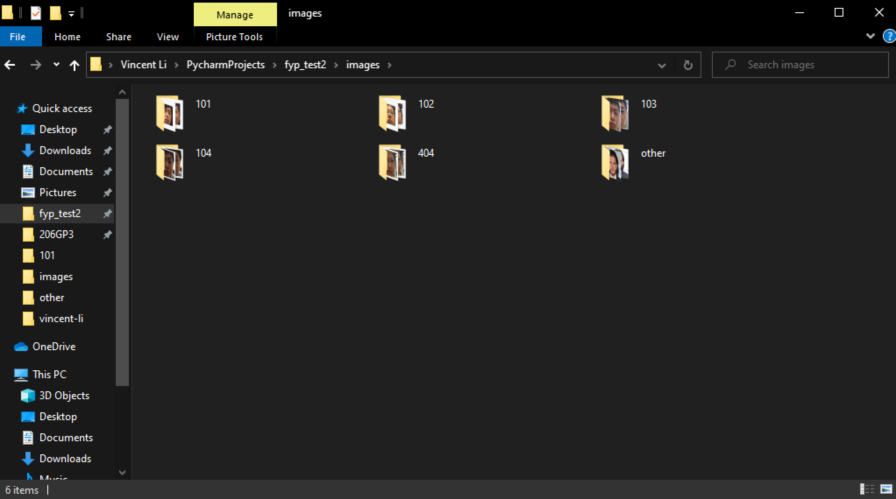Fig 42

### **7.8.3 Face recognition**

Once the student input its Student ID, a recognition program will start running. Same as the process of face capture, the face recognition is also real time with face captured using haarcascade_frontalface_alt2.xml and the images taking during recognition will be compared to the training model which the system will then identify if they are the same person. If the system do not identify, the system will display a rectangle highlight just like in face capture with not identified the student is displayed, allowing the student to adjust its position. Once the system recognised, the camera screen will be closed and the record with time will uploaded to the database.

## **7.9 Security and privacy**

All the data is stored locally in school, including all the staff/student information and student images. As the school already have the image of each students and staff stored for the profile and school identity card, there will not have privacy issue when taken the student image for face recognition. Besides, the school can stored the data to a place that only the staff need who is responsible for face capture and face training can view those image. The system will not show the image of the student and the face recognition terminal only use the face recognition model to compare with the student face, it is believed it will not have the privacy and security problem.

## **7.10 System limitation**

1. The haarcascade_frontalface_alt2.xml of OpenCV is not perfect, sometimes it will identified patterns on the clothes or walls in the background as human face when capturing the image. If those wrong image is trained, it may affect the accuracy of the recognition. It is suggested that the student should wear cloths with plain colour and the school should do the process in front of a clean wall with plain colour to reduce the rate of error. Moreover, the staff should check the photos after capture to even ensure if there are photos without face mixed to other correct images.
2. The system only captures 2D images of each student, which a clear selfie photo may be identified as a real person, resulting the classmates may use his friends image and help them to take the record. However, compared to students filled in the printed out excel file which they can sign in a large amount of cells without discovered, their behaviour will be easy to be discovered by the CCTVs installed everywhere in school.
3. Twins cannot be recognized by the system as they look extremely similar, resulting in they can exchange login or help the other to login and no one will identified. This problem is difficult to solved which Apple Face ID using 3D mapping on human face still cannot solved the problem due to their features in face is too similar.
4. Facial hair or glasses may affect the accuracy of the recognition. As mentioned before, the system extract the features from the image captured, if the length of facial hair is changed or wear glasses, the feature will be different from the model, resulting in the system believe they are not the same person. It is suggested that the student should keep their face as identical as possible to their face when captured for training.
5. Light source may affect the accuracy and performance of the recognition. Similar to photography, the photo quality is bad when the camera is facing light source or in a dark room. In the recognition system, those bad quality photo affect the feature extraction process, resulting in unable to identify the student. It is suggested that the camera should not facing the light source during face capture or face recognition and the room should be bright enough to ensure the image quality.
6. Currently, each model can only identify one students, resulting a large amount of models need to be created to identified all students in school, not only results in large storage space to store all data, but also leads to extremely large training time for all models.

# **8. Testing**

## **8.1 Test plan**

|  |  |
| --- | --- |
| Test case | Objective |
| Test 01  Add new student | Test if the system can upload the student data to the database and check if the system can shows the changes |
| Test 02  Add new staff | Test if the system can upload the staff data to the database and check if the system can shows the changes |
| Test 03  Add new course | Test if the system can upload the course data to the database and check if the system can shows the changes |
| Test 04  Add new course member | Test if the system can upload the course member data to the database and check if the system can shows the changes |
| Test 05  Add course timetable | Test if the system can upload the course timetable data to the database and check if the system can shows the changes |
| Test 06  Modify student information | Test if the system can upload the modified student data to the database and check if the system can shows the changes |
| Test 07  Modify staff information | Test if the system can upload the modified staff data to the database and check if the system can shows the changes |
| Test 08  Modify course information | Test if the system can upload the modified course data to the database and check if the system can shows the changes |
| Test 09  Remove student from course | Test if the system can remove student from specific course in the database and check if the system can shows the changes |
| Test 10  Modify class timetable | Test if the system can upload the modified course timetable data to the database and check if the system can shows the changes |
| Test 11  Send notification | Test if the system can successfully send and receive notification, check if the received notification is saved to text file and able to view all past notification |
| Test 12  Clear notification | Test if the notification saved in the text file can be cleared |
| Test 13  Capture face | Test if the system can captured face of a person and saved according to Student ID |
| Test 14  Face training | Test if the system can train a face recognition model |
| Test 15  Attendance taking | Test if the system can identify a person, save the data to the database and display in the system |
| Test 16  Login (main program) | Test if accounts with different permission can login to the system and the system can show the permission difference |
| Test 17  Logout (main program) | Test if user can logout the system |
| Test 18  Login (attendance taking terminal) | Test if the user can login to the system and show the correct Timetable ID and course name |

## **8.2 Test cases**

|  |  |
| --- | --- |
| Test 01 | Add new student |

|  |  |  |  |  |
| --- | --- | --- | --- | --- |
| Steps | Action | Test data | Expected result | Pass/fail |
| 1 | Input first name, last name, sex, date of birth | Peter, Chan, M, 10-10-1999 | Data upload to database (Fig 45) and student list can show the changes | Pass |

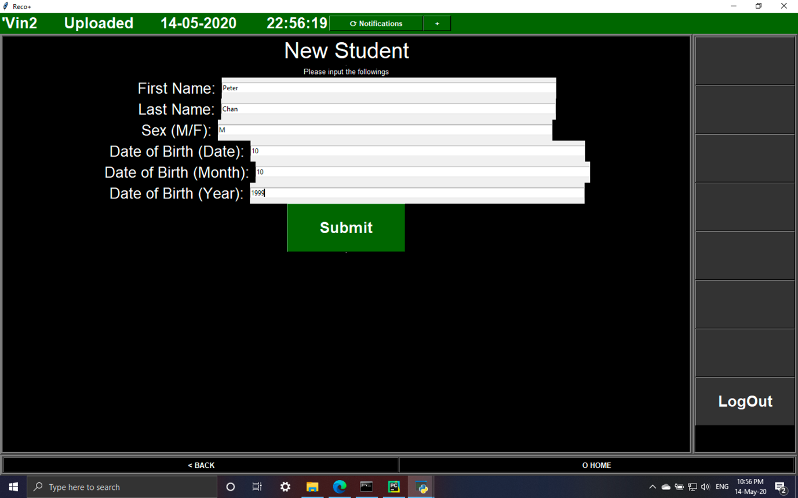Fig 43

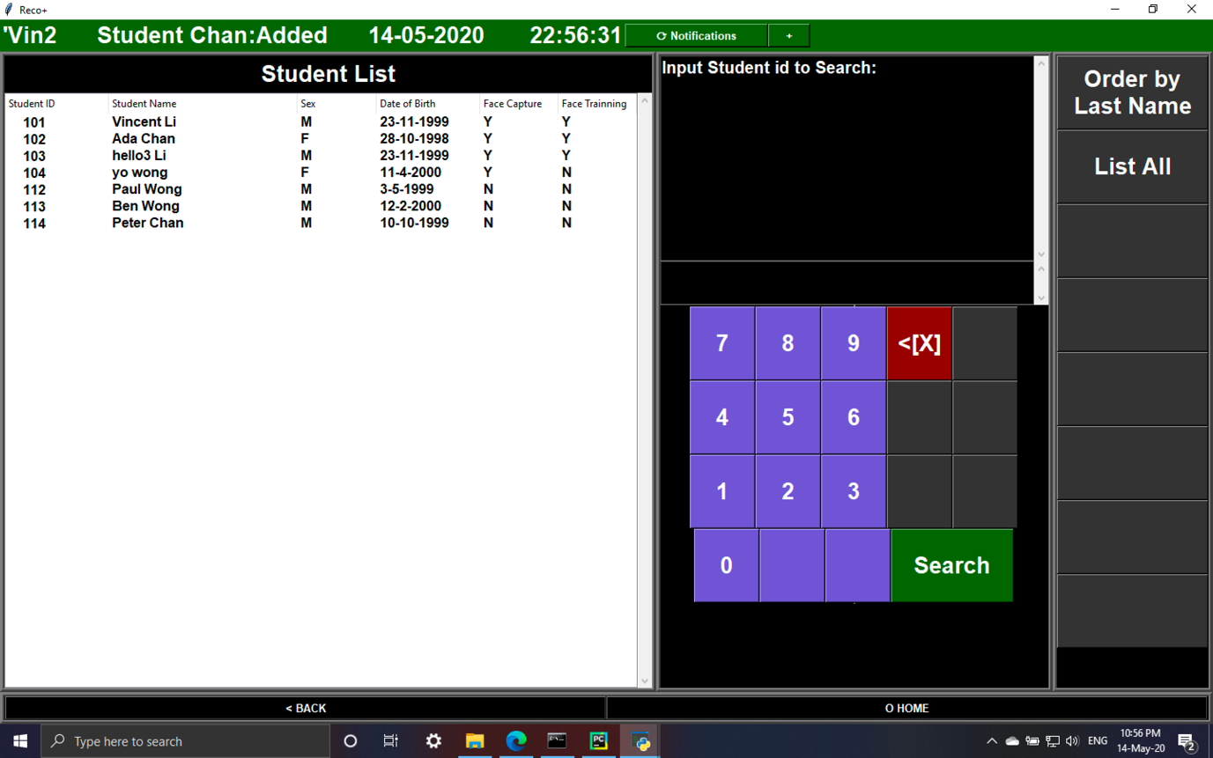

Fig 44

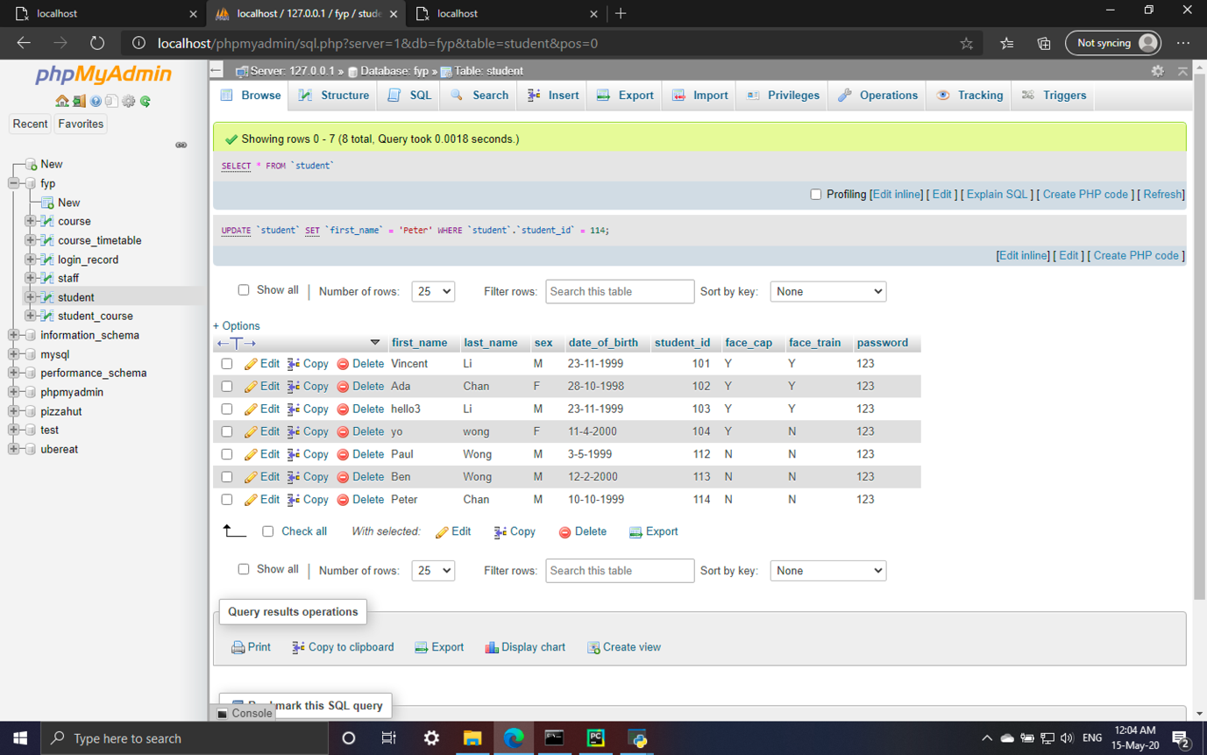Fig 45

|  |  |
| --- | --- |
| Test 02 | Add new staff |

|  |  |  |  |  |
| --- | --- | --- | --- | --- |
| Steps | Action | Test data | Expected result | Pass/fail |
| 1 | Input first name, last name, sex, date of birth, position | Ken, Chan, M, 10-10-1990, Officer | Data upload to database and staff list can show the changes | Pass |

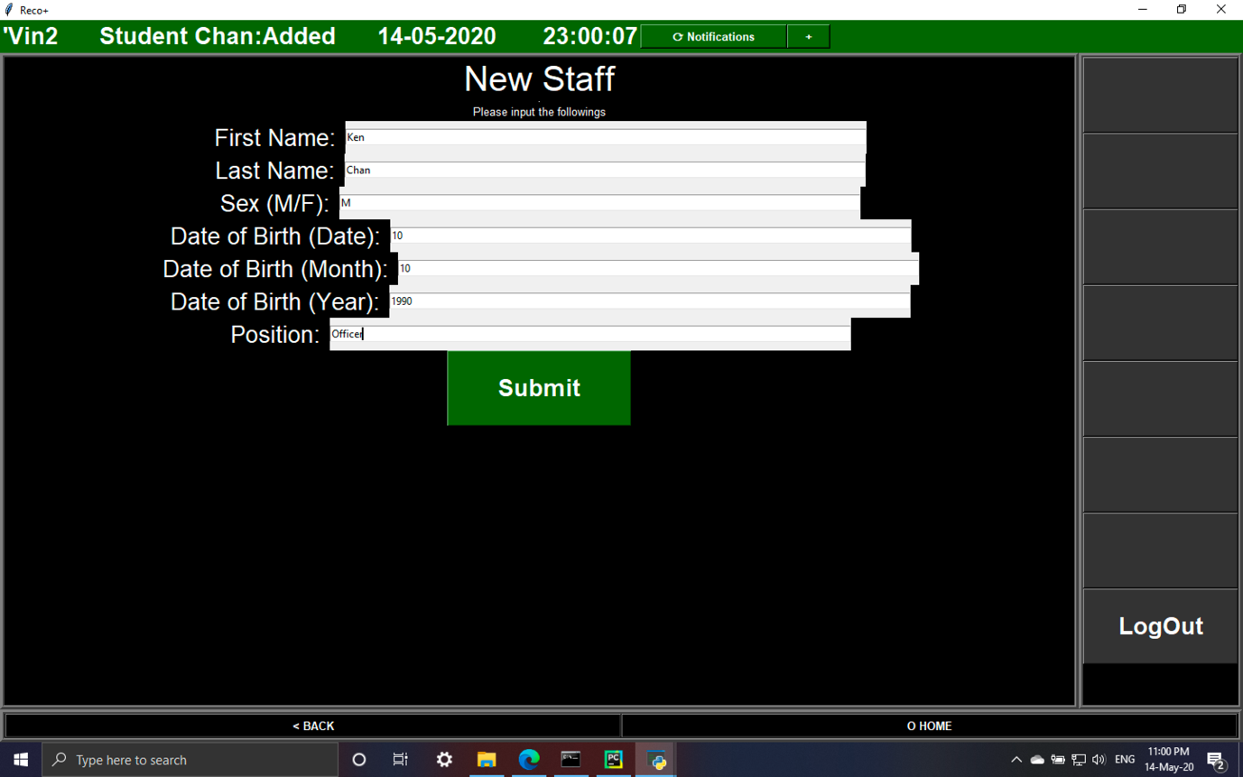Fig 46

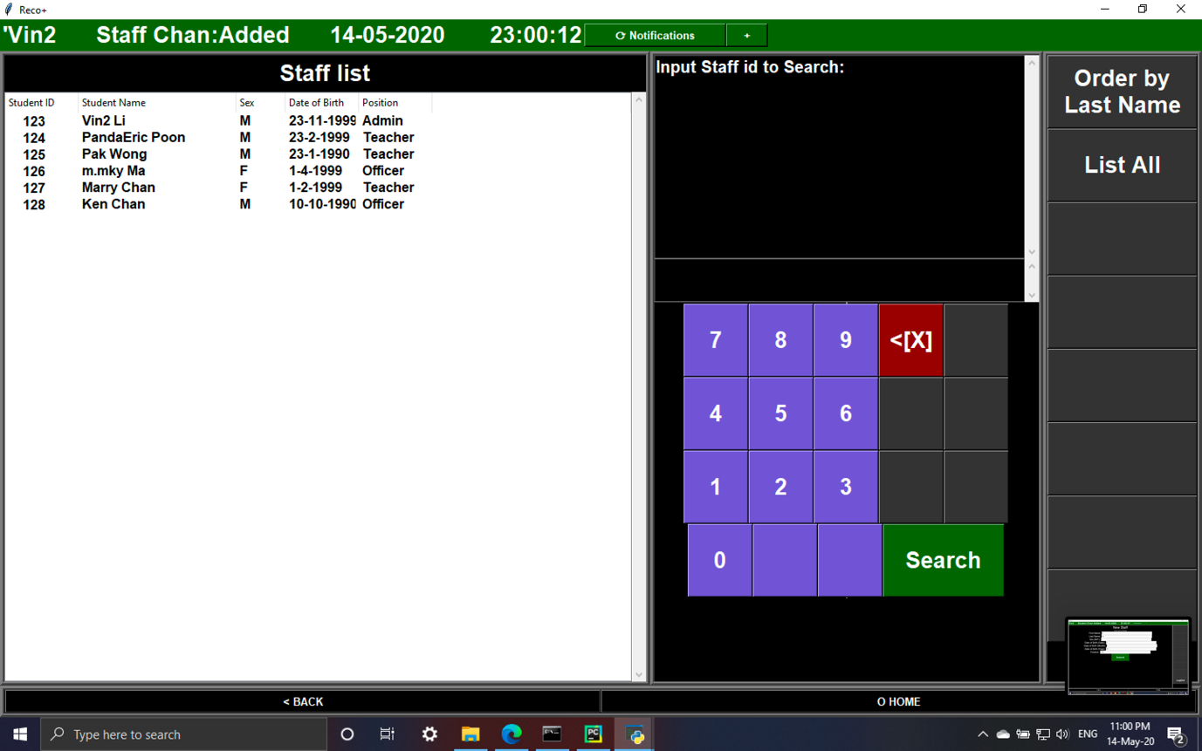

Fig 47

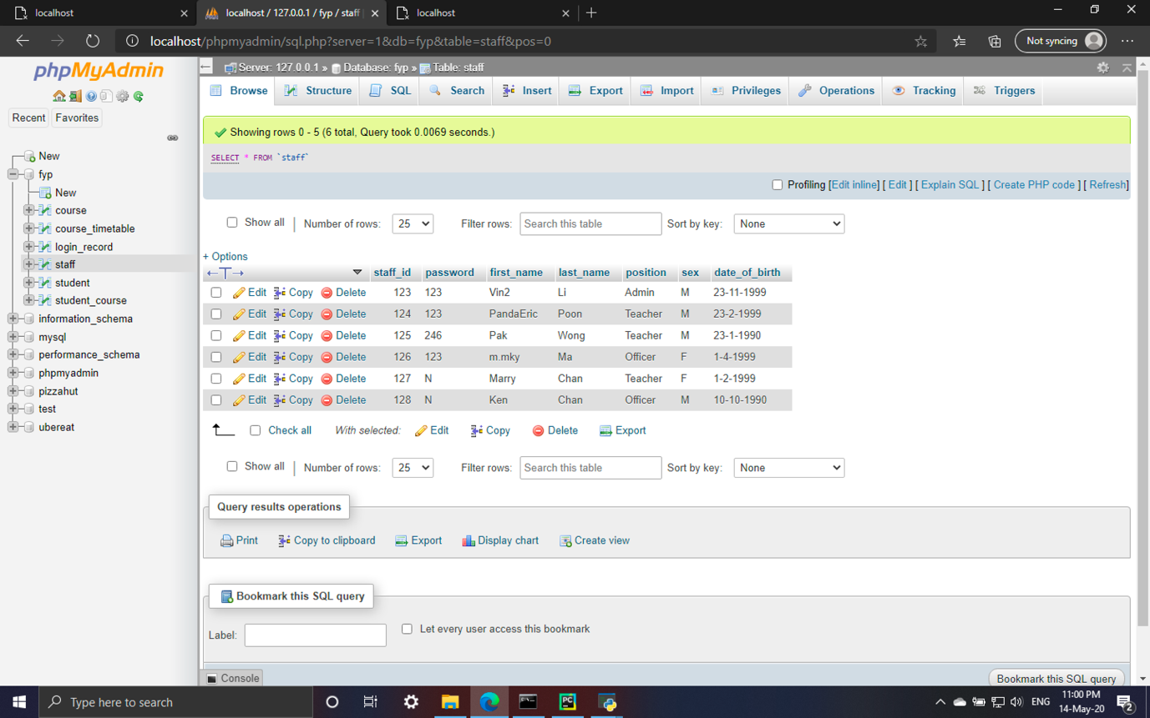

Fig 48

|  |  |
| --- | --- |
| Test 03 | Add new course |

|  |  |  |  |  |
| --- | --- | --- | --- | --- |
| Steps | Action | Test data | Expected result | Pass/fail |
| 1 | Input course name, existed Staff ID | Project Management, 125 | Data upload to database and course list can show the changes | Pass |
| 2 | Input course name, non-existed Staff ID | Modern Web, 202 | Database not updated and course list not updated | Pass |

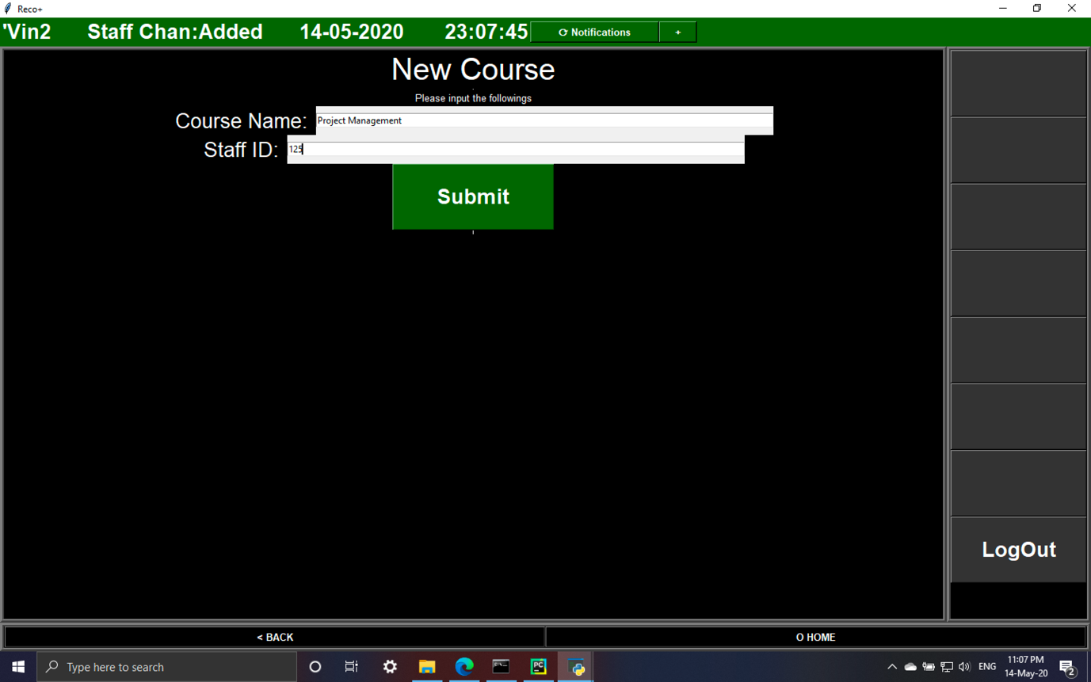Fig 49

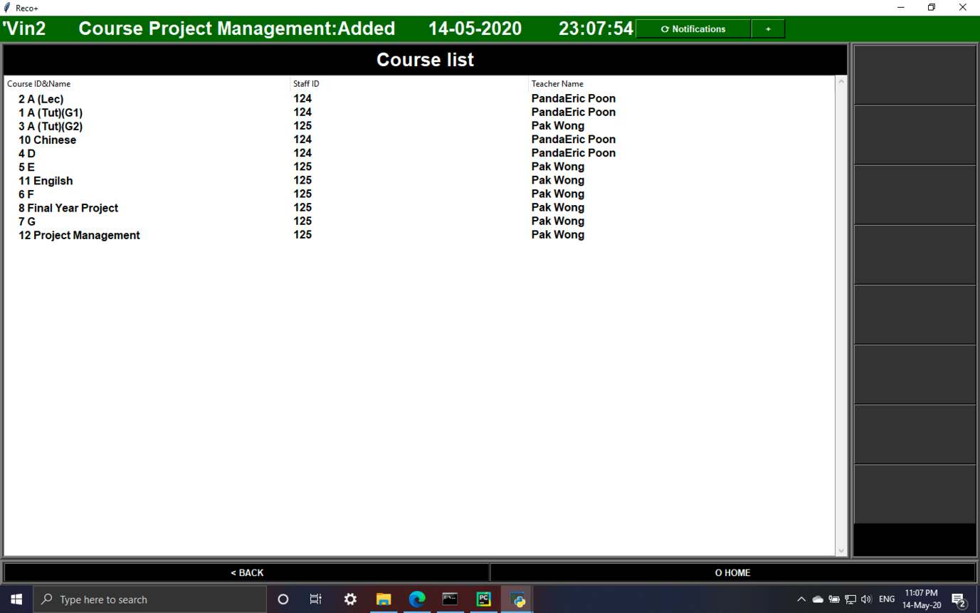Fig 50

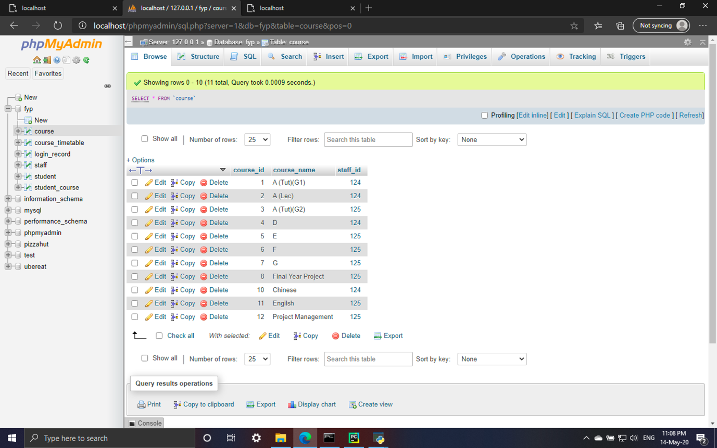Fig 51

|  |  |
| --- | --- |
| Test 04 | Add new course member |

|  |  |  |  |  |
| --- | --- | --- | --- | --- |
| Steps | Action | Test data | Expected result | Pass/fail |
| 1 | Input existed Student ID, existed Course | 114,12 | Data upload to database and course member list can show the changes | Pass |
| 2 | Input non-existed Student ID, existed Course | 303,12 | The system cannot find the result, require user to input a existed ID | Pass |
| 3 | Input existed Student ID, non-existed Course | 114,903 | The system cannot find the result, require user to input a existed ID | Pass |
| 4 | Input non-existed Student ID, non-existed Course | 303,903 | The system cannot find the result, require user to input a existed ID | Pass |

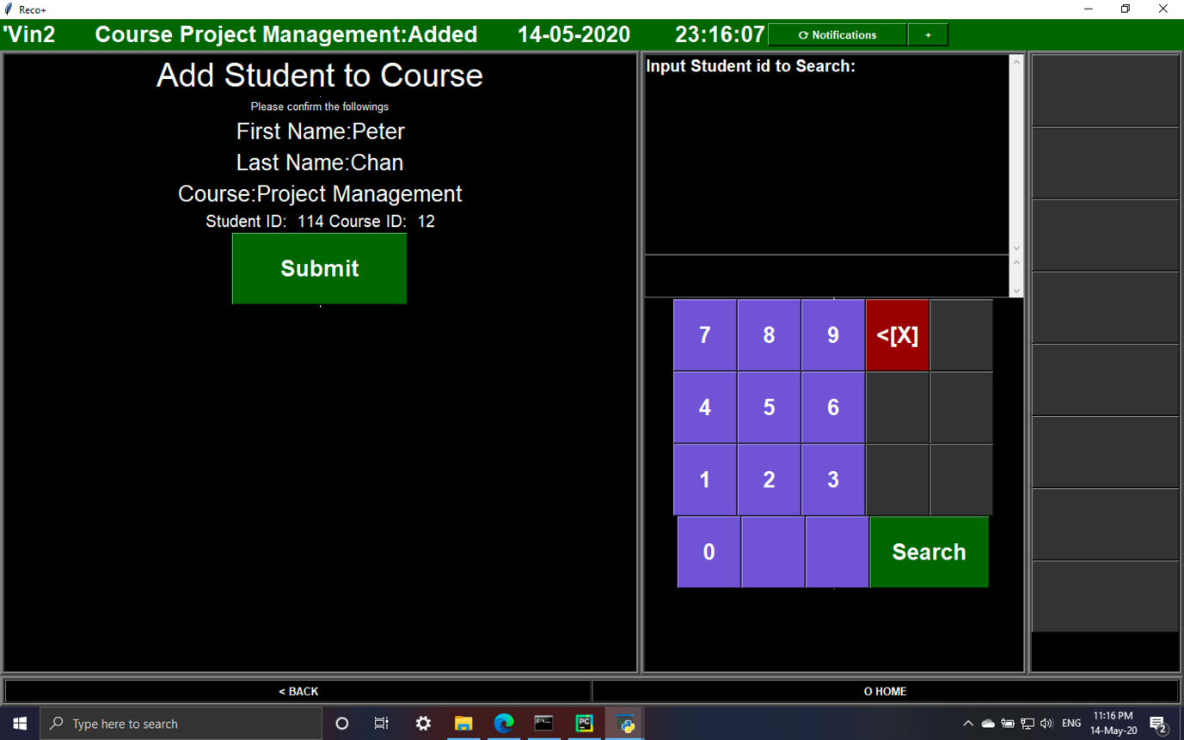Fig 52

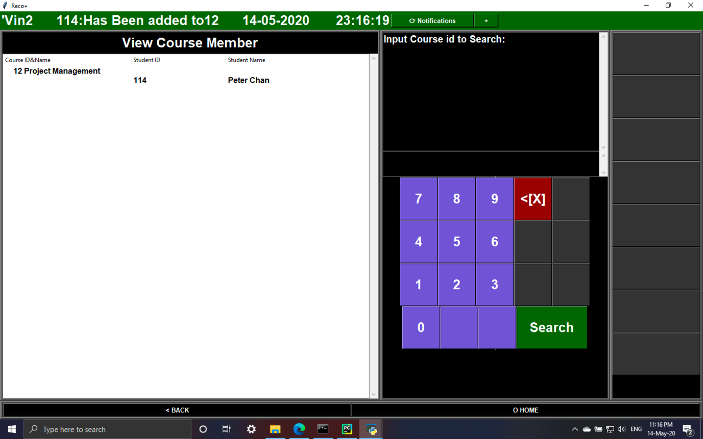Fig 53

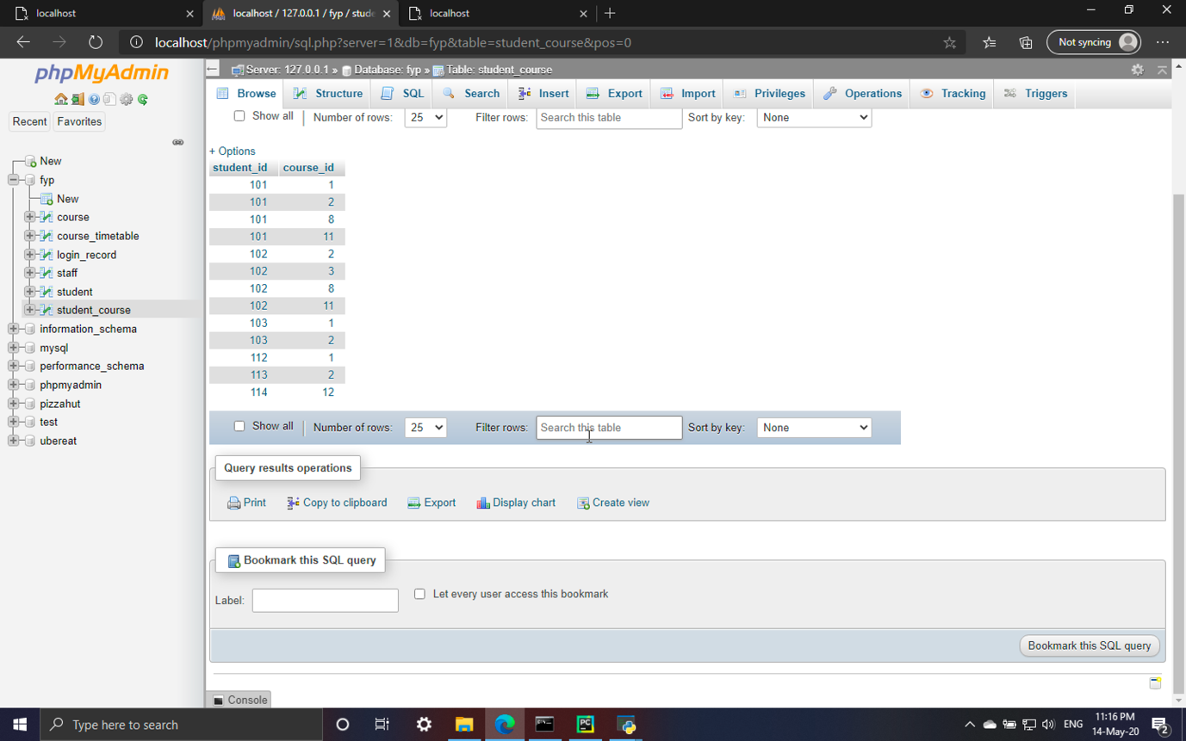

Fig 54

|  |  |
| --- | --- |
| Test 05 | Add course timetable |

|  |  |  |  |  |
| --- | --- | --- | --- | --- |
| Steps | Action | Test data | Expected result | Pass/fail |
| 1 | Input existed Course ID, date, time, room | 12, 22-8-2020, 12:00, 134 | Data upload to database and student list can show the changes | Pass |
| 2 | Input non-existed Course ID, date, time, room | 400, 22-8-2020, 12:00, 101 | The system cannot find the result, require user to input a existed ID | Pass |

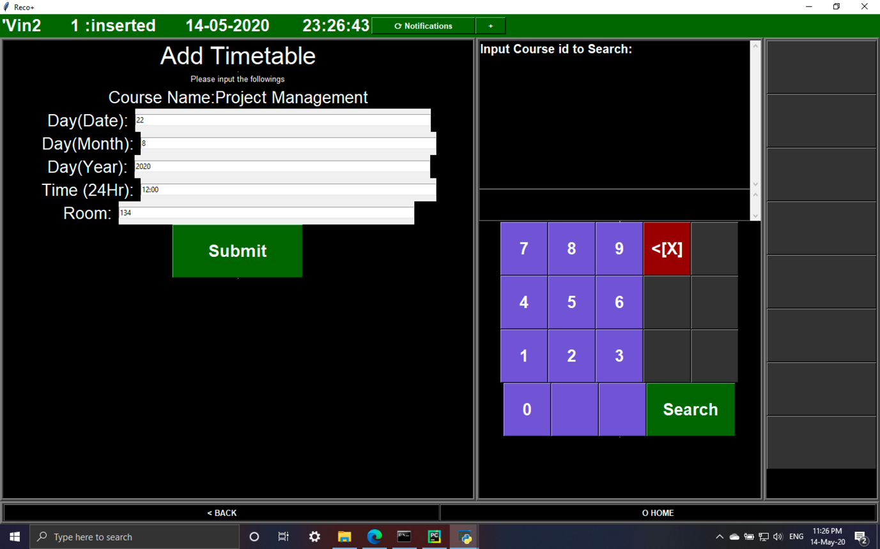Fig 55

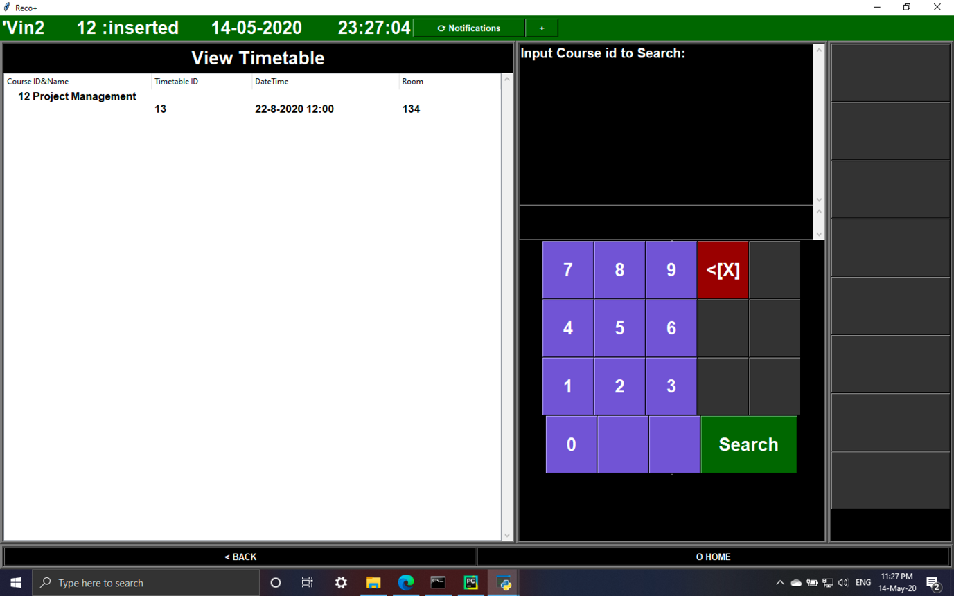Fig 56

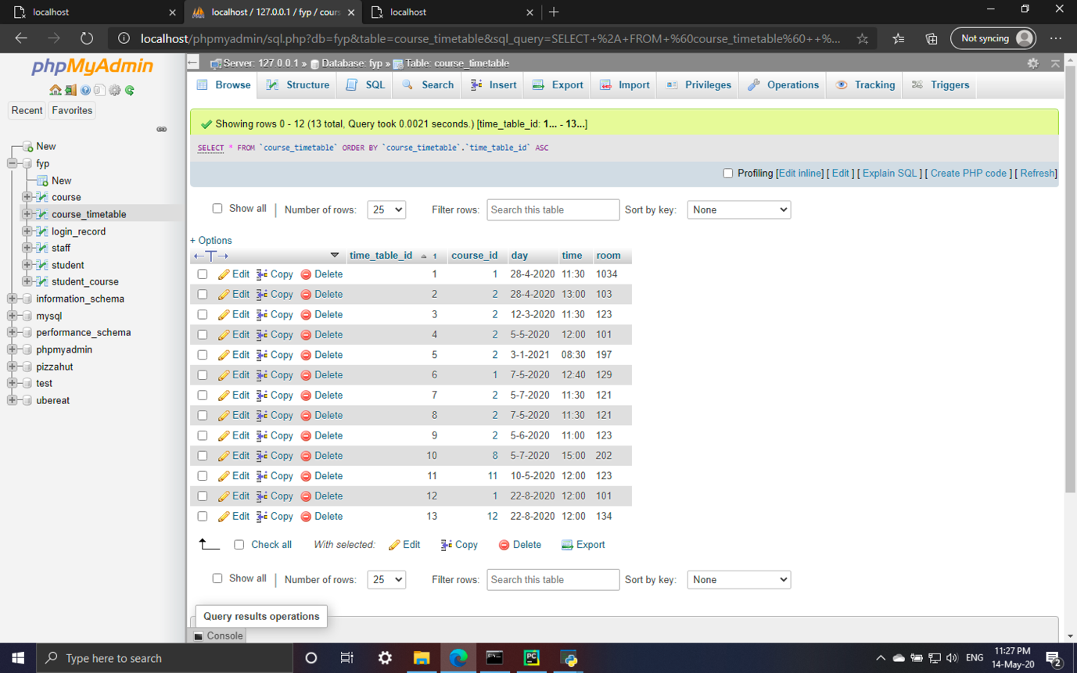Fig 57

|  |  |
| --- | --- |
| Test 06 | Modify student information |

|  |  |  |  |  |
| --- | --- | --- | --- | --- |
| Steps | Action | Test data | Expected result | Pass/fail |
| 1 | Search by non-existed Student ID | 200 | The system cannot find the result, require user to input a existed ID | Pass |
| 2 | Search by existed Student ID | 114 | The display the student information in the input box | Pass |
| 3 | Update first name, last name, sex, date of birth | Paul, Chen, F, 11-11-1998 | Data upload to database and student list can show the changes | Pass |

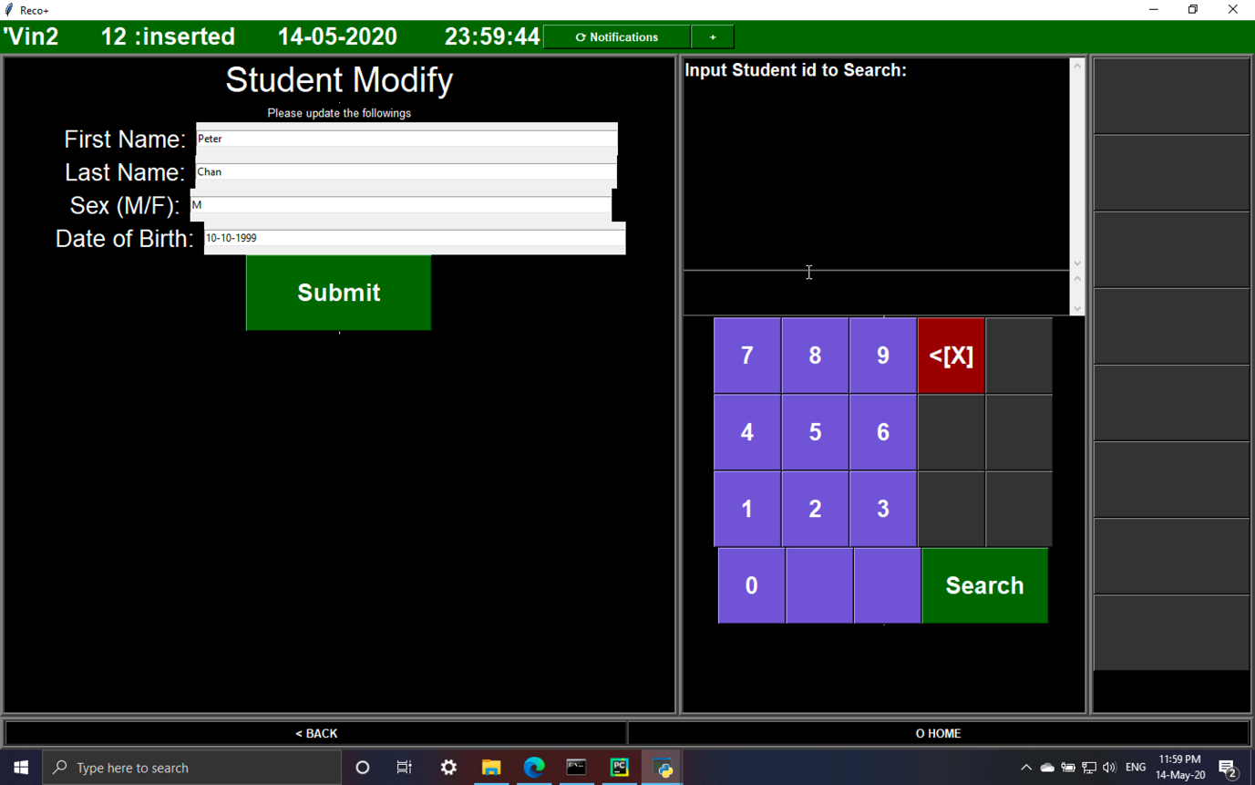Fig 58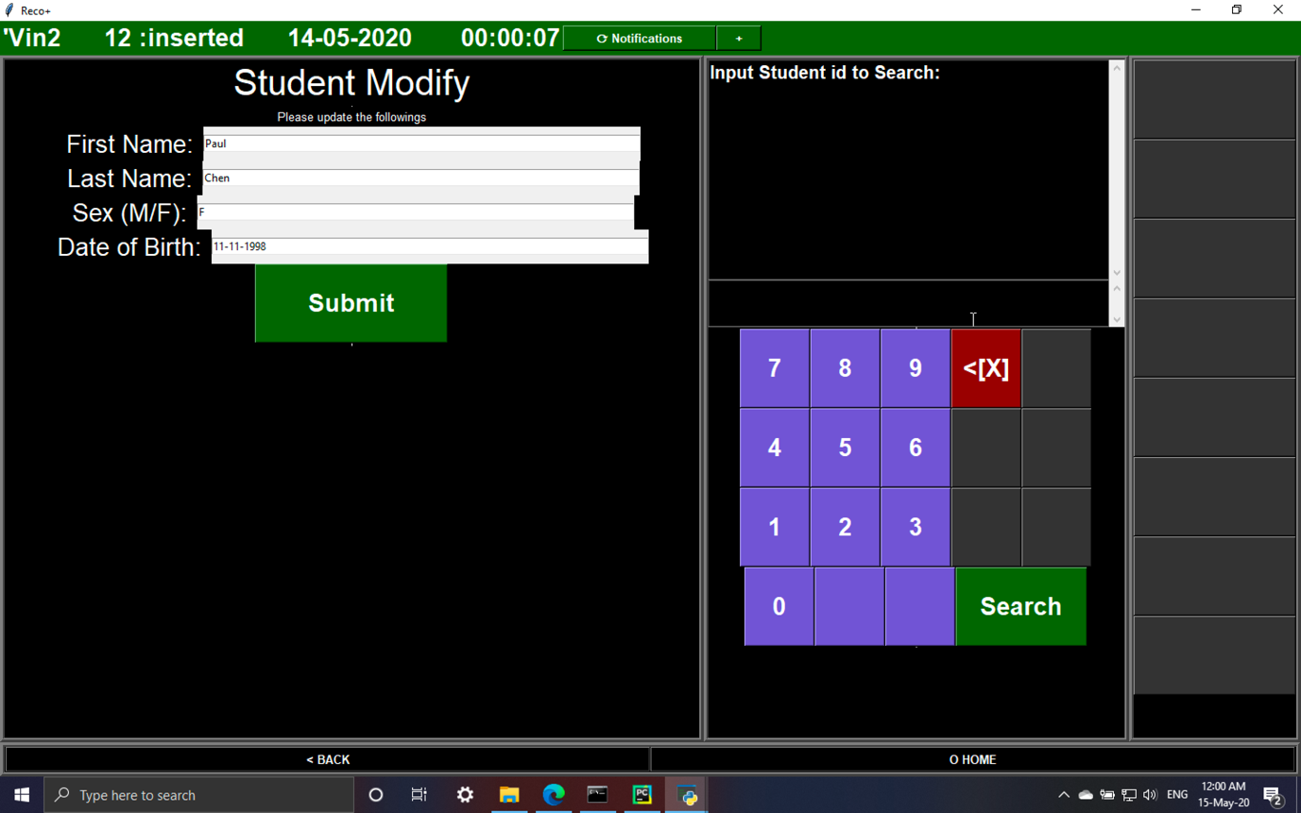Fig 59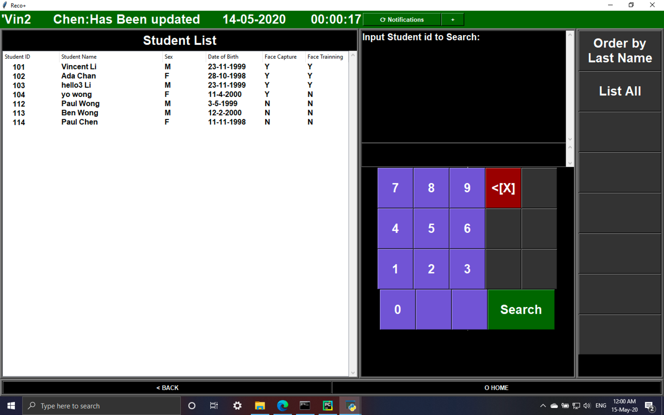

Fig 60

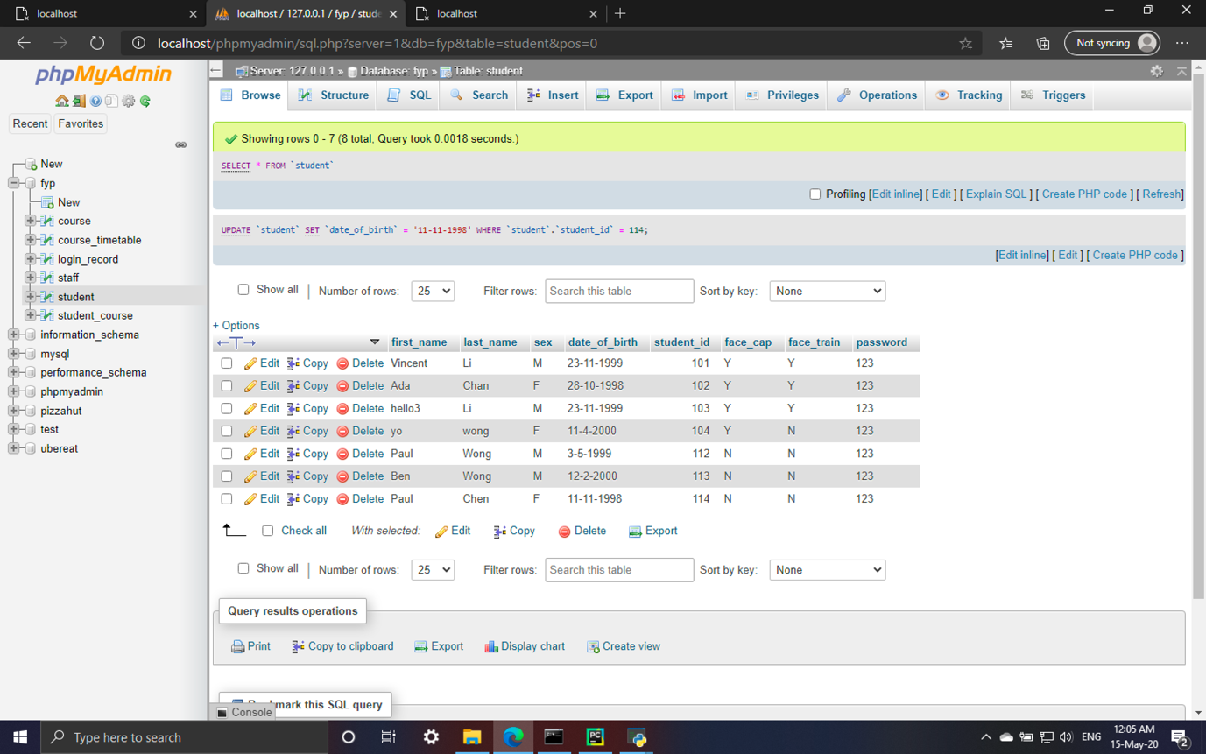Fig 61

|  |  |
| --- | --- |
| Test 07 | Modify staff information |

|  |  |  |  |  |
| --- | --- | --- | --- | --- |
| Steps | Action | Test data | Expected result | Pass/fail |
| 1 | Search by non-existed Staff ID | 200 | The system cannot find the result, require user to input a existed ID | Pass |
| 2 | Search by existed Staff ID | 128 | The display the staff information in the input box | Pass |
| 3 | Update first name, last name, sex, date of birth, position | Kan, Chen, F, 11-11-1991, Teacher | Data upload to database and student list can show the changes | Pass |

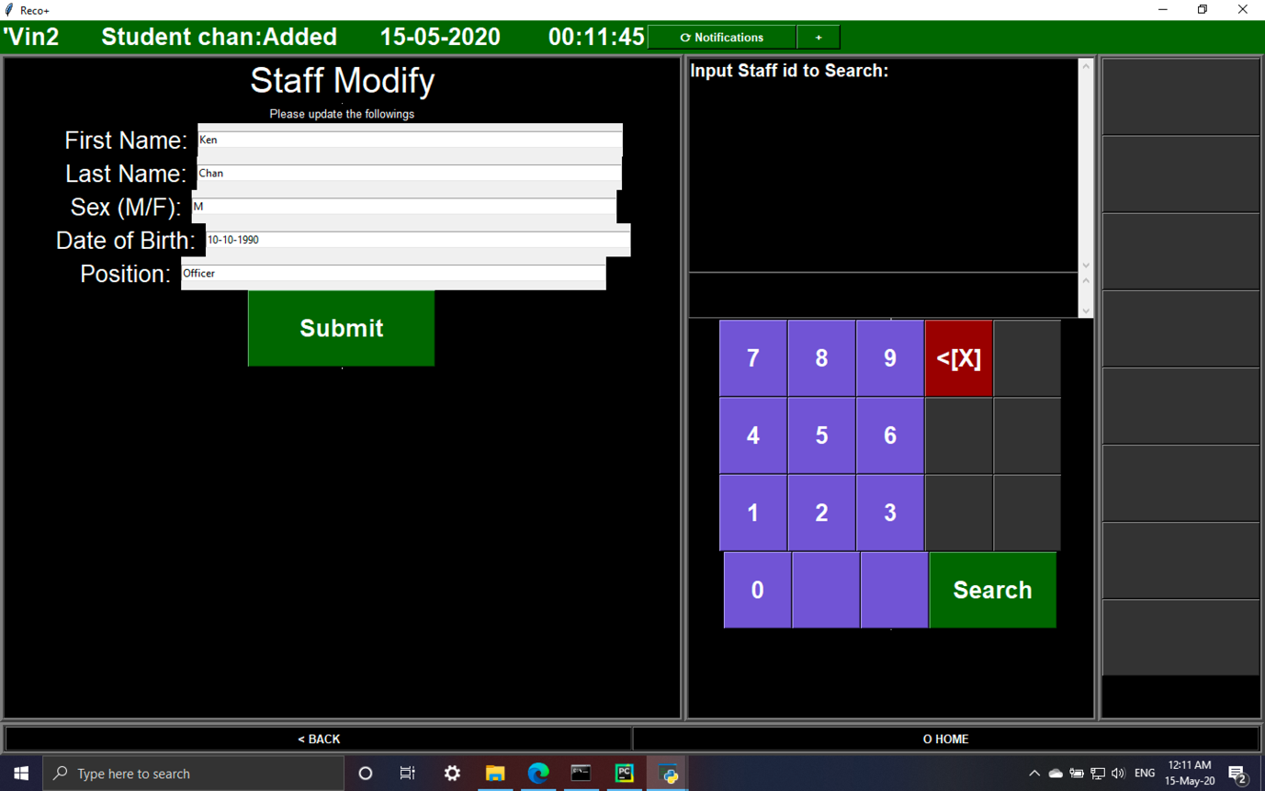Fig 62

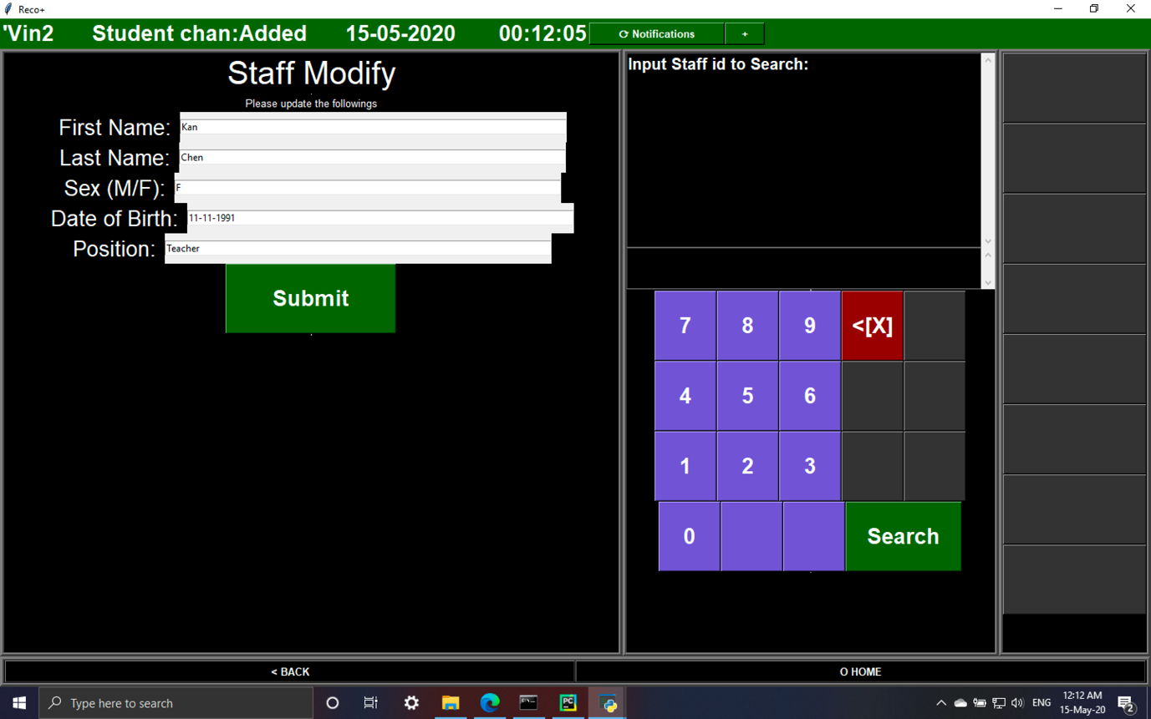Fig 63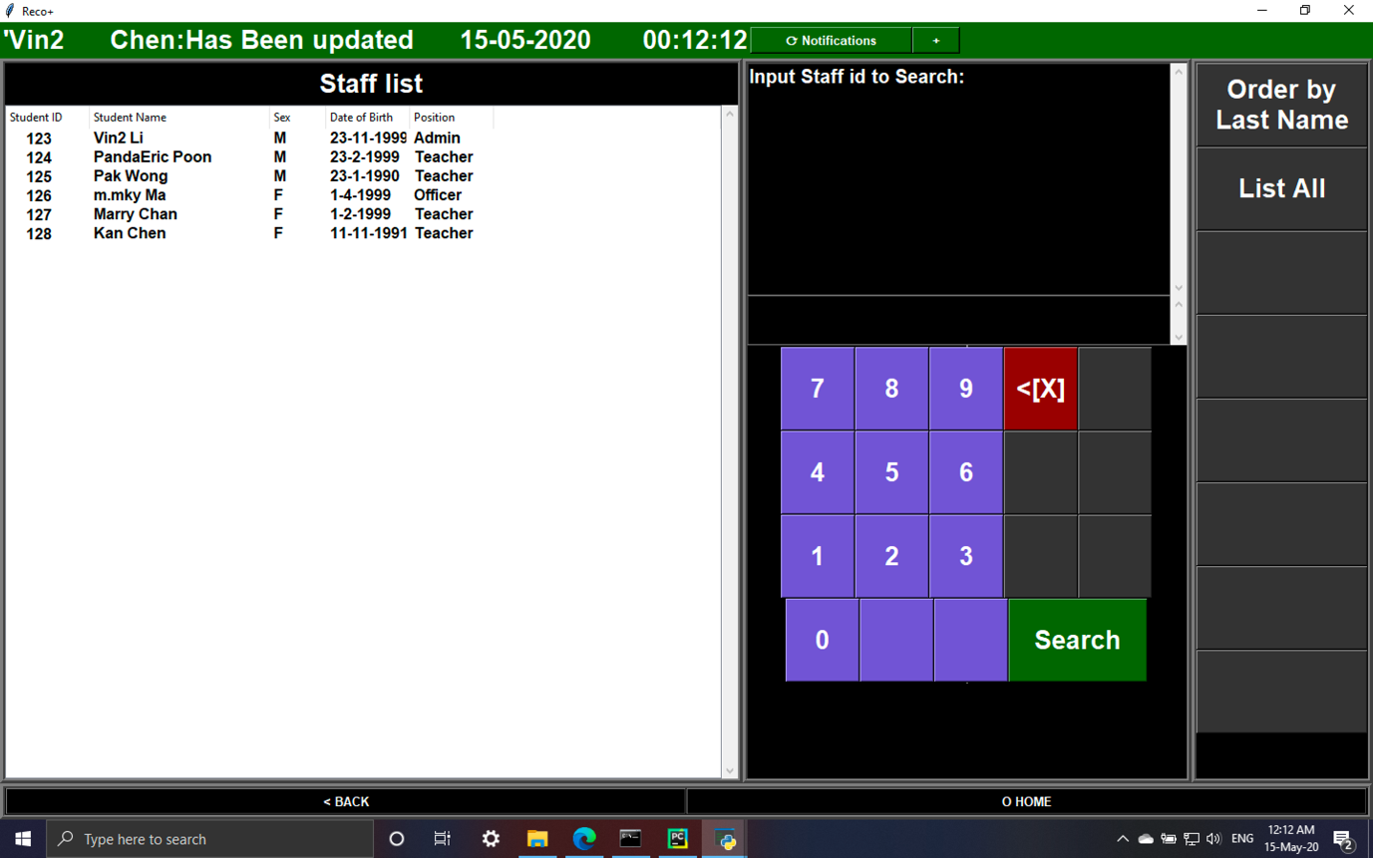

Fig 64

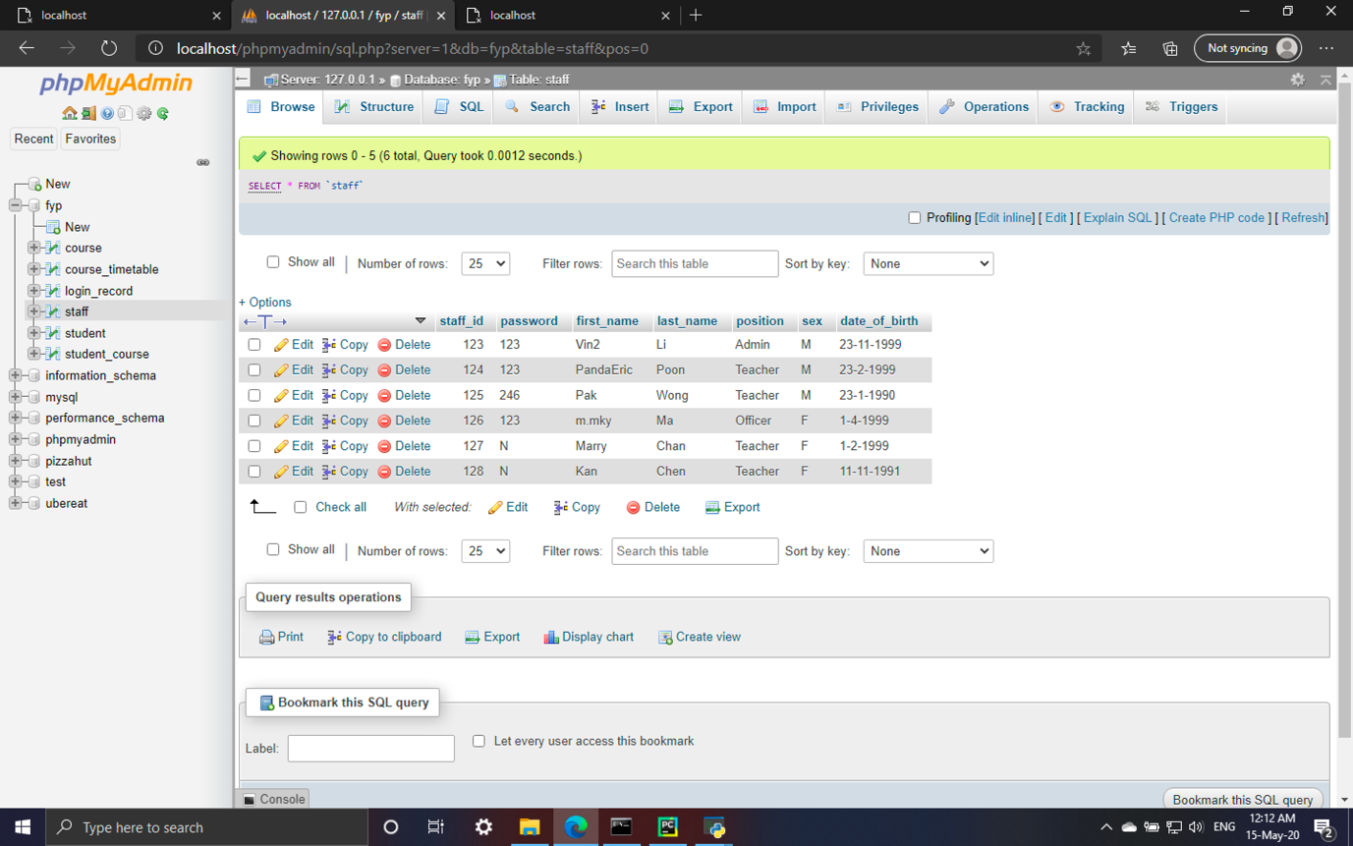Fig 65

|  |  |
| --- | --- |
| Test 08 | Modify course information |

|  |  |  |  |  |
| --- | --- | --- | --- | --- |
| Steps | Action | Test data | Expected result | Pass/fail |
| 1 | Input non-existed Course ID | 100 | The system cannot find the result, require user to input a existed ID | Pass |
| 2 | Input existed Course ID | 12 | The display the course information in the input box | Pass |
| 3 | Input non-existed Staff ID | 900 | Database not updated and course list not updated | Pass |
| 4 | Input existed Staff ID | 124 | Data upload to database and course list can show the changes | Pass |

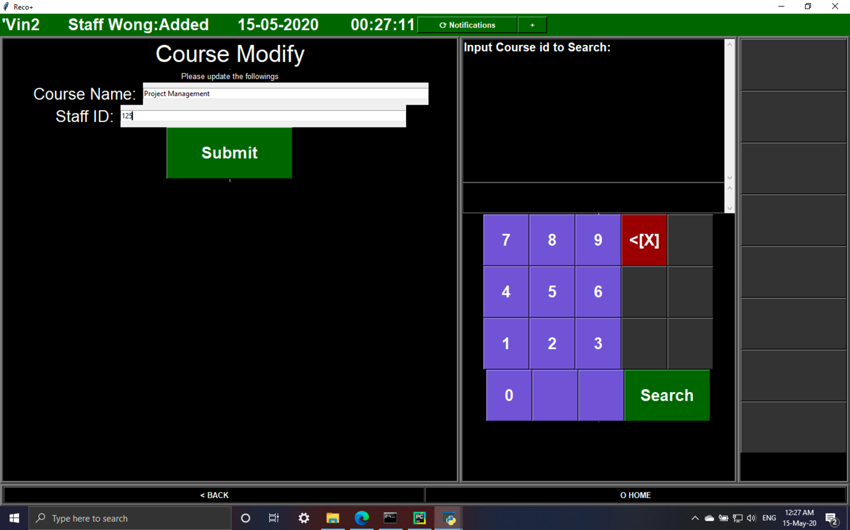Fig 66

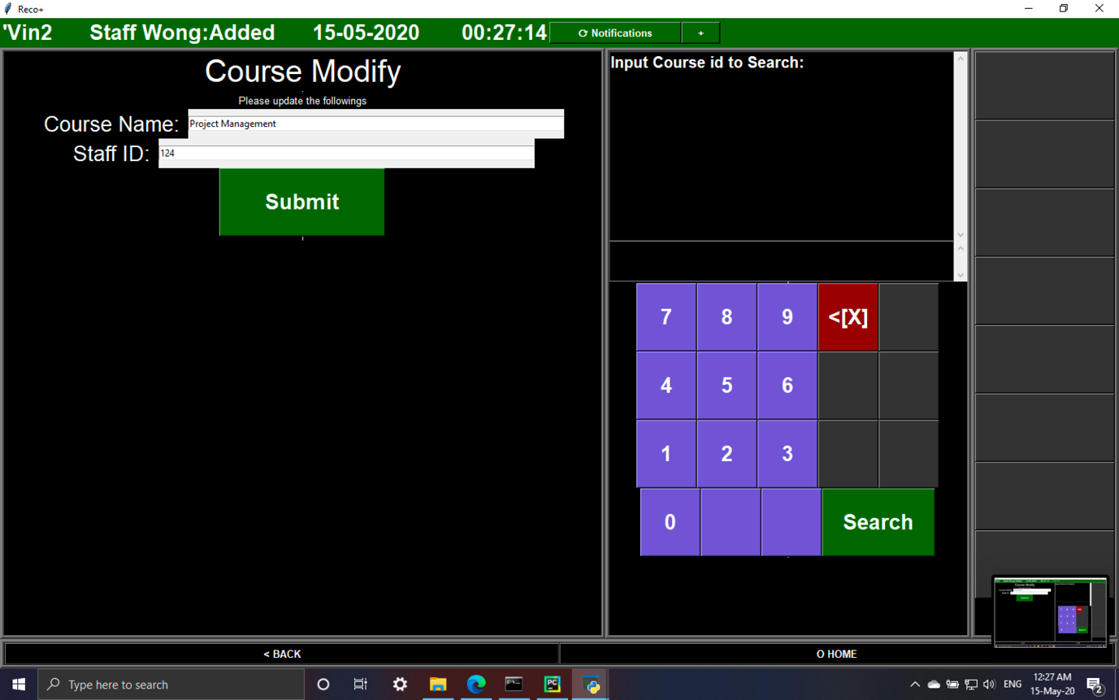Fig 67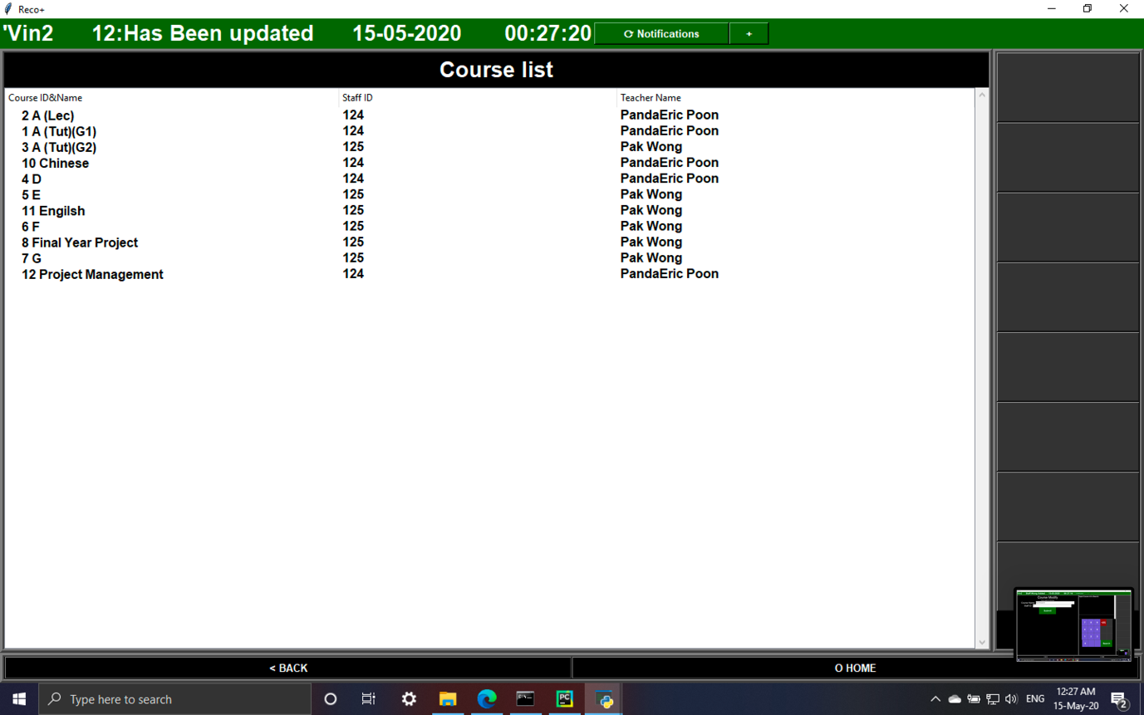Fig 68

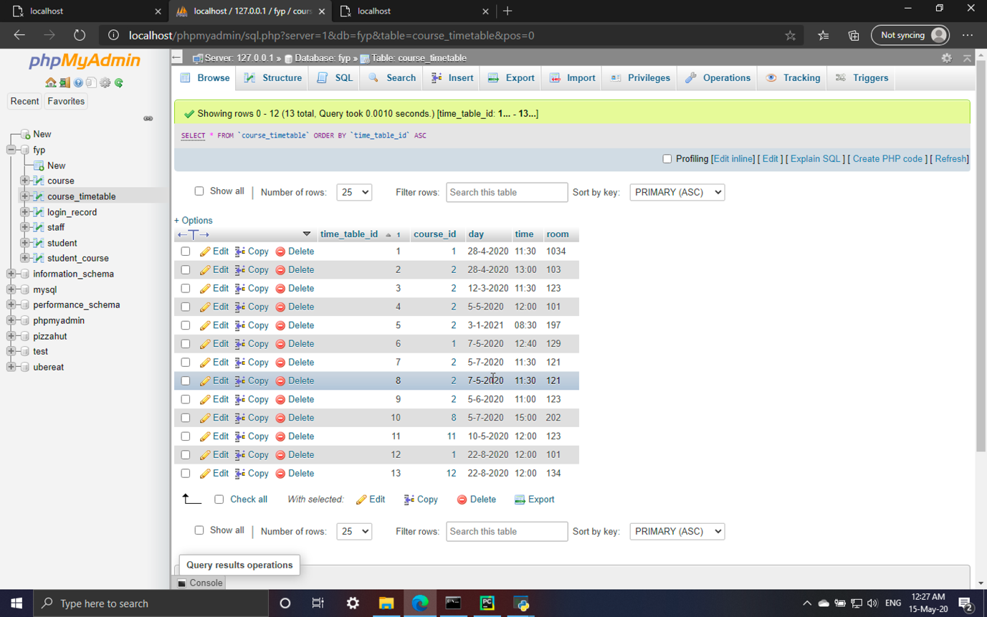Fig 69

|  |  |
| --- | --- |
| Test 09 | Remove student from course |

|  |  |  |  |  |
| --- | --- | --- | --- | --- |
| Steps | Action | Test data | Expected result | Pass/fail |
| 1 | Input non-existed Student ID | 190 | The system cannot find the result, require user to input a existed ID | Pass |
| 2 | Input non-existed Course ID | 190 | The system cannot find the result, require user to input a existed ID | Pass |
| 3 | Input Student ID and Course ID which the student is in the course member list | 114,12 | Data upload to database and course member list can show the changes | Pass |
| 4 | Input Student ID and Course ID which the student is not in the course member list | 114,11 | Nothing is changed in the database, ‘not existed’ should be displayed in status bar | Pass |

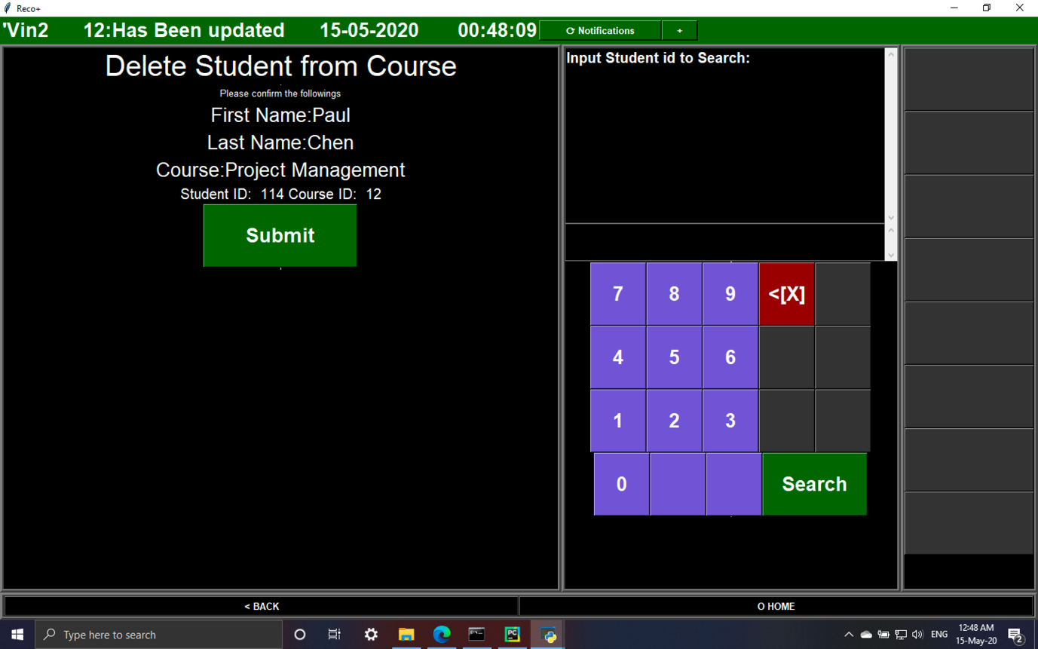Fig 70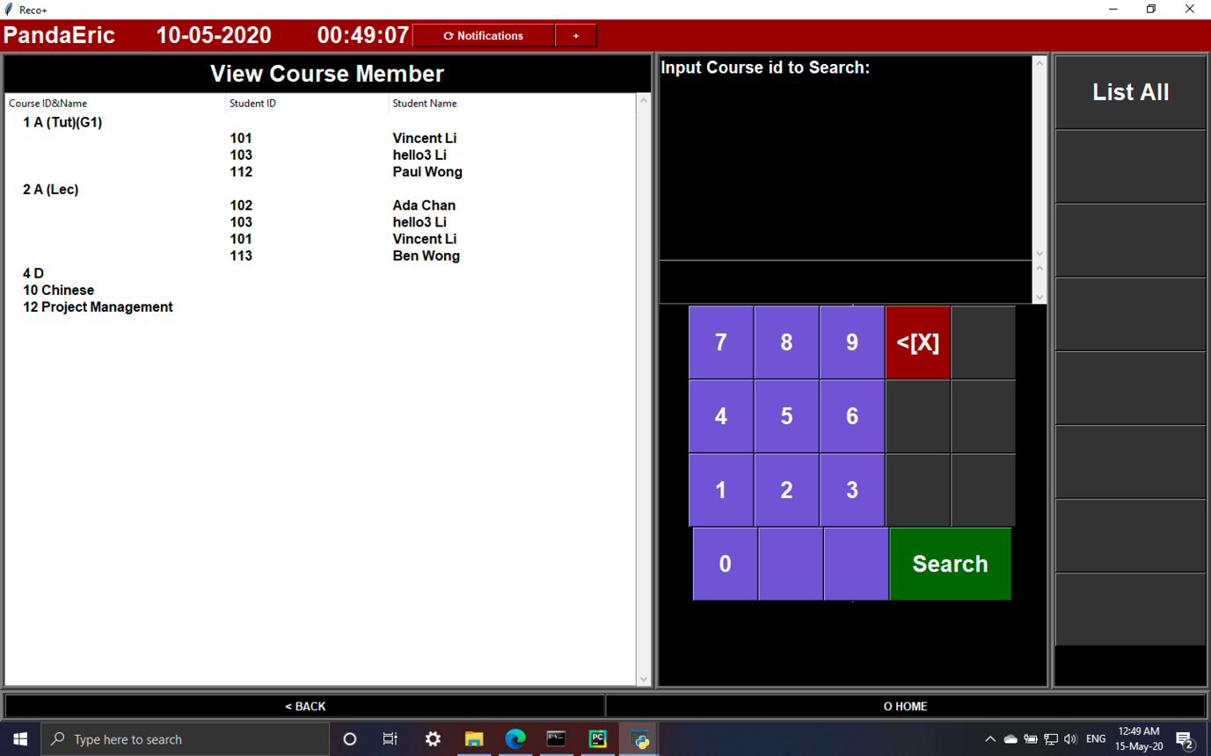Fig 71

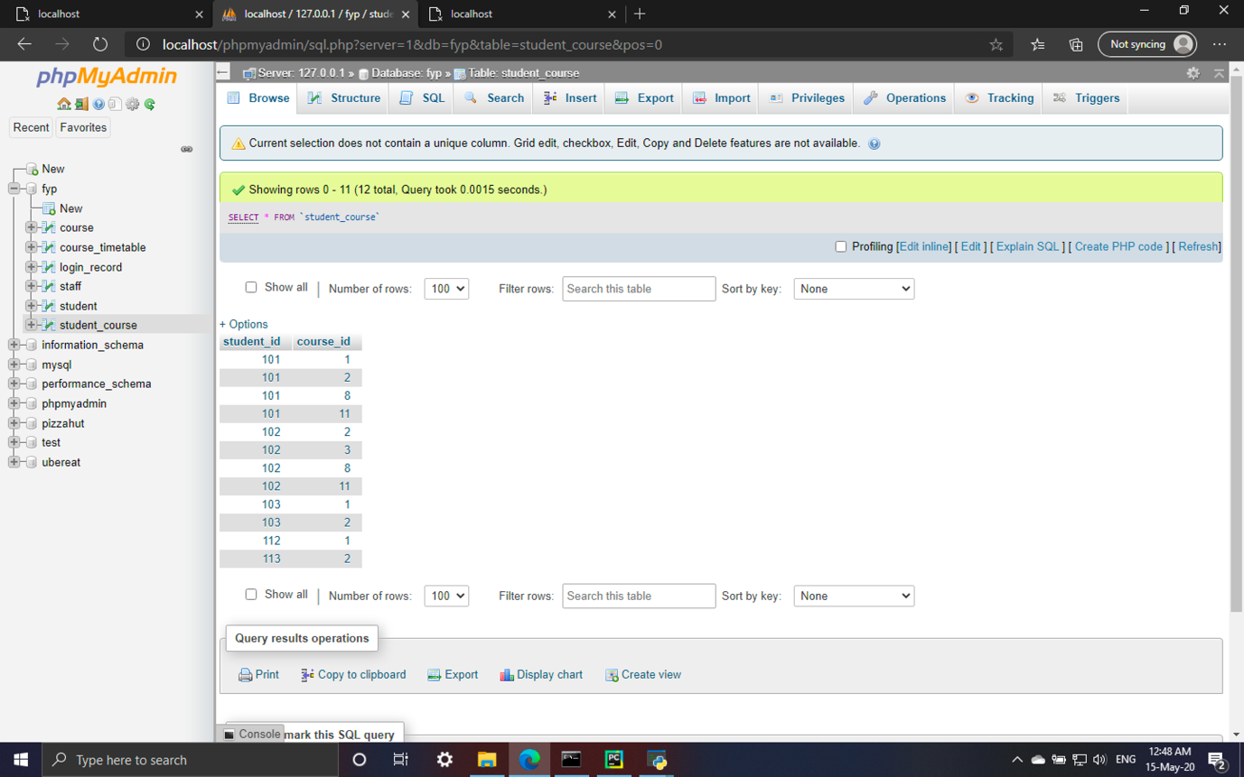Fig 72

|  |  |
| --- | --- |
| Test 10 | Modify class timetable |

|  |  |  |  |  |
| --- | --- | --- | --- | --- |
| Steps | Action | Test data | Expected result | Pass/fail |
| 1 | Input non-existed Timetable ID | 190 | The system cannot find the result, require user to input a existed ID | Pass |
| 2 | Input existed Timetable ID | 13 | The display the course information in the input box | Pass |
| 3 | Update Course ID, date, time, room | 2, 11-8-2020, 13:00, 142 | Data upload to database and timetable list can show the changes | Pass |

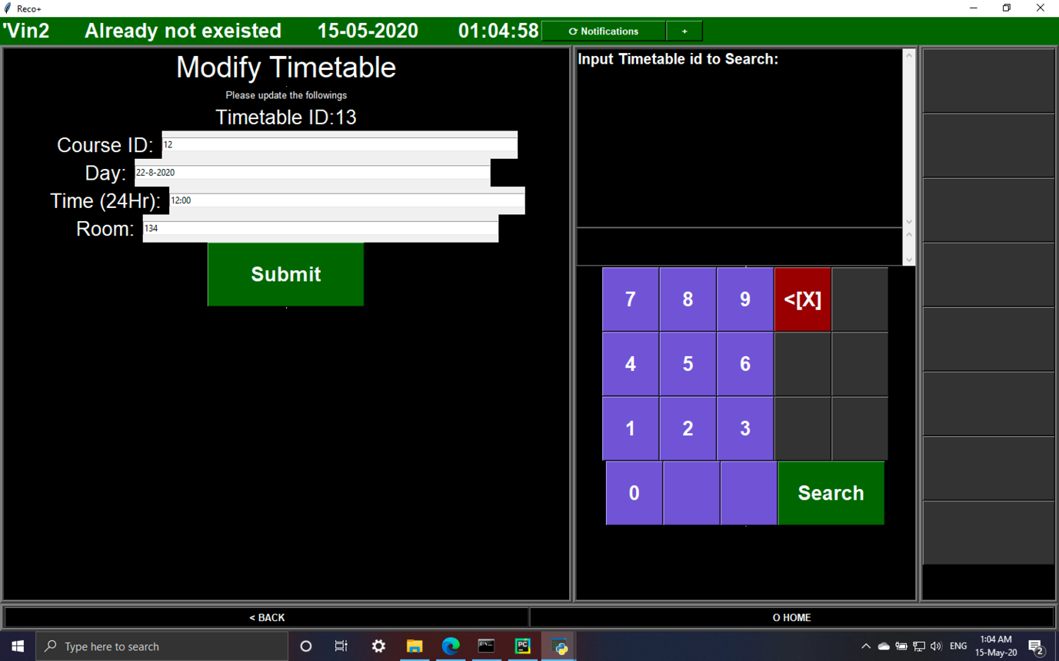Fig 73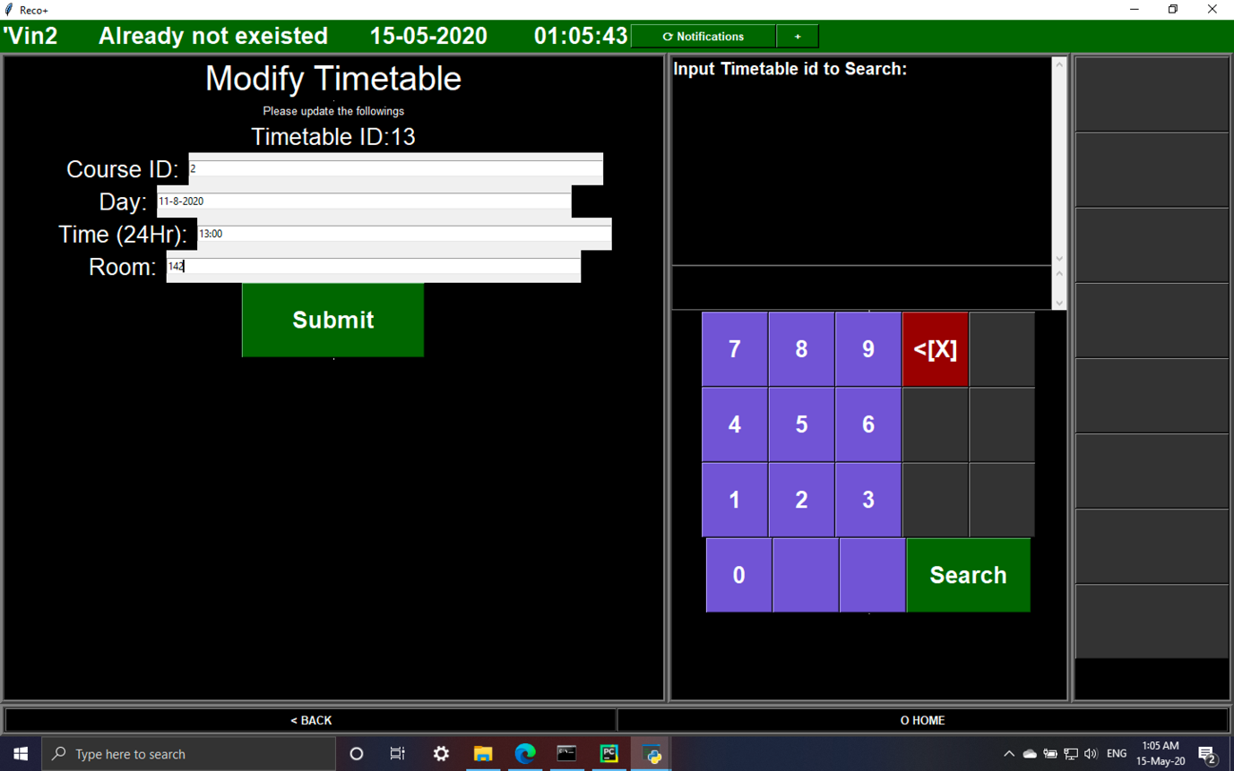Fig 74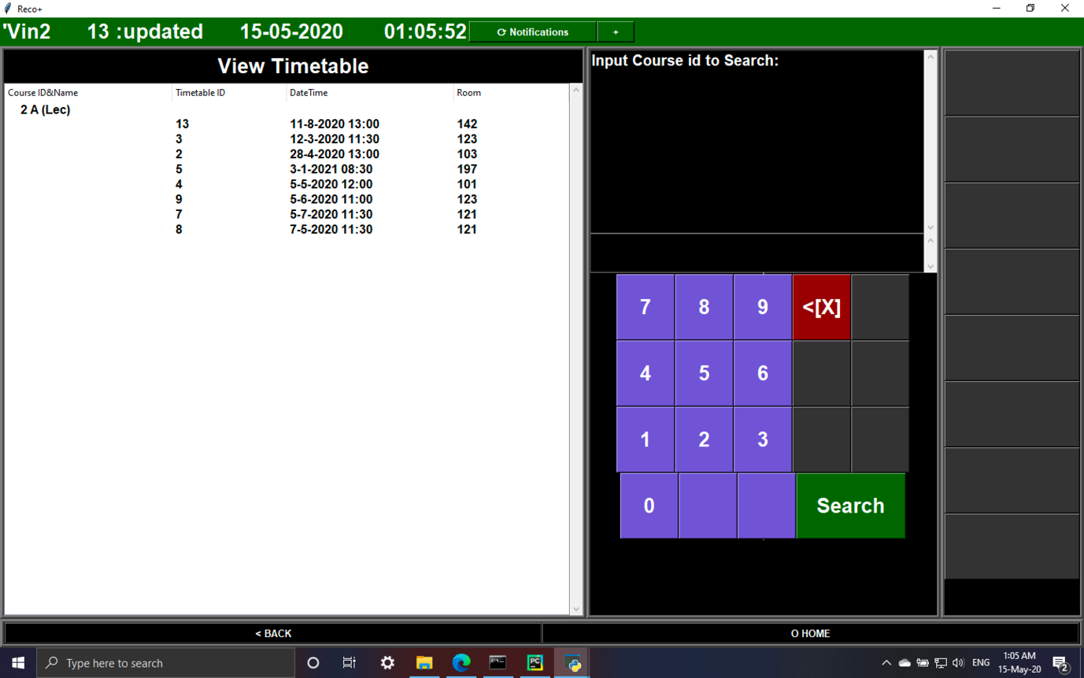Fig 75

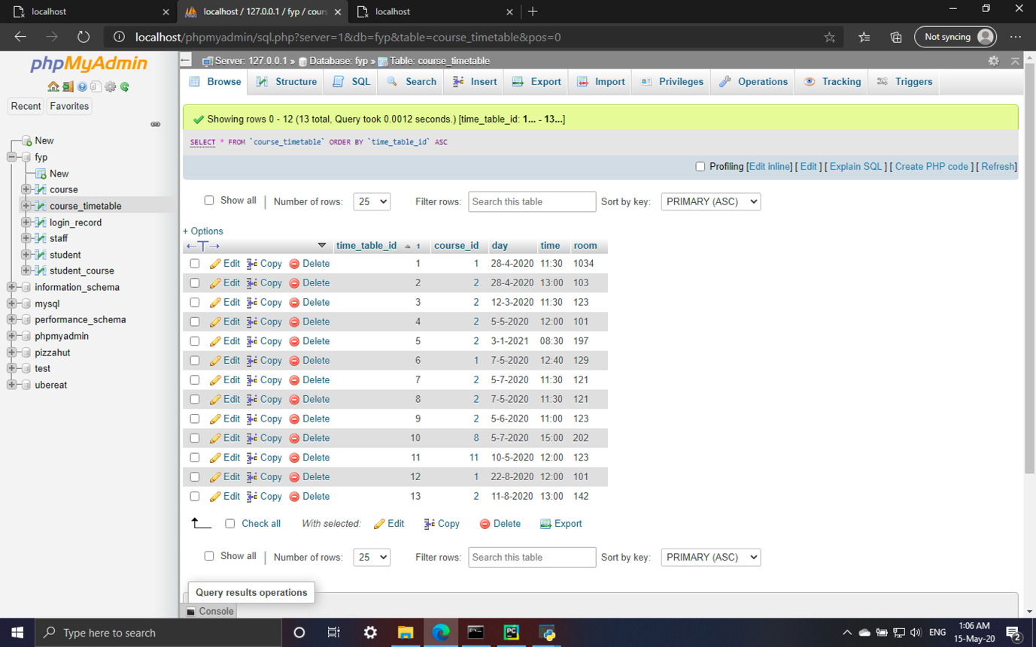Fig 76

|  |  |
| --- | --- |
| Test 11 | Send notification |

|  |  |  |  |  |
| --- | --- | --- | --- | --- |
| Steps | Action | Test data | Expected result | Pass/fail |
| 1 | Input and send message | System Testing 123 | Message should be upload and download through nodes.js | Pass |
| 2 | Check past notification | / | Downloaded message should be saved to text file (Fig 80) and able to view in past notifications page | Pass |

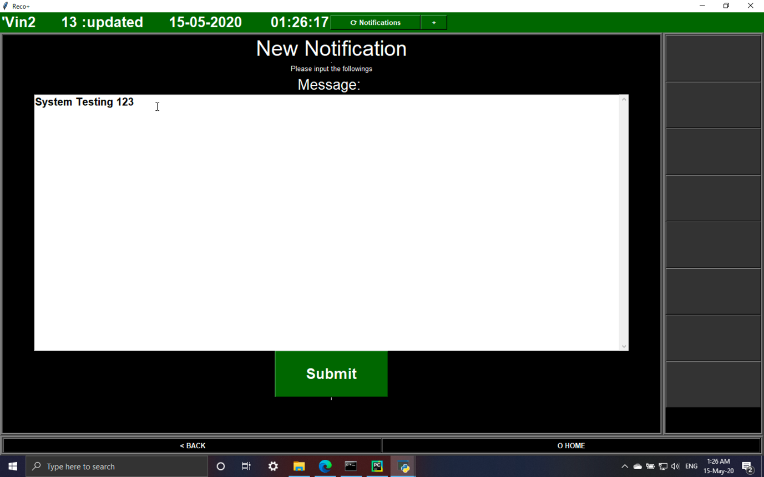Fig 77

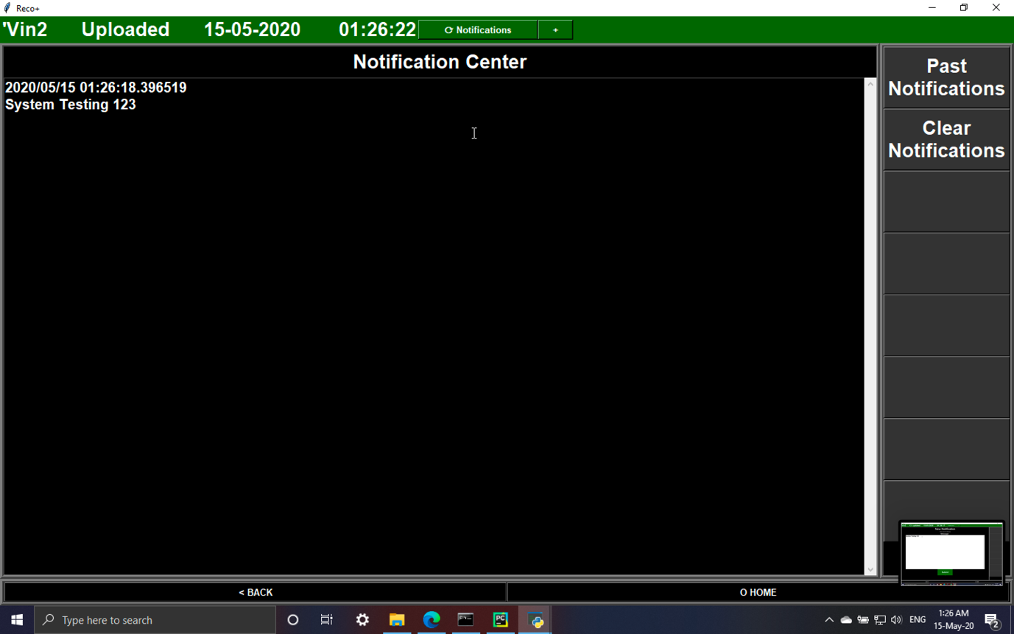Fig 78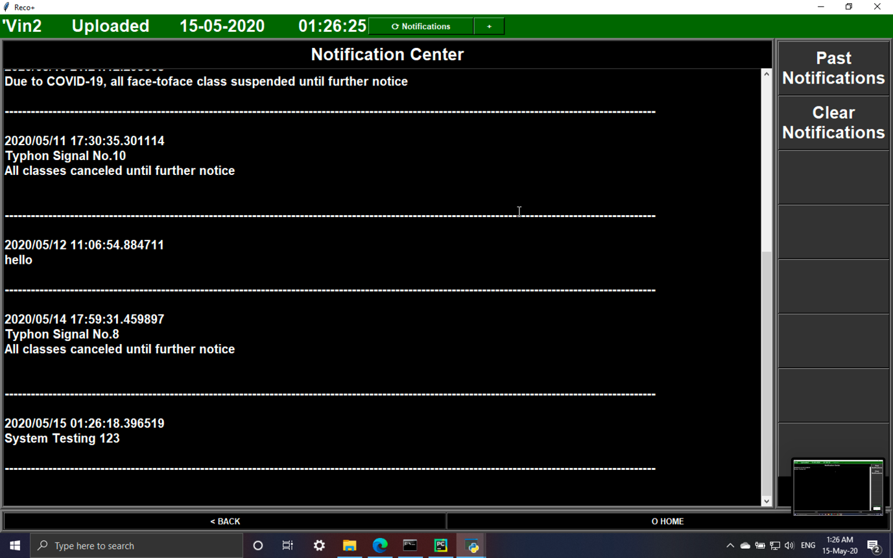Fig 79

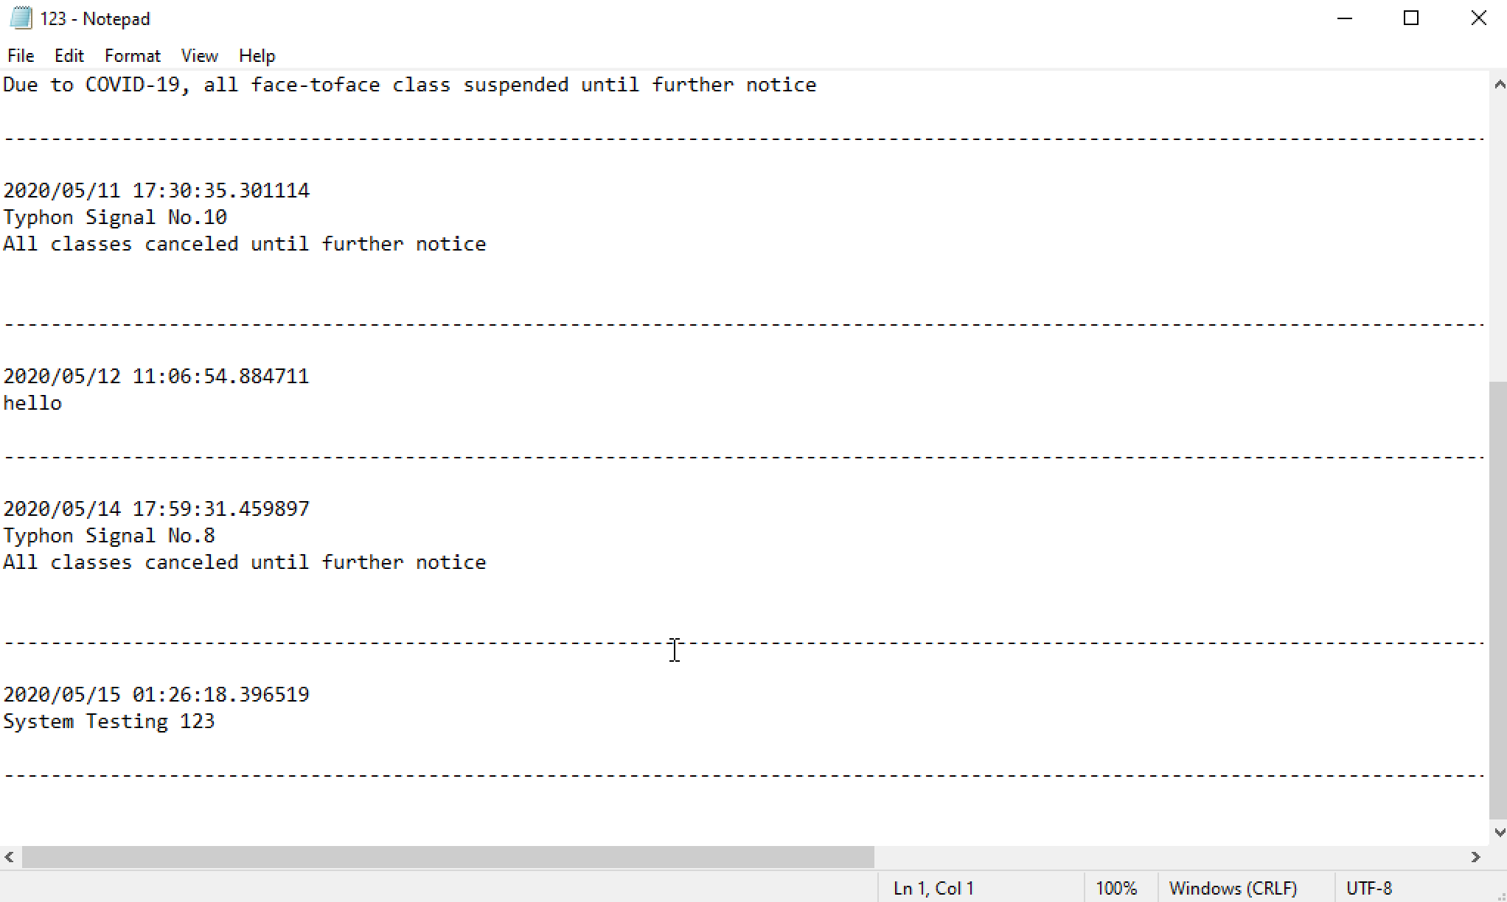Fig 80

|  |  |
| --- | --- |
| Test 12 | Clear notification |

|  |  |  |  |  |
| --- | --- | --- | --- | --- |
| Steps | Action | Test data | Expected result | Pass/fail |
| 1 | Click clear notifications | / | Notification in text file is cleared and the past notifications page is cleared | Pass |

|  |  |
| --- | --- |
| Test 13 | Capture face |

|  |  |  |  |  |
| --- | --- | --- | --- | --- |
| Steps | Action | Test data | Expected result | Pass/fail |
| 1 | Input Student ID, | 104, face of person | Image of face should be captured and the image is saved to a file named by Student ID | Pass |

|  |  |
| --- | --- |
| Test 14 | Face training |

|  |  |  |  |  |
| --- | --- | --- | --- | --- |
| Steps | Action | Test data | Expected result | Pass/fail |
| 1 | Input Student ID | 104 | A training model named by Student ID is saved | Pass |
| 2 | Try to use the model to identify a person | The model created in the previous step | The system can able to identify the person the person | Pass |

|  |  |
| --- | --- |
| Test 15 | Attendance taking |

|  |  |  |  |  |
| --- | --- | --- | --- | --- |
| Steps | Action | Test data | Expected result | Pass/fail |
| 1 | Input Student ID, recognise the face | 101, the face | The system is able to recognise the student and display ‘OK’ on the screen.  The record is uploaded to the database and able to view the record in the system (Fig 83) | Pass |

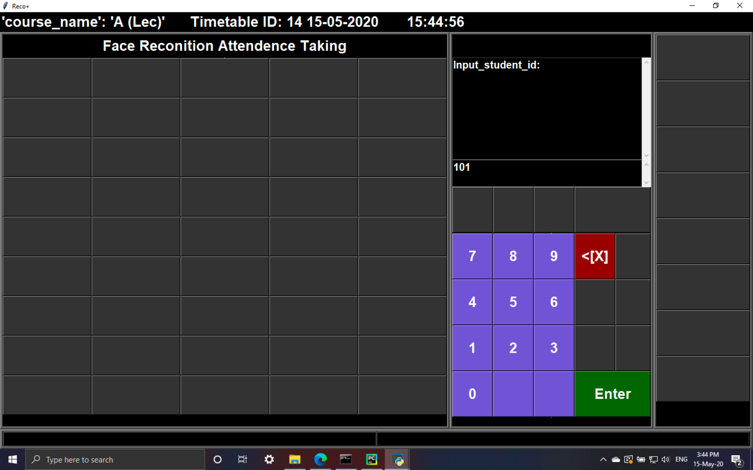Fig 81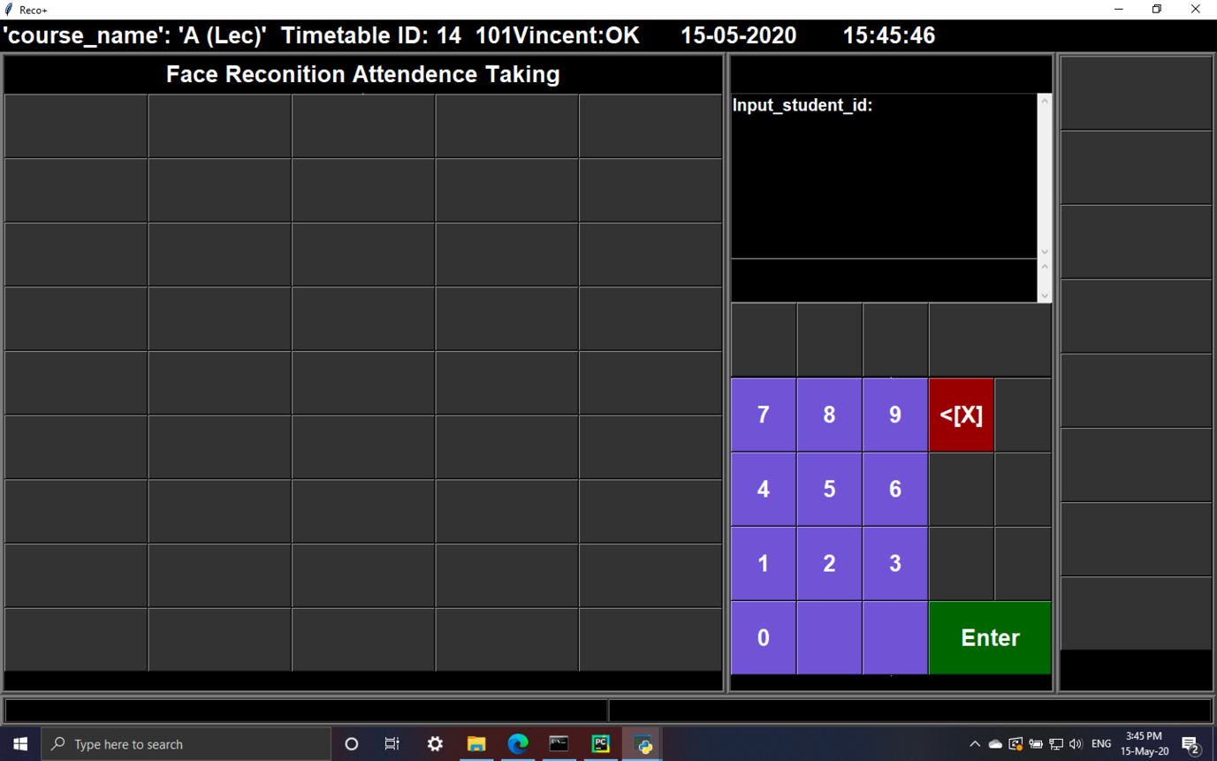Fig 82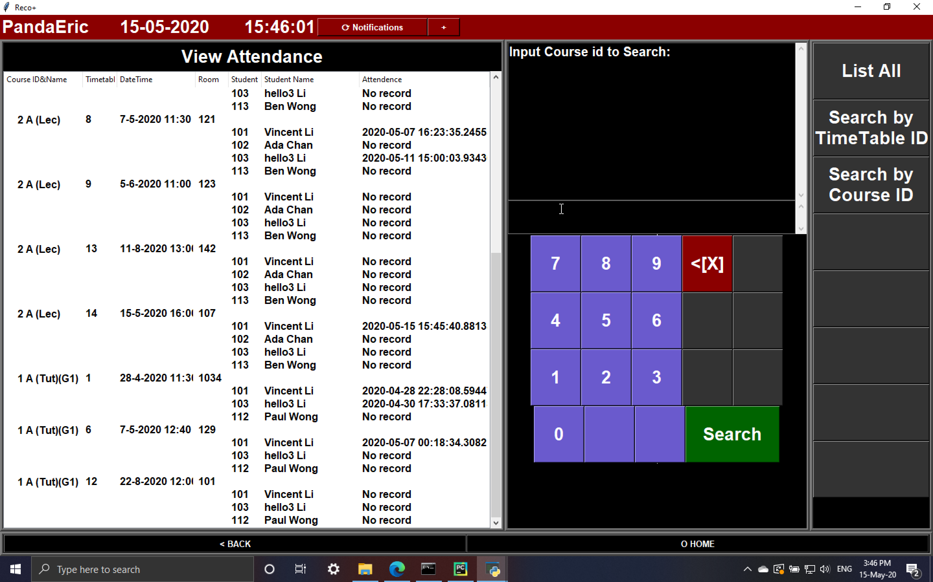Fig 83

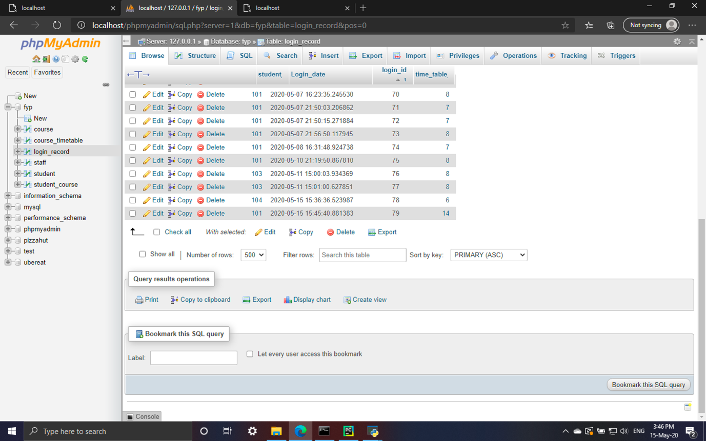Fig 84

|  |  |
| --- | --- |
| Test 16 | Login (main program) |

|  |  |  |  |  |
| --- | --- | --- | --- | --- |
| Steps | Action | Test data | Expected result | Pass/fail |
| 1 | Login with admin account | Staff ID: 123 | All features in the main program with green status bar displayed | Pass |
| 2 | Login with officer account | Staff ID: 129 | All features in the main program with green status bar displayed | Pass |
| 3 | Login with teacher account | Staff ID: 124 | Features for teacher in the main program with red status bar displayed | Pass |
| 4 | Login with student account | Student ID: 101 | Features for student in the main program with blue status bar displayed | Pass |

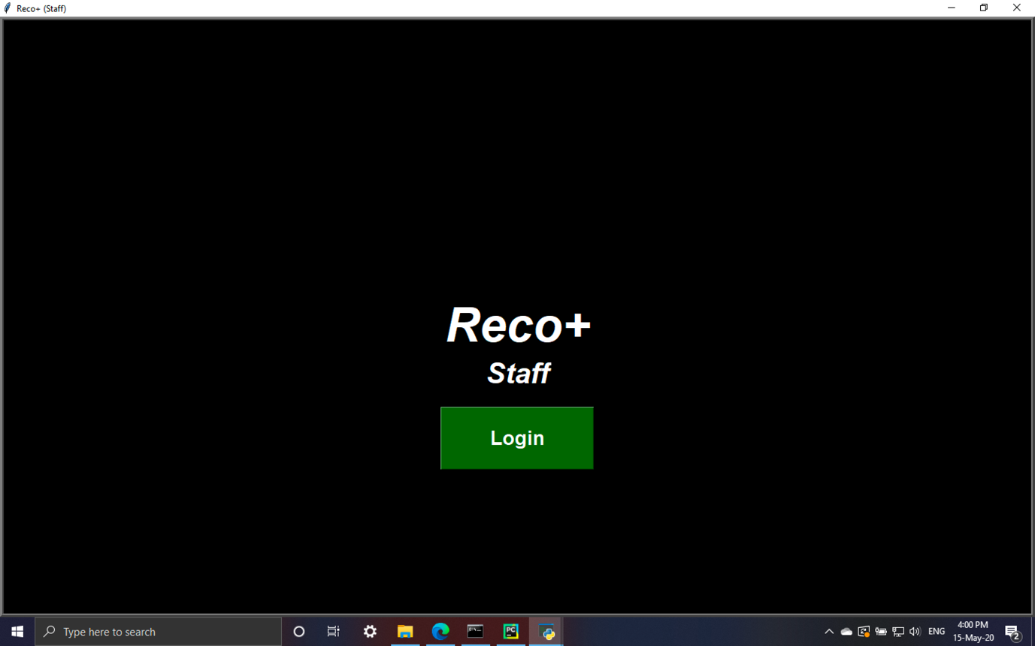Fig 85, Staff login

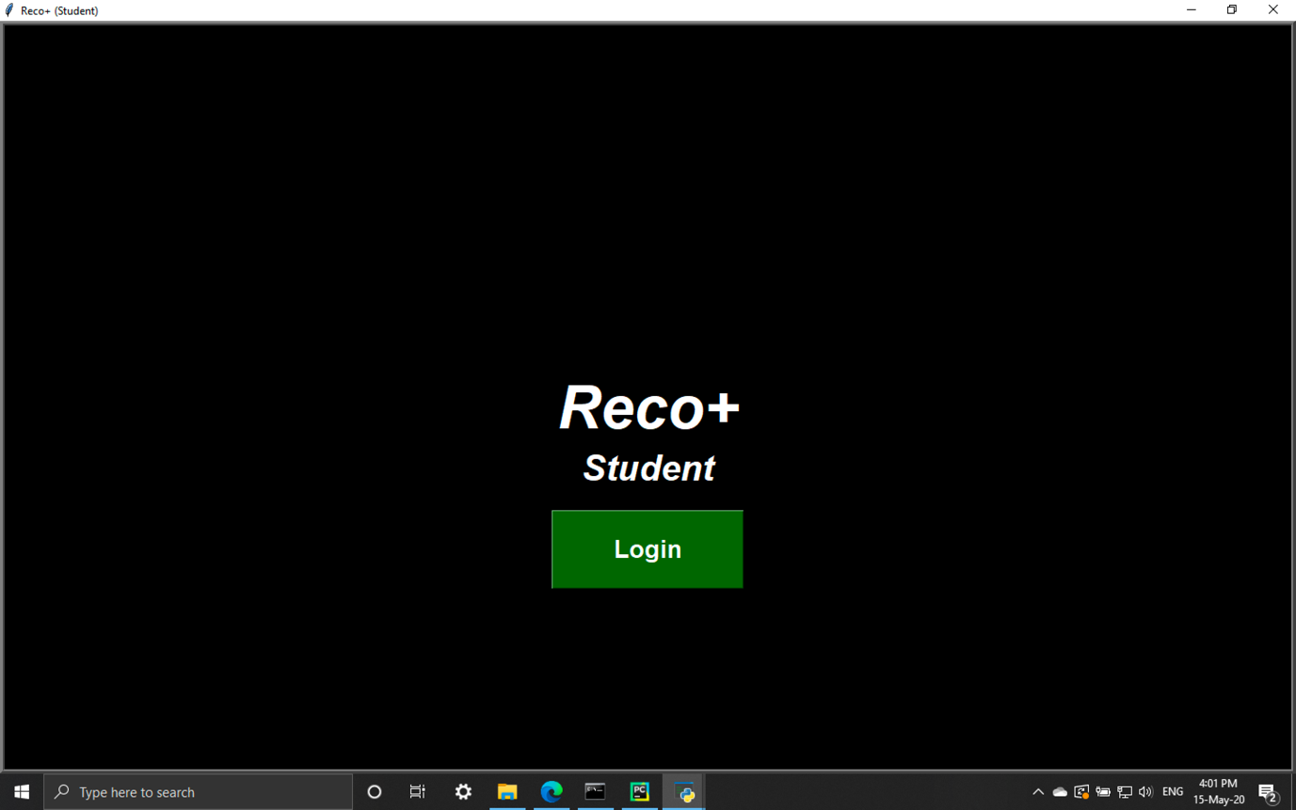Fig 86, Student login

|  |  |
| --- | --- |
| Test 17 | Logout (main program) |

|  |  |  |  |  |
| --- | --- | --- | --- | --- |
| Steps | Action | Test data | Expected result | Pass/fail |
| 1 | Click logout in with staff account | / | Staff login page displayed | Pass |
| 2 | Click logout in with student account | / | Student login page displayed | Pass |

|  |  |
| --- | --- |
| Test 18 | Login (attendance taking terminal) |

|  |  |  |  |  |
| --- | --- | --- | --- | --- |
| Steps | Action | Test data | Expected result | Pass/fail |
| 1 | Input Staff ID, password and Timetable ID | 123,123,14 | Successfully log in with correct course name and Timetable ID displayed | Pass |

# **9. Further development**

Although the system achieves the targets successfully, allowing the school to organise, management the class and checking attendance record easily with communication platform between schools and student provided, there are still many features and improvements can be implemented to further improve the user experience and convince the users.

1. The latest trend of online and distance learning can be benefit from the system. Teachers have difficulties to identify the identity of the student when using video conferencing tools like ZOOM meeting, which shows their blurry webcam screen with the login username, resulting in students may consider finding others to help them attending lesson. Besides, it is difficult for teachers to keep track if the students is listening as the screen can only show a few webcam screen at once. The system in the project can help identifying the identity of the student with features of tracking if they are watching the screen can be developed, helping teachers to focus on teaching.
2. Smartphone app and website version can be developed to even convince the user. Currently, the app only supports traditional computer platforms including Windows and Mac, which the device using those operating system (OS) is less portable than the smartphones which is a necessity of modern society. A brand new smartphone app allowing the student receive announcement from school when they are connected to the internet, with the face recognition for distance learning mentioned above allows the user have a larger flexibility to choose the device that suitable their environment. On the other hand, the website version is suitable for those people that have limited local storage in their device which other LMS including Canvas also provided.
3. To further perfect the system, a file download and upload system with assignment handling should be introduced. At the beginning of the project, it is aimed this platform should group all the features at once including class management and announcement. File transfer is always the core features used by students in LMS, allowing them to download the course materials only instead of spreading the hard copy materials during class, which is not only more environmental friendly, but also convenience the student. The supports of file download and upload with assignment handling decrease the complexity as there is no need to use another platform like Google Drive to exchange files.
4. Direct integration to other third party apps like Google Docs should be considered. Google provides API that allows third-party developers to implement access from their apps to the google drive folders. A typical example is Canvas, allowing user to access a shared Google Docs folder or connect to a ZOOM meeting directly, improving the work flow efficiency.
5. Attendance rate should be calculated and displayed. Currently, the system only displays the attendance taken date and time of each lesson which users may find difficult to find the attendance rate which some courses in university requires specific attendance rate like 70% to pass the courses. Displaying this information helps schools to identify the students do not meet the requirements.

# **10. Conclusion**

To conclude, the aims and objective is achieved by the main features of the system.

1. Increase the confirmation of identity of student

Through the face recognition system built, the student are required to compare their face to the model stored in the computer before entering the classroom, decrease the chance of students help others tick the attendance form. Besides, it is much more difficult to cheat the system without discover by the staff in school, as it is so obvious if the student use the photo to take the record which not only staff walk nearby will realize, but also the CCTV will record the situation easily.

2. Decrease the work load of teachers/officer

The attendance taking terminal contributes to no need for interrupting the class for attendance taking and reduce the work of teacher. After installing the system, the teacher only need to login to the terminal and they can prepare for the lesson. Besides, there is no need for teacher or other school officer to input the record to the computer manually, which also improves the workflow efficiency.

3. Allow students to receive latest information from school

The notification centre allows schools to broadcast the latest information including traffic news, weather and school activities to the student and student are able to receive the notifications through the system instantly.

4. Grouped all features in to one platform

The system not only includes notifications and attendance taking, but also include student, staff, class and timetable management, allowing the staff and student to view and management all those information at the same platform. Besides, more features including assignment and file upload/download is suggested to be implemented in the future which further supports the idea.

## **10.1 Evaluation**

A post implementation questionnaire is distributed in order to evaluate the effectiveness of the system. The questionnaire with a video demo of the two systems are distributed using both snowball and convenience sampling. The non-probability characteristics of snowball contribute to obtain rare sample, increasing the effectiveness of the evaluation (Dudovskiy 2019). On the other hand, with the convenience sampling, the evaluation are able to achieve in a short period of time. There are total 31 feedbacks received with 30 valid samples pass the first two filter questions.

### **10.1.1 Questionnaire design**

There are 6 questions in total which can separate them to two categories. The first two questions in the questionnaire are the filter questions, ensuring the users have at least watch how to use both attendance taking terminal and the main program in the project with knowledge of apps providing similar features in the market. If the user clicked no in either first or second question, the questionnaire will immediately ended to prevent they provide irreverent opinions. The third to sixth questions are questions with Likert scale from 1 (not important/ strongly disagree) to 5 (very important/ strongly agree in order to obtain the distribution of level of importance, level of expectation, level of performance and overall satisfaction of each features of the system.

* The level of importance shows if the user believe the features like attendance taking or announcement is important.
* The level of expectation shows the belief of user before they watch the demo/ use the system like if they believe that the user interface should be easy to understand
* The level of performance shows the final rating on each features after they have seen the demo/use the system.
* The overall satisfaction shows the overall rating of the software

Finally, a captcha verification (reCAPTCHA v2) is implemented as an extra question. The verification developed by google displays 9 images choices and the user need to select the photos relevant to the topic provided, ensuing the respondent are human as robots have difficulties on identifying the all images correctly.

### **10.1.2 Findings and Discussion**

The data collection period start from 17th May 2020 and end at 20th May 2020 with 30 valid response are processed by SPSS and Microsoft Excel for analysis.

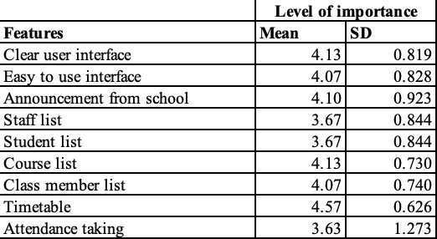

Table 1: Respondent’s rating on level of importance of each features

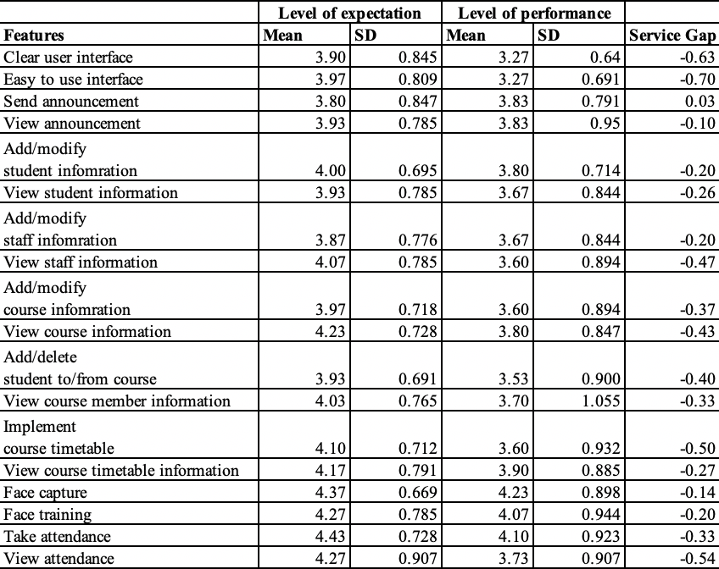

Table 2: Respondent’s rating on level of expectation and performance of each features

The Importance-Performance Analysis (IPA) is implemented to identify what features are important with poor rating, contributes to further improvement on those features in the future. This method have demonstrated its combability on providing valuable information to improve satisfaction (Martilla and James 1977 cited in Huang 2010: 2339).

The above table 1 and 2 shows the mean and standard deviation of the rating on each features on level of importance, expectation and performance with its service gap (difference of mean between performance and expectation). Based on table 2, the mean of level of performance on all features is above 3 with face capture, face training and attendance taking which are the focus of the project, gain the marks above 4. This shows the respondent are mostly satisfied the performance of the system. However, the standard deviation of level of performance on view course member of information is higher than 1, meaning the range of the result is much diverse than other questions.

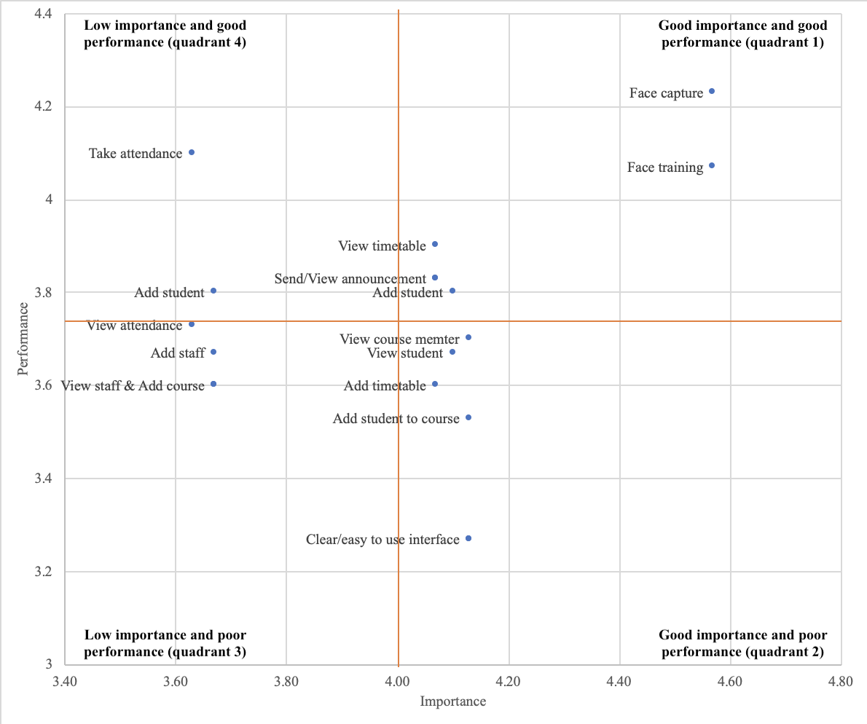Fig 87, Importance-Performance matrix of each features

The above figure shows that most of the features are fall in quadrant 1 with typical example face capture and face training, suggesting that they are both important and performs well. In contrast, attendance taking and add student fall in quadrant 4 which means they have good performance with low importance. Moreover, the features fall in quadrant 2 or 3 suggests they perform poorly and the feature is important in quadrant 2 or not important in quadrant 3.

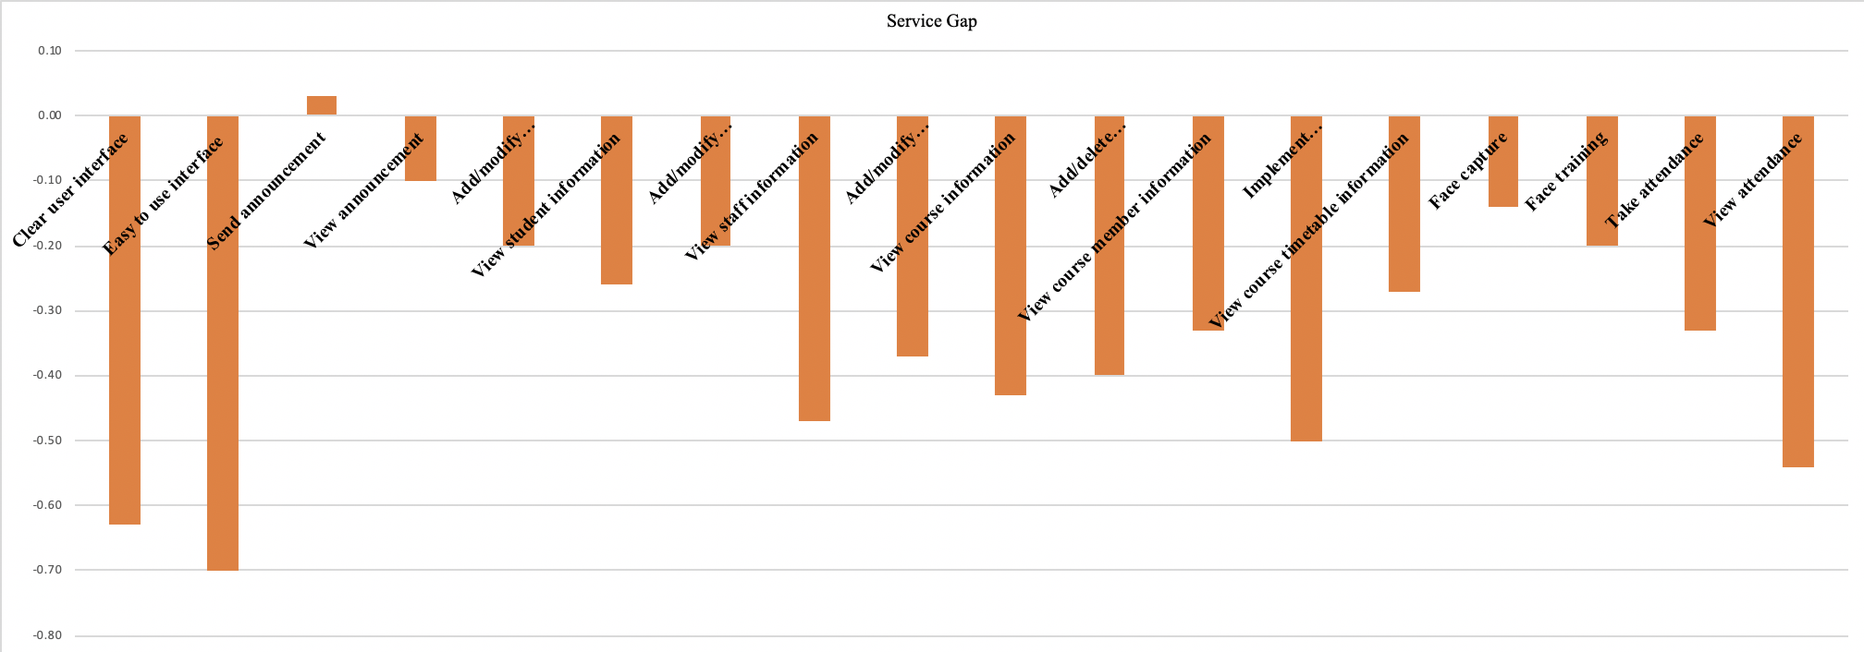Fig 88, Service gap by different features

The above figure shows the service gap on each feature. Except sending announcement, the expectation on other features is higher than the rating of the result, especially on user interface, implement timetable and view attendance which the difference is larger of equal to -0.5.

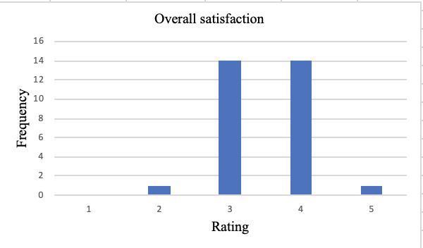

Fig 89, Percentage distribution of overall satisfaction level

The above figures shows the overall satisfaction of the system, with most people choose 3 or 4 as the final rating.

### **10.1.3 Conclusion on evaluation**

Although the sampling size is small and may not review the most accurate result, the survey also suggested that the effectiveness of the systems is good with space to further improve the quality. The main features of the system including face training, face capture and attendance taking received high ratings and all other features receive marks higher than 3 – the passing marks. However, the expectation marks is higher than performance marks in most features except send announcement, contribute to room for improvement in those area. It is suggest that improvement can be implement in the future according to the IPA matrix figure from quadrant 2 to quadrant 3 and 4. Besides, further survey can be done to investigate the how the user believe what is needed in each features to improve the systems.

## **10.2 Reflection**

For the first time ever, face recognition is suggested and implemented as focus of the project. I have tried lots of new tools, including OpenCV and TensorFlow, which those tools are known after I start finding the solution of the project. Compared to the prior projects, there are no tutorial lessons teaching how to use the new tools, which is a challenge on learning all tools and solution by my own. I overcome all obstacles by reading and watch the online tutorials website and videos, which requires a lot of time for research, trial and error, as not every tutorial may solve a problem and other problem may face after fixing a problem. This not only allows me to learn the new tools, but also increasing my problem solving skills.

In order to keep the all the programming files safe, I use GitHub as the backup platform, which not only keep my data safe, but also allows me to implement the version control by displaying the difference between the previous build and the latest build.

Time management is also core factor in this project. Most of the project done in the recent years are in group with the benefits of much larger human resources that a big group could be divided in to smaller groups, allowing to implement both development and documentation or testing and documentation at the same time. As the scale of this project is comparable or even larger than those previous group project, time management become extremely important factor. A detailed time management is achieved by planning the target each day, allowed me to finish the project on time with quality.

# **List of References**

Abadi, M., Agarwal, A., Barham, P., Brevdo, E., Chen, Z., Citro, C., Corrado, G. S., Davis,

A., Dean, J., Devin, M., Ghemawat, S., Goodfellow, I., Harp, A., Irving, G., Isard, M., Jia, Y., Jozefowicz, R., Kaiser, L., Kudlur, M., Levenberg,J., Mane ́, D., Monga, R., Moore, S., Murray, D., Olah, C., Schuster, M., Shlens, J., Steiner, B., Sutskever, I., Talwar, K., Tucker, P., Vanhoucke., V., Vasudevan, V., Vie ́gas, F., Vinyals, O., Warden, P., Wattenberg, M., Wicke, M., Yu, Y. and Zheng, X. (2015) *TensorFlow: Large-Scale Machine Learning on Heterogeneous Distributed Systems* [online] available from <https://arxiv.org/pdf/1603.04467.pdf> [12 May 2020]

Afifi, M. and Abdelhamed, A. (2017) *AFIF: Deep Gender Classification based on AdaBoost-*

*based Fusion of Isolated Facial Features and Foggy Faces* [online] available from <https://arxiv.org/pdf/1706.04277.pdf> [17 May 2020]

Beal, V. (2020) *Programming Language* [online] available from

<https://www.webopedia.com/TERM/P/programming_language.html> [14 May 2020]

Balckboard (2018) *Attendance* [online] available from

<https://help.blackboard.com/Learn/Instructor/Grade/Attendance> [17 May 2020]

Bruce, V. and Young, A. (1986) ‘Understanding face recognition’ *British Journal of*

*Psychology* [online] 77, 305-237. available from <https://onlinelibrary.wiley.com/doi/epdf/10.1111/j.2044-8295.1986.tb02199.x> [9 May 2020]

Canvas Doc Team (2020a) *How do I take roll call using the Attendance tool?* [online]

available from <https://community.canvaslms.com/docs/DOC-13077-4152107412> [11 December 2019]

Canvas Doc Team (2020b) *What is the Roll Call Attendance Tool?* [online] available from

<https://community.canvaslms.com/docs/DOC-10725-67952720324> [16 May 2020]

Casiano, L. (2020) ‘How China uses its massive surveillance apparatus to track its citizens,

keep them in line’. *Fox News* [online] 1 May. available from <https://www.foxnews.com/world/china-massive-surveillance-apparatus-track-citizens> [9 May 2020]

Chandrashekar, R., Shinde, J. and Mane, D. (2013) ‘Importance and Analysis of RFID in

Attendance System’. *International Journal of Emerging Science and Engineering (IJESE)* [online] 1 (9), 90-92. available from <http://citeseerx.ist.psu.edu/viewdoc/download?doi=10.1.1.678.2017&rep=rep1&type=pdf> [13 December 2019]

Coble, R. (2020) *Learning and Course Management Systems (LMS/CMS)* [online] available

from <https://cft.vanderbilt.edu/learning-and-course-management-systems/> [15 May 2020]

Conrad, R. (2019) *Taking Attendance - Must We?* [online] available from

<https://teaching.berkeley.edu/news/taking-attendance-must-we> [10 December 2019]

Dudovskiy, J. (2019) *Snowball sampling.* [online] available from <https://research-

methodology.net/sampling-in-primary-data-collection/snowball-sampling/> [21 May 2020]

ETink (2019) *What is an LMS? The Basics of Learning Management Systems.* [online]

available from <https://ethinkeducation.com/blog/what-is-an-lms-the-basics-of-learning-management-systems/> [13 December 2019]

Expert System (2020) *What is Machine Learning? A definition* [online] available from

<https://expertsystem.com/machine-learning-definition/> [13 May 2020]

Fouquet, H. (2020) ‘Paris Tests Face-Mask Recognition Software on Metro Riders’.

*Bloomberg* [online] 7 May. available from <https://www.bloomberg.com/news/articles/2020-05-07/paris-tests-face-mask-recognition-software-on-metro-riders?sref=C3P1bRLC> [10 May 2020]

Global Industry Analysts, Inc. (n.d.) *E-Learning market analysis, trends and forecasts.*

[online] <https://www.strategyr.com/market-report-e-learning-forecasts-global-industry-analysts-inc.asp> [12 December 2019]

Martilla, J. A., and James, J. C. (1977) ‘Importance-performance Analysis’. *Journal of*

*Marketing* 41*,* 77-79. cited in Huang, Y. (2010) ‘The Effect of Airline Service Quality on Passengers’ Behavioural Intentions Using SERVQUAL Scores: A TAIWAN Case Study’. *Journal of the Eastern Asia Society for Transportation Studies* [online]8, 2330-2343: 2339. available from <https://www.jstage.jst.go.jp/article/easts/8/0/8_0_2330/_pdf/-char/en> [21 May 2020]

OpenCV (2020) *OpenCV About* [online] available from <https://opencv.org/about/> [13 May

2020]

Pai, A. (2020) *CNN vs. RNN vs. ANN – Analyzing 3 Types of Neural Networks in Deep*

*Learning* [online] available from <https://www.analyticsvidhya.com/blog/2020/02/cnn-vs-rnn-vs-mlp-analyzing-3-types-of-neural-networks-in-deep-learning/> [12 May 2020]

Prabhu (2018) *Understanding of Convolutional Neural Network (CNN) — Deep Learning*

[online] available from <https://medium.com/@RaghavPrabhu/understanding-of-convolutional-neural-network-cnn-deep-learning-99760835f148> [17 May 2020]

Serokell (2020) *Artificial Intelligence vs. Machine Learning vs. Deep Learning: What’s the*

*Difference* [online] available from <https://medium.com/ai-in-plain-english/artificial-intelligence-vs-machine-learning-vs-deep-learning-whats-the-difference-dccce18efe7f> [12 May 2020]

Sufyanu, Z., Mohamad, F. S., Yusuf, A. A., Musa, A. N. and Abdulkadir, R. (2016) ‘Feature

Extraction Methods For Face Recognition’ *International Review of Applied Engineering Research (IRAER)* [online] 5 (3), 5658-5668. available from <https://www.researchgate.net/publication/313360566_FEATURE_EXTRACTION_METHODS_FOR_FACE_RECOGNITION> [9 May 2020]

TensorFlow (2020) *GPU support* [online] available from

<https://www.tensorflow.org/install/gpu> [15 May 2020]

TIBOE (2020) *TIOBE Index for May 2020* [online] available from

<https://www.tiobe.com/tiobe-index/> [14 May 2020]

TutorialsPoint (2020) *Node.js – Introduction* [online] available from

<https://www.tutorialspoint.com/nodejs/nodejs_introduction.htm> [16 May 2020]

Viola, P. and Jones, M. (2001) ‘Rapid Object Detection using a Boosted Cascade of Simple

Features’ IEEE Computer Society Conference on Computer Vision and Pattern Recognition (CVPR 2001) [online] 1, 511-518. available from <https://www.cs.cmu.edu/~efros/courses/LBMV07/Papers/viola-cvpr-01.pdf> [10 May 2020]

Warden, P. (2017) *How many images do you need to train a neural network?* [online]

available from <https://petewarden.com/2017/12/14/how-many-images-do-you-need-to-train-a-neural-network/> [17 May 2020]

Watson, W. R. and Watson, S. L. (2007) ‘An argument for clarity: what are learning

management systems, what are they not, and what should they become?’. *TechTrends, Springer Verlag* [online]51(2), 28-34. available from <https://hal.archives-ouvertes.fr/hal-00692067/document> [14 May 2020]

Womersley, K. (2018) *Would you rather be late — or wrong? A strategic case for Waterfall*

*Development* [online] available from <https://medium.com/@kawomersley/would-you-rather-be-late-or-wrong-a-strategic-case-for-waterfall-development-35d81911022c> [13 May 2020]

# **Appendix A: Project Meeting Log (Term 1)**

|  |  |  |
| --- | --- | --- |
| Project ID: ITB-018 | Student Name: Li Yat Long | Student ID: 55201950 |

|  |  |  |  |
| --- | --- | --- | --- |
| Meeting Date | Discussion and action | Student sign | Supervisor sign |
| 16/9/2019 | [Face to Face]   * Kick-off meeting * Introduction of FYP * Provide direction and suggestion on how to start the project |  |  |
| 14/10/2019 | [Face to Face]   * Exchange opinions on the topic chosen * Provide suggestion on what should do next |  |  |

# **Appendix A: Project Meeting Log (Term 2)**

|  |  |  |
| --- | --- | --- |
| Project ID: ITB-018 | Student Name: Li Yat Long | Student ID: 55201950 |

|  |  |  |  |
| --- | --- | --- | --- |
| Meeting Date | Discussion and action | Student sign | Supervisor sign |
| 6/5/2020 | [Zoom meeting]   * Discuss the plan of presentation * Provide suggestion on presentation * Review the current progress of the project * Provide suggestion on the project |  |  |
| 11/5/2020 | [Zoom presentation]   * Presentation * Provide suggestion on documentation |  |  |
| 12/5/2020 | [Messaging App]   * Provide suggestion on documentation |  |  |
| 17/5/2020 | [Email]   * Review the post implementation questionnaire * Provide suggestion on the questionnaire |  |  |

**Appendix B: Questionnaire** 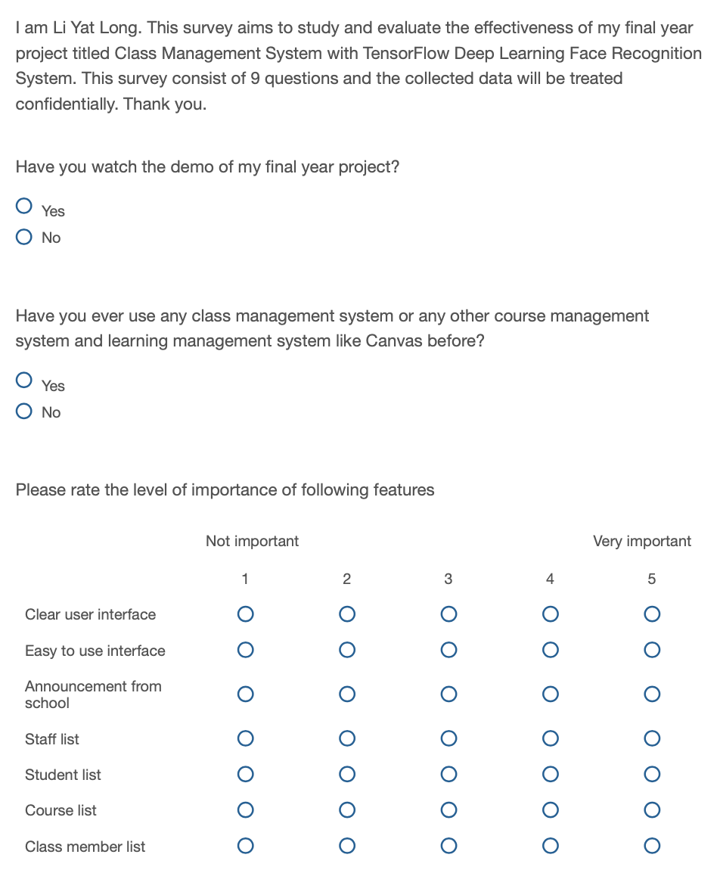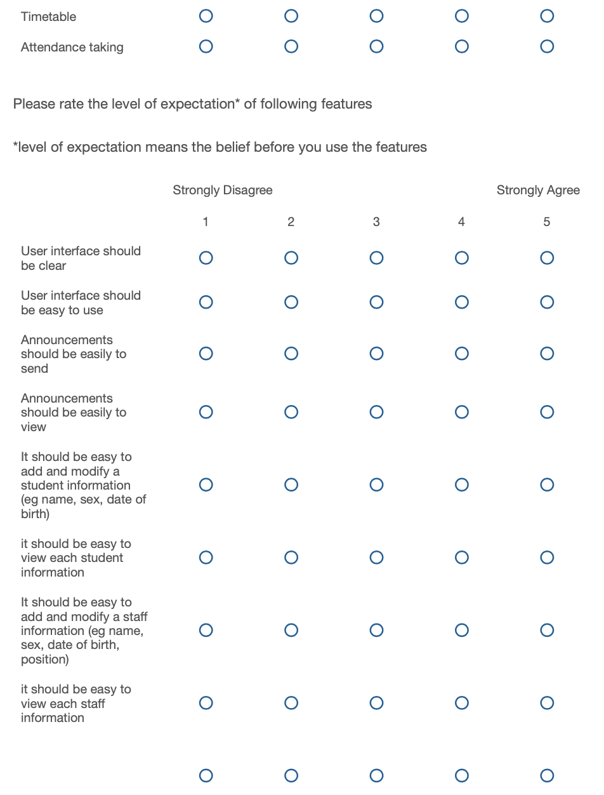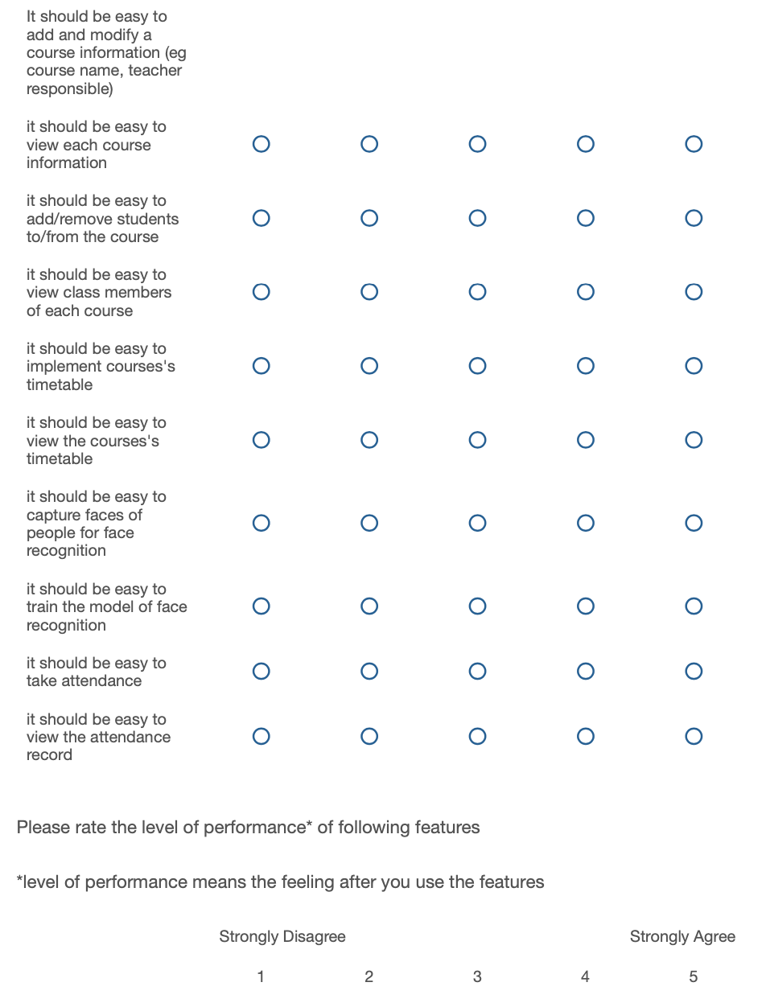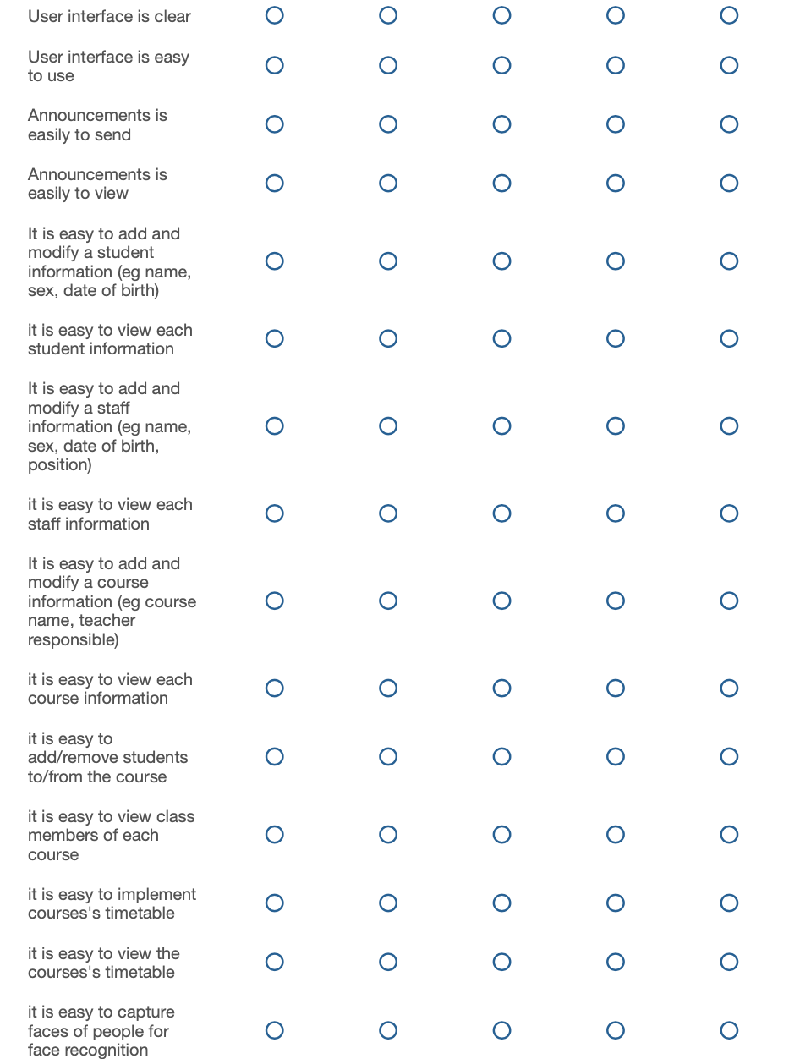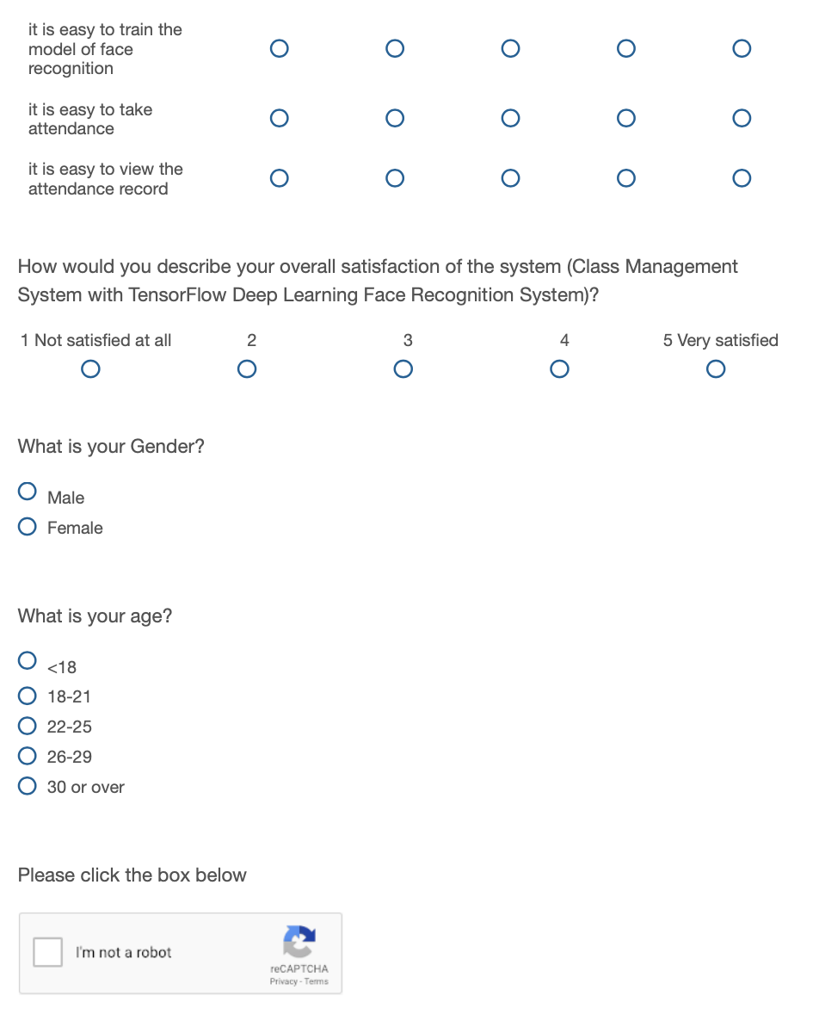

# **Appendix C: GitHub link**

<https://github.com/vincennt99v1123li/FYP?files=1>

# **Appendix D: Questionnaire result**

<https://drive.google.com/file/d/1OK1Jgs_uJnhc_gCI3LL_7TH7hvRrLM8-/view?usp=sharing>